
Local Plan Evidence Base:
Renewable and Low Carbon Energy

April 2026

Contents

1.0 Introduction 2
2.0 Planning Policy 2
2.1 National Planning Policy Framework 2
2.2 Government Policy Statement 4
2.3 Planning Practice Guidance 4
2.4 Local Plan 5
2.5 Emerging New Local Plan 6
3.0 Strategic Renewable Energy Opportunities 7
3.1 Wind Turbines 8
3.1.1 Site Search Criteria and Buffer Distances 9
3.1.2 Detailed Site Considerations for Applicants 13
3.1.3 Map 1: Suitable Sites for Wind Turbine Development 15
3.1.4 Map 2: Wind Speeds in North Tyneside 16
3.2 Solar Farms 17
3.2.1 Site Search Criteria and Buffer Distances 17
3.2.2 Detailed Site Considerations for Applicants 20
3.2.3 Map 3: Suitable Sites for Solar Farm Development 23
4.0 Heat Networks 24
5.0 Recommendations 25
5.1 Local Plan Policies 25
5.2 Development Proposals 26
6.0 Supporting Documents 26

- Introduction
North Tyneside Council is preparing a new Local Plan, which will replace the current Local Plan adopted in 2017. The planning system plays a key role in facilitating the delivery of renewable and low carbon energy infrastructure, contributing to the mitigation of climate change and the transition to a low carbon economy.

To inform the preparation of the new Local Plan, this Renewable and Low Carbon Energy Assessment considers the potential for key renewable and low carbon energy sources within the borough. The assessment provides an evidence base to support the development of a positive planning strategy for renewable and low carbon energy.

As part of this work, the assessment identifies broad areas of potential suitability for wind and solar energy development, which are key sources of renewable energy. This is undertaken at a strategic level to help guide policy development and decision-making, and does not allocate sites or determine the acceptability of individual development proposals.

- Planning Policy

National Planning Policy Framework
The National Planning Policy Framework (NPPF) was updated in December 2024 and places sustainable development at the heart of the planning system. The NPPF establishes twelve principles of sustainable development that should underpin plan making and decision-taking; the encouragement of renewable energy and climate change mitigation is one of these key principles. Chapter 14 of the NPPF states that planning plays a key role in supporting the delivery of renewable and low carbon energy and associated infrastructure (paragraph 161).

Paragraph 165 of the NPPF sets out:
“To help increase the use and supply of renewable and low carbon energy and heat, plans should:

- Provide a positive strategy for energy from these sources, that maximises the potential for suitable development, and their future re-powering and life extension, while ensuring that adverse impacts are addressed appropriately (including cumulative landscape and visual impacts);

- Consider identifying suitable areas for renewable and low carbon energy sources, and supporting infrastructure, where this would help secure their development; and

- Identify opportunities for development to draw its energy supply from decentralised, renewable or low carbon energy supply systems and for co-locating potential heat customers and suppliers.”

Paragraph 160 of the NPPF outlines how proposals for renewable energy development within Green Belt should be approached:

“When located in the Green Belt, elements of many renewable energy projects will comprise inappropriate development. In such cases developers will need to demonstrate very special circumstances if projects are to proceed. Such very special circumstances may include the wider environmental benefits associated with increased production of energy from renewable sources.”

Government Policy Statement
In July 2024, the Government published a Policy Statement regarding onshore wind energy that resulted in the removal of constraints which required areas for wind energy development to be identified in the development plan or a supplementary planning document. Therefore, applications for onshore wind developments are treated the same as applications for other renewable energy development proposals.

Planning Practice Guidance
The government published the Planning Practice Guidance (PPG) in March 2014 for renewable energy. The practice guidance has not been updated to reflect the July 2024 policy statement and subsequent National Planning Policy Framework (NPPF) changes. However, it still offers guidance that is relevant to policies regarding renewable energy developments.

The PPG emphasises the important role of the planning system in the delivery of renewable and low carbon energy infrastructure in locations where the local environmental impact is acceptable. It encourages Local Planning authorities to develop positive strategies to promote the delivery of renewable energy through their Local Plans but also stresses that the responsibility to increase renewable energy generation does not automatically override environmental protections and the planning concerns of local communities.

The PPG offers support for criteria based policies for renewable energy in Local Plans and states that the following factors should be taken into account in developing Local Plan policies:

- The need for renewable energy does not automatically override environmental protections;
- Cumulative impacts, particularly on landscapes and local amenity;
- Local topography;
- Heritage assets and their setting;
- National Parks and Areas of Outstanding Natural Beauty;
- Importance of local amenity.

With regards to setting appropriate buffer zones/separation distances from development, the PPG states that:

“Local Planning authorities should not rule out otherwise acceptable renewable energy developments through inflexible rules on buffer zones or separation distances. Other than when dealing with set back distances for safety, distance of itself does not necessarily determine whether the impact of a proposal is unacceptable. Distance plays a part, but so does the local context including factors such as topography, the local environment and near-by land uses. This is why it is important to think about in what circumstances proposals are likely to be acceptable and plan on this basis.”

Local Plan
North Tyneside’s Local Plan 2017 sets out the Council’s policy approach regarding the delivery of renewable energy and low carbon technologies to support the transition to net zero, meeting energy needs and improving energy security.

Policy DM7.6 “Renewable Energy and Low-Carbon Technologies”:

The Council will encourage the local production of energy from renewable and low carbon sources to help to reduce carbon emissions. The Council will also encourage and support community energy schemes that reduce, manage and generate energy to bring benefits to the local community.

Where planning permission is required, proposals for development involving the provision of renewable and/or low carbon technologies, including micro-generation technologies, will be supported and encouraged except where the proposal would have unacceptable adverse effects that are not outweighed by the local and wider environmental, economic, social and other considerations of the development.

Commercial scale renewable energy generation projects will be supported in locations where other policies of the Plan can be satisfied. Developments of this type should be supported by a comprehensive assessment of their impact. When considering applications, regard will be given to the wider benefits of providing the energy from renewable sources as well as the potential effects at the local scale.

The Local Plan does not identify specific locations for renewable energy developments. Some renewable and low energy technologies can be installed through existing permitted development rights. Where planning permission is required, the Council will positively consider schemes that adequately address any negative impacts. These may include landscape character and design impacts.

Emerging New Local Plan
North Tyneside Council is preparing a new Local Plan to guide development up to 2042. Consultation on the Vision, Issues and Options stage was undertaken between August and October 2025. This consultation identified a range of key issues to be addressed through the Local Plan, climate change and the transition to net zero.

In January 2026, the Council commenced consultation on the next stage of the emerging Local Plan, which set out proposed policies to address these key issues. The emerging plan signals a clear intention to support and encourage the generation of energy from renewable and low-carbon sources as part of efforts to reduce greenhouse gas emissions and respond to climate change. It also supports the expansion of heat networks and associated infrastructure across the borough.

The emerging policy approach indicates that proposals for renewable and low carbon energy generation, associated infrastructure and energy storage are to be supported in principle, subject to appropriate assessment. Proposals would be required to avoid unacceptable adverse impacts on matters such as the environment, landscape character, heritage assets, residential amenity, aviation safety, and other material considerations, unless such impacts are demonstrably outweighed by the wider environmental, economic and social benefits of the development.
This Renewable and Low Carbon Energy Assessment provides part of the evidence base to support the development of these emerging policies, including consideration of where opportunities for renewable and low carbon energy development may exist within the borough.

- Strategic Renewable Energy Opportunities
Strategic Renewable Energy Opportunities are those that would support large-scale renewable energy generation. North Tyneside has the potential to provide renewable energy from several sources including solar panels, wind turbines, ground source heat pumps, air source heat pumps, biomass and anaerobic digestion. These resources offer opportunities to contribute to national net zero targets while supporting local energy resilience and innovation.

The Council has undertaken an assessment to identify the most suitable locations for wind turbine and solar energy installations which are key sources of renewable energy. While potential locations have been identified, these do not represent formal site allocations within the Local Plan. Their identification is intended to support the delivery of renewable energy in appropriate locations.

Wind Turbines
In assessing the potential suitability of locations for wind energy development in North Tyneside, a range of environmental, technical and policy-based constraints have been considered, alongside the application of buffer zones where relevant. These constraints have been applied on a strategic basis across the borough to inform a high-level site search.

For the purposes of this assessment, constraints are applied broadly across different turbine scales. While turbine size and height can influence detailed design, operational impacts and visual effects, the high-level suitability of a location for wind energy development is generally determined by baseline environmental and policy considerations rather than turbine size alone. The scale of turbines proposed will, however, be an important factor at the planning application stage.

Typical wind turbine scales are defined as follows:
- Micro: less than 2.5 kW power output and less than 10 metres in height.
- Small: 1.5–50 kW power output and up to 30 metres in height.
- Medium: 50 kW–1 MW power output and between 30 and 100 metres in height.
- Large: 1–3 MW or over power output and over 100 metres in height.

For certain considerations, such as proximity to residential areas and key infrastructure, indicative buffer zones have been applied as part of the strategic site search process. These buffers are based on typical assumptions relating to average-sized turbines and are intended solely to support high-level screening.

Larger turbines may require increased separation distances to address potential effects, which would be assessed on a case-by-case basis through detailed technical assessment. Conversely, smaller turbines may be capable of being accommodated with reduced buffers where this can be justified by local context, turbine design and mitigation measures.

Site Search Criteria and Buffer Distances
The identification of potentially suitable locations for wind energy development has been undertaken through a high-level strategic site search. This process has been informed by a series of baseline constraints and indicative buffers to help identify areas where wind development may be more or less likely to be appropriate in principle.

The constraints and buffers used at this stage are not intended to represent fixed exclusion zones, minimum separation distances or definitive tests of acceptability. Instead, they provide a proportionate screening tool to inform the Local Plan evidence base and to identify areas that may warrant further, site-specific assessment at the planning application stage, in line with national planning policy and guidance.

- Residential Areas
There is no formal separation distance in planning law between wind turbines and residential areas. For the purposes of this strategic assessment, a buffer of 350 metres has been applied to help identify potentially suitable areas in principle. For larger turbines, this distance may not be sufficient to meet noise standards or avoid other amenity impacts. The suitability of wind turbine proposals will therefore be determined on a case-by-case basis, informed by detailed assessment of noise, shadow flicker and visual amenity. Local factors such as topography, landscape character and surrounding land uses play an important role in determining appropriate separation distances.

- Roads and Railways
There is no formal separation distance in planning law between wind turbines and transport infrastructure. For the purposes of strategic screening, a buffer of 110 metres has been applied, based on typical turbine dimensions, for A and B roads and railways. At the planning application stage, site suitability will be assessed on a case-by-case basis, taking account of factors such as blade throw risk, driver visibility and potential distraction, to ensure that turbine siting does not compromise safety or transport operations.

- Overhead Electrical Transmission Lines
Northern Powergrid advises that a minimum separation distance equivalent to turbine height plus 10% be maintained between wind turbines and overhead power lines. For typical turbine sizes, this equates to a buffer of approximately 110 metres, which has been applied for the purposes of identifying potentially suitable locations.
For larger turbines, greater separation distances may be required, and this would be assessed on a site-specific basis at the planning application stage.

- Wind Resource
Wind energy development is generally reliant on sufficient wind speeds to ensure operational efficiency and economic viability. Wind speeds of approximately 3.5–4 metres per second are typically suitable for small-scale turbines, while speeds of between 5.8 and 8 metres per second are generally considered appropriate for larger-scale turbines.

Wind speed data from the Numerical Objective Analysis of Boundary Layer (NOABL) wind speed database has been used to inform the identification of potential areas for wind energy development at a strategic level.

- Historic Assets
Designated heritage assets, including World Heritage Sites, Registered Parks and Gardens, Listed Buildings, Conservation Areas and Scheduled Monuments, have been excluded from the strategic search area in order to avoid direct impacts. Proposals will be required to assess any potential effects on the setting of heritage assets through site-specific heritage impact assessment.

- Designated Nature Conservation Sites
The boundaries of designated nature conservation sites have been excluded from the search area to protect biodiversity and avoid direct impacts on ecologically important habitats. These include the Northumbria Coast Ramsar site, Northumbria Coast Special Protection Area, Northumberland Shore Sites of Special Scientific Interest, Local Nature Reserves and Local Wildlife Sites.

- Green Belt
The open space to the north of the borough is designated as Green Belt and has been included within the search area for suitable wind energy sites. However, many elements of renewable energy developments may constitute inappropriate development within the Green Belt. In line with national planning policy, any such proposals must demonstrate very special circumstances to be considered acceptable. These circumstances may include the wider environmental benefits associated with increased renewable energy generation.

- Recreation and Parks
Sports facilities, play sites, parks, gardens, cemeteries and amenity spaces have been excluded from the search area to safeguard valued recreational and community facilities.

- Public Rights of Way
A buffer of 10 metres has been applied to public rights of way to maintain openness, protect user experience and allow for landscape screening. The treatment of rights of way should be assessed in detail on a site-specific basis.

- Watercourses
A buffer of 10 metres has been applied alongside watercourses to protect habitats and allow for maintenance access, subject to site-specific ecological and flood risk considerations.

- Meteorological Sites
Wind turbines can affect meteorological infrastructure, including weather radar operations. The nearest radar installation to North Tyneside is located at High Moorside. North Tyneside lies outside the 20 km safeguarding consultation zone for this installation, and therefore meteorological radar does not represent a strategic constraint to wind energy development within the borough. Consultation may still be required for larger proposals at the application stage.

Detailed Site Considerations for Applicants
Where sites for wind turbine development are progressed to the application stage, applicants will be expected to undertake proportionate, site-specific assessment to demonstrate that proposals are suitable for their location. This should include consideration of the following matters:

- Newcastle International Airport Aerodrome Safeguard Area
The Newcastle International Airport aerodrome safeguarding area covers the entirety of North Tyneside. Wind energy developments within this area must be assessed on a case-by-case basis to determine potential impacts on aviation safety and navigational systems. As a result, no specific criteria have been applied in this assessment when identifying suitable locations for wind energy development. Instead, any proposed wind turbine schemes must consult with the Airport, as turbines may pose risks to aviation operations and infrastructure.

- Grid connection
The proximity of wind turbine developments to substations or transmission infrastructure can improve scheme viability by reducing the need for additional infrastructure.

- Technical Feasibility
Proposals should consider wind resource, topography and the suitability of the local road network for construction and long-term maintenance.

- Visual Impact
Wind energy development can introduce significant visual change. Applicants should assess landscape sensitivity, cumulative effects and potential mitigation measures through a Landscape and Visual Impact Assessment (LVIA).

- Drainage
Proposals should assess drainage and surface water management arrangements, including the potential use of sustainable drainage systems (SuDS), to ensure that proposals do not increase flood risk on-site or elsewhere.

- Community consultation
Early consultation with local communities is recommended for all projects.

Map 1: Suitable Sites for Wind Turbine Development
Areas have been identified which are suitable for wind turbines in North Tyneside, using the constraints and associated buffer zones set out in the previous section. These can be viewed on the interactive map or the map below.
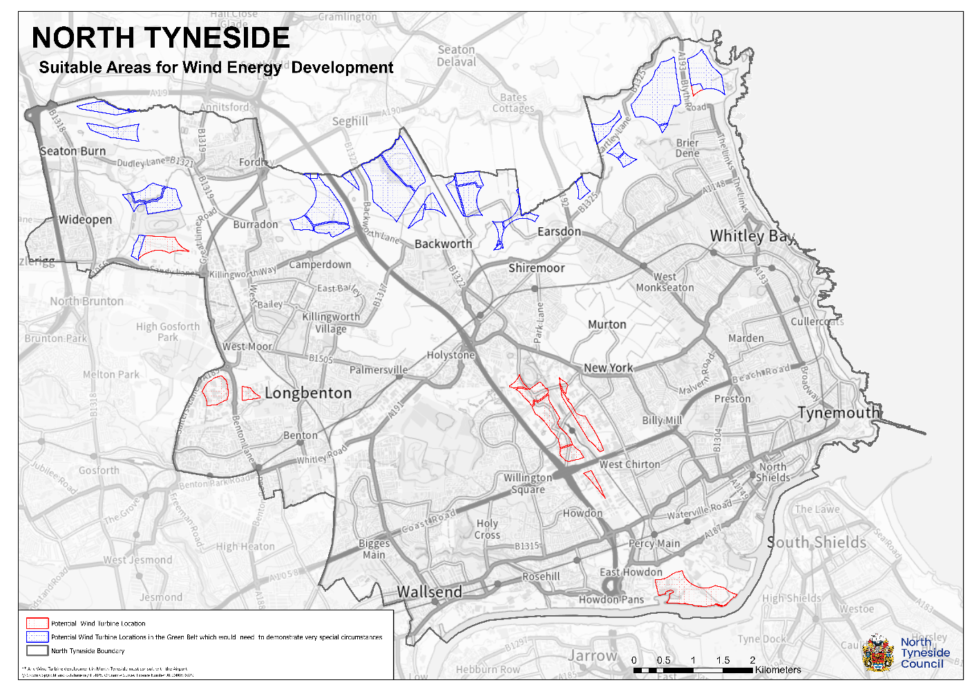

Map 2: Wind Speeds in North Tyneside
The following map shows wind speeds across the borough at a height of 10 metres above sea level using the NOABL data. Although site-specific wind resource assessments will still be required, the available data indicates that the identified sites have sufficient wind speeds to support at least a small wind turbine up to 10 metres in height.

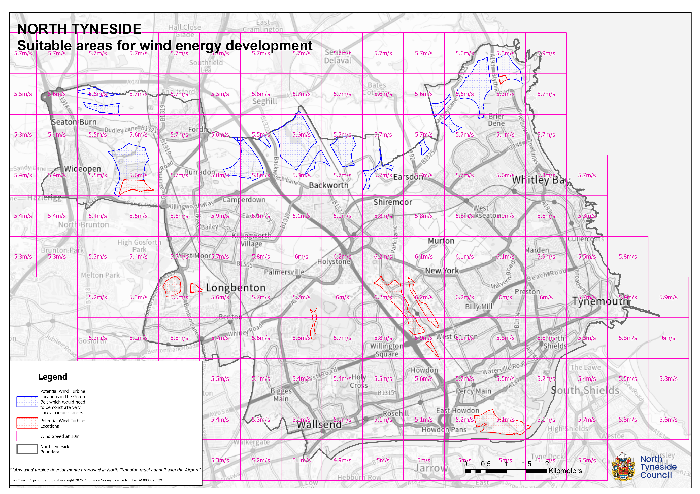

Solar Farms
In assessing the potential suitability of locations for solar energy development in North Tyneside, a range of environmental, technical and policy-based constraints have been considered. These constraints have been applied on a strategic, borough-wide basis to inform a high-level assessment of potential opportunities for solar farm development.

The constraints are applied broadly across different scales of solar development. While the size, layout and design of solar farms will influence detailed impacts, including landscape, visual and amenity effects, the strategic suitability of locations is generally driven by baseline environmental characteristics and planning considerations.

For certain factors, such as proximity to residential areas and key infrastructure, indicative buffers have been applied as part of the strategic site search. These buffers are intended to assist with high-level screening only and reflect the need to consider potential amenity, operational and access-related impacts, rather than representing fixed safety or separation distances.

Site Search Criteria and Buffer Distances
The identification of potentially suitable locations for solar farm development has been undertaken through a high-level strategic site search. This process has been informed by a series of baseline constraints and indicative buffers to help identify areas where solar development may be more or less likely to be appropriate in principle.

The constraints and buffers applied at this stage do not represent fixed exclusion zones or a definitive assessment of acceptability. Instead, they provide a proportionate screening tool to inform the Local Plan evidence base and to highlight areas that may warrant further, site-specific assessment at the planning application stage, in accordance with national planning policy and guidance.

- Site Size
There is no statutory minimum land size for solar farm development. For the purposes of this strategic assessment, a minimum site area of 2 hectares has been applied as an indicative threshold to identify sites more likely to be capable of supporting economically viable solar farm development. Smaller sites may still be appropriate subject to site-specific assessment.

- Overhead Electrical Transmission Lines
A buffer of 30 metres has been applied around overhead electricity transmission lines and pylons. This reflects operational requirements, maintenance access and compatibility considerations.

- Roads and Railways
A buffer of 10 metres has been applied around roads and railways to reflect construction access requirements, potential glint and glare considerations, and opportunities for landscaping and screening. These factors should be considered in detail on a site-by-site basis at the planning application stage.

- Designated Nature Conservation Sites
The boundaries of designated nature conservation sites have been excluded from the search area to protect biodiversity and avoid direct impacts on ecologically important habitats. These include the Northumbria Coast Ramsar site, Northumbria Coast Special Protection Area, Northumberland Shore Sites of Special Scientific Interest, Local Nature Reserves, and Local Wildlife Sites. The potential for indirect effects on designated sites would need to be assessed through site-specific ecological appraisal.

- Historic Assets
Designated heritage assets, including World Heritage Sites, Registered Parks and Gardens, Listed Buildings, Conservation Areas and Scheduled Monuments, have been excluded from the search area. This reflects a precautionary approach at the strategic level to avoid direct impacts. Proposals would still be required to assess potential effects on the setting of heritage assets on a site-specific basis.

- Flood Risk
Areas within Flood Zone 3 have been excluded from the search area for solar farm development to avoid locations at the highest risk of flooding.

- Residential Areas
Solar farm developments can introduce visual and amenity impacts, which can often be mitigated through appropriate siting, layout and landscape screening. For the purposes of strategic screening, a buffer of 50 metres has been applied around residential areas. Actual separation distances should be determined on a site-specific basis, taking account of topography, visibility, landscaping and design.

- Recreation and Parks
Existing sports facilities, play areas, parks, gardens, cemeteries and amenity spaces have been excluded from the search area to safeguard valued recreational, open space and community assets.

- Public Rights of Way
A buffer of 10 metres has been applied around public rights of way to protect user experience, maintain openness and allow for landscape screening. Opportunities to retain or enhance access should be considered on a site-specific basis.

- Watercourses
A buffer of 10 metres has been applied alongside watercourses to protect riparian habitats and allow for maintenance access, subject to site-specific flood risk and ecological assessment.

- Green Belt
Designated Green Belt land has been included within the search area for suitable solar farm sites. However, elements of renewable energy development may constitute inappropriate development in the Green Belt. In accordance with national planning policy, proposals within the Green Belt would need to demonstrate very special circumstances to be considered acceptable, which may include the wider environmental benefits associated with renewable energy generation.

Detailed Site Considerations for Applicants
Where sites for solar farms are progressed to the application stage, applicants will be expected to undertake proportionate, site-specific assessment to demonstrate that proposals are suitable for their location. This detailed work should include the following:

- Agricultural Land
The quality of agricultural land in England is classified nationally based on five grades. Most of the existing agricultural land within the Borough is estimated to be Grade 3; that is of “good to moderate” quality, with only a low to moderate likelihood of being the Best and Most Versatile agricultural land. Grade 3 is split into the sub-categories of 3a and 3b, category 3a being the best and most versatile (BMV), whilst category 3b being moderate. Solar farms should avoid BMV agricultural land and should use lower graded land (category 3b, 4 and 5). Applicants will need to do an Agricultural Land Assessment to determine the classification.

- Visual Impact
Solar farms can introduce visual change within the landscape. Proposals should assess landscape sensitivity, potential cumulative effects with other developments, and opportunities for mitigation through layout, design and landscaping. These impacts should be assessed through a Landscape and Visual Impact Assessment (LVIA), proportionate to the scale of the development.

- Glint and Glare
Due to the reflective nature of solar panels, large scale solar farms can cause glint and glare that can have an impact on sensitive receptors, including residents and users of aircraft, rail and road. Proposals for solar energy schemes will be considered on a case by case basis to ensure that solar developments are suitably located to prevent potential hazards to public safety caused by glint and glare and to protect residential amenity. Any proposed solar farm schemes must consult with the Airport, as they may pose risks to aviation operations.

- Grid Connection
The proximity of solar farm developments to substations or transmission infrastructure can reduce the need for additional connection works and improve overall scheme viability. Grid connection should be considered as part of site selection and scheme design.

- Technical Feasibility
Proposals should consider solar resource, site topography, ground conditions and the suitability of the local road network for construction and long-term maintenance access.

- Drainage
Proposals should assess drainage and surface water management arrangements, including the potential use of sustainable drainage systems (SuDS), to ensure that proposals do not increase flood risk on-site or elsewhere.

- Community consultation
Early consultation with local communities is recommended for all projects.

Map 3: Suitable Sites for Solar Farm Development
Areas have been identified which are suitable for solar farms in North Tyneside, using the constraints and associated buffer zones set out in the previous section. These can be viewed on the interactive map or the map below.

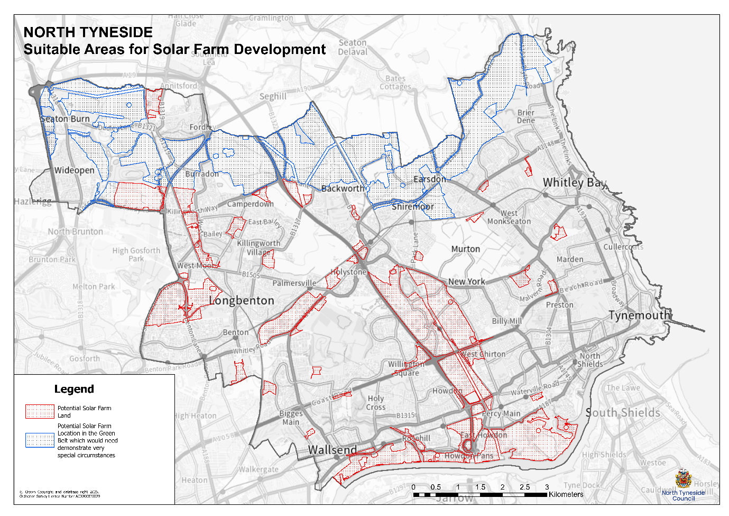

- Heat Networks
Heat networks, which distribute heat from a central source to multiple buildings via underground insulated pipes, are an important technology in the decarbonisation of heat. By connecting a range of building types, including residential, commercial and public sector uses, heat networks can support the efficient delivery of low-carbon heat at scale.

Heat network zoning is a national policy initiative intended to support the expansion of heat networks at the scale required to meet the UK’s net zero targets. Locally designated heat network zones are intended to enable the delivery of cost-effective low-carbon heat to buildings where this represents the most viable decarbonisation option. Such zones can play a key role in supporting the transition away from fossil fuel-based heating systems.

The Council supports the development of viable heat networks and associated infrastructure across the borough. A range of feasibility work has been undertaken to consider the potential for retrofitting heat networks in appropriate locations. This work reflects the importance of identifying areas with sufficient heat demand density and suitable low-carbon heat sources.

In 2022, the Council undertook the Killingworth Heat Network Assessment, which identified that a centralised heat production system could deliver energy and carbon savings by connecting local authority buildings, housing and businesses to a low-carbon heat source derived from underground mine water. The subsequent feasibility study focused on a potential heat network centred on the Council’s Killingworth Depot and serving surrounding homes and businesses. This study has now concluded and provides a practical example of how heat networks could contribute to decarbonising heat in suitable locations within the borough.

The findings from this and other feasibility work help to inform the Council’s understanding of where heat networks may represent a viable option and provide evidence to support the development of Local Plan policies that encourage their delivery where appropriate.

- Recommendations
This Renewable and Low Carbon Energy Assessment supports a proactive approach to renewable and low-carbon technologies, consistent with national planning policy. The NPPF requires local planning authorities to support the transition to a low-carbon future, including through facilitating renewable and low carbon energy development and addressing climate change through mitigation and adaptation.

The findings of this assessment should be used to inform the preparation of the new Local Plan and the development of policies relating to renewable and low-carbon energy generation, associated infrastructure and energy storage. The assessment is also intended to provide clarity for applicants and decision-makers on the opportunities and considerations relevant to such development within the borough.

5.1 Local Plan Policies
In light of the evidence presented in this assessment, the Local Plan should:
- Include a positive strategy that supports and encourages energy generation from renewable and low-carbon sources, contributing to the reduction of greenhouse gas emissions;
- Support proposals for renewable and low-carbon energy generation, associated infrastructure and energy storage, subject to proposals avoiding unacceptable adverse impacts on environmental, landscape, heritage, amenity and other relevant considerations, or where such impacts are demonstrably outweighed by the wider benefits of the development; and
- Support the development of viable heat networks and associated infrastructure where opportunities exist and impacts can be satisfactorily addressed.

5.2 Development Proposals
In preparing proposals for renewable and low-carbon energy development, applicants should:
- Use this assessment as a starting point to help identify areas of potential suitability for wind and solar energy development, recognising that site-specific assessment will always be required;
- Have regard to the recommended site-specific considerations set out in this assessment, proportionate to the scale and nature of the proposal; and
- Assess separation distances and potential buffer zones on a site-specific basis, informed by local context, technical evidence and relevant guidance.

- Supporting Documents
This assessment has been informed by the following national and local policy documents, strategies and technical evidence:

- National Planning Policy Framework, Ministry of Housing, Communities and Local Government, December 2024.
- Planning Practice Guidance: Renewable and Low Carbon Energy, Ministry of Housing, Communities and Local Government, last updated 2023.
- Supporting Policy Statement on Onshore Wind, UK Government, July 2024.
- North Tyneside Carbon Net-Zero 2030 Action Plan, North Tyneside Council, 2022.
- Climate Change Adaptation Strategy and Action Plan, North Tyneside Council, 2026.
- North Tyneside Climate Emergency Action Plan, North Tyneside Council, 2020.
- North Tyneside Climate Emergency Action Plan Update, North Tyneside Council, 2025.
- North Tyneside Heat Network Mapping Report, North Tyneside Council, 2016.
- Numerical Objective Analysis of Boundary Layer Wind Speed Database, technical wind resource dataset used to inform high-level wind energy potential assessment.

Policy Statement on onshore wind, UK Government, 2024.

