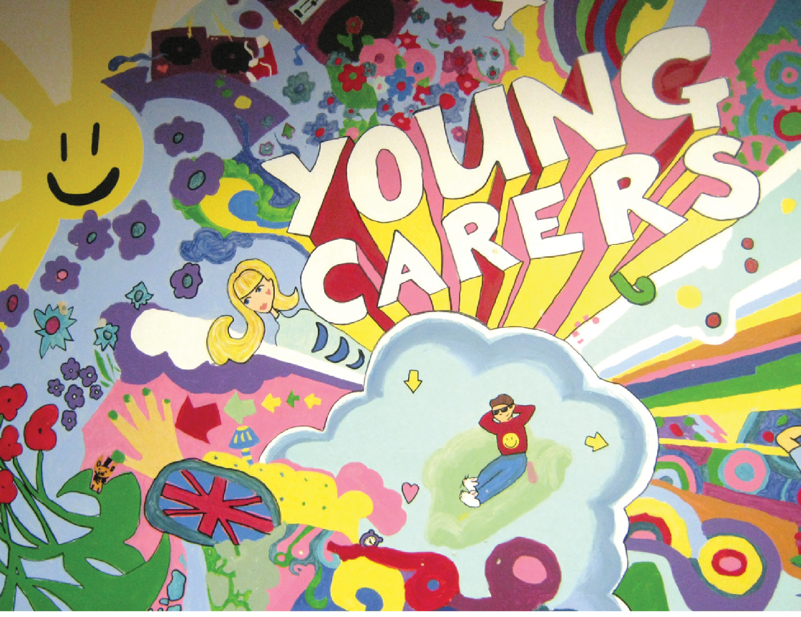

Young Carers’ Needs
Assessment (YCNA)
Over 12’s
Revised Edition March 2026
Thank you to the group of Young Carers for all their hard work in developing these documents.
This is a statutory assessment and must be completed within 28 days.
Note:
Part 1 to be completed with the young carer
Part 2 to be completed with parents/carers, school and other professionals/agencies working with the young carer and family
www.northtyneside.gov.uk

DETAILS
Young carers details
Full name
DOB
Gender
Address
School Name
Parent Details
Full Name
Tel.
Email
Cared for details
Full name
DOB
Gender
Care needs/ reason for care
Assessor details
Full name and role
Organisation
Tel
Email
Date assessment completed
I have been given and understand the leaflet on Information Sharing and in signing this form I am agreeing to receiving the service and that my personal information and that of the children I have parental responsibility for, can be shared with other agencies as required, to ensure I receive the best service and support.
Signature of young carer
Signature of parent/carer
Completed Young Carers’ Needs Assessments parts 1 & 2 should be sent via secure email to: youngcarersassessment@northtyneside.gov.uk

MY WORLD & ME
Name: …………………………… Age: ….. School Year: …………
Things that make you feel good and well supported are; (e.g. spending time with friends, hobbies, favourite places, getting enough sleep, eating well, exercising, religion/beliefs, pets, interests)
Things that make me feel bad/worried/upset and unsupported are; (e.g. not seeing my friends, not having time to do school/college work, getting in trouble at school, not sleeping well)
What are your hopes/ambitions/plans for the future, and are you working with Connexions?

Do you have any worries for the future? If so tell us about them…
How is your physical health? Do you get regular exercise, eat well and sleep well?
Do you want help to improve this? Do you have an ease card, if so describe how you are using it?
How does your caring role impact your mental health?
How is your school life? (e.g. learning, enjoyment, concentration in lessons, attendance/punctuality, friendships/relationships with teachers)

MY HOME
Who lives with you in your house? Do you have any pets?
Do you have any other family members or family friends who you see regularly who don’t live with you? If yes please tell us about them….
Who is it in your family that you provide care for? Do you know what condition/illness/disability the person you care for has, and can you describe it?
Is there anybody who used to live with you who are no longer living with you? And/or any one you used to see regularly who you no longer have contact with?
Thing I like about being in my home are… (e.g. spending time with my brother)
Things that I don’t like about being in my home are… (e.g. noise, caring tasks)

MY RELATIONSHIPS
Who is important to you and why, how often do you see them? (e.g. family, friends, teachers, pets) Are you happy with how often you see them?

MY CARING ROLE
Do you help the person you care for and/or any other in the house with their emotions or feelings, for example helping to make them feel better?

Does anybody else in the house have caring responsibilities? If so please tell us about them…

Fill in the main tasks below
Keep someone company
Take brothers/sisters to school
Take someone out
Interpret or use sign language
Food shopping
Clean the house
Pay bills
Help someone wash
Help someone dress
Lift or carry heavy things
Look after brothers and /or sisters
Wash dishes

Do you have to deal with adult/grown up situations? If so please tell us about these... (e.g. do you manage money, bills or shopping etc.)
Do you worry about the person you care for when are not with them? Why?
What support are you already getting? (e.g. from school, other organisations, people)
What support do you think you need? (e.g. Someone to talk to in school, counselling services, advice about college, apprenticeships or jobs, 1-1 support to discuss your thoughts and feelings)
(If you are unsure please ask the professional carrying out your assessment)

Is there anything else you think we should know in order to best support you?
Do you have any questions?

North Tyneside Young Carers Needs Assessment – Part 2
This is an assessment and should include the views of the young carer and their parents, school and other agencies working with the family
Family Name
Family Address
Telephone No
Post Code

Children/young people involved
(A dependant child is defined as an individual aged under 18)
Name | DOB | Gender | Relationship | Caring Role | YCNA | Disability | School/Nursery | EHCP
 |  |  |  | Y/N | Y/N | Y/N |  | Y/N
 |  |  |  | Y/N | Y/N | Y/N |  | Y/N
 |  |  |  | Y/N | Y/N | Y/N |  | Y/N
 |  |  |  | Y/N | Y/N | Y/N |  | Y/N
 |  |  |  | Y/N | Y/N | Y/N |  | Y/N
 |  |  |  | Y/N | Y/N | Y/N |  | Y/N

Who is important to this family?
(All those individuals aged 18 or over, living in or outside of the family home)
Name | DOB | Gender | Relationship | Caring Role | Disability/Illness | Address
 |  |  |  | Y/N | Y/N
 |  |  |  | Y/N | Y/N
 |  |  |  | Y/N | Y/N
 |  |  |  | Y/N | Y/N
 |  |  |  | Y/N | Y/N
 |  |  |  | Y/N | Y/N
What other family, friends or people in the community could be involved in a ‘Family Network’ of approx 3-5 who could offer the family emotional and/or practical support?
Details of any disability/illness/condition in the family
1. Can you tell me more about this/give me some more information e.g. mental health problems, drug and alcohol, terminal illness, ADHD/ASD etc
2. How do you manage on a day-to-day basis?
Name | DoB | Gender | Relationship | Caring | Disability | Address
 | or age |  |  | Role
 |  |  |  | Y/N | Y/N
 |  |  |  | Y/N | Y/N
 |  |  |  | Y/N | Y/N
 |  |  |  | Y/N | Y/N
 |  |  |  | Y/N | Y/N
 |  |  |  | Y/N | Y/N
Services involved with the family (please complete as fully as possible)
 | Name and Role | Address and Contact Details | Contributed to the assessment?
School/Nursery
School/Nursery
PHSN
Social Worker
Family Partner
GP
CAMHS
NT Carers’ Centre

Presenting Issues
1.
2.
3.
4.
5.
6.
Please record in detail, not bullet points. Use additional sheets if required.
What are we worried about? | What’s working well? | What needs to happen?
Home
Social
Emotional
Education
Aspirations
Danger Statement/s- |  | Safety Goal/s-
How have you included the voice of the young carer?
Action Plan and Review for:
Remember, this needs to link to the 3 columns.
(Include the specific actions required to meet the needs identified in the 3 columns, including details of actions relating to individual family members and who will carry them out)

Why are we doing this? | What needs to happen? | Who will do this? | When will this happen by?

Next YCNA Review date (6 months): __________
Once you have completed this form, if you have secure email, please send to:
YoungCarerAssessment@northtyneside.gov.uk
Alternatively, please send a copy via post or courier to:
Early Help Assessment Team, North Tyneside Council, Quadrant East, Silverlink North, Cobalt Business Park, North Tyneside, NE27 0BY
Courier Code: D1
_________________________________________________________________________________

