
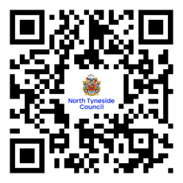




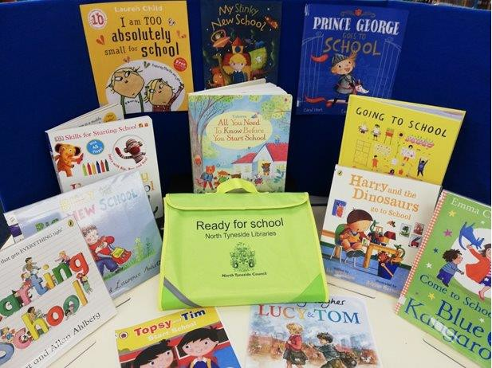
Starting School
Help your child get excited about starting school by borrowing our

Ready for School Bag.
Each bag contains specially chosen stories to share,
exploring what it’s like to go to ‘big’ school.

The bags are available to loan at Killingworth, North Shields, Wallsend & Whitley Bay Community Hub and Libraries, and can be ordered from any North Tyneside Library

North Tyneside Community Hubs and Libraries northtynelibraries
@NorthTyneLibs
www.bookwhen.com/northtynesidelibraries

