North Shields 800 Fact of the Day - June
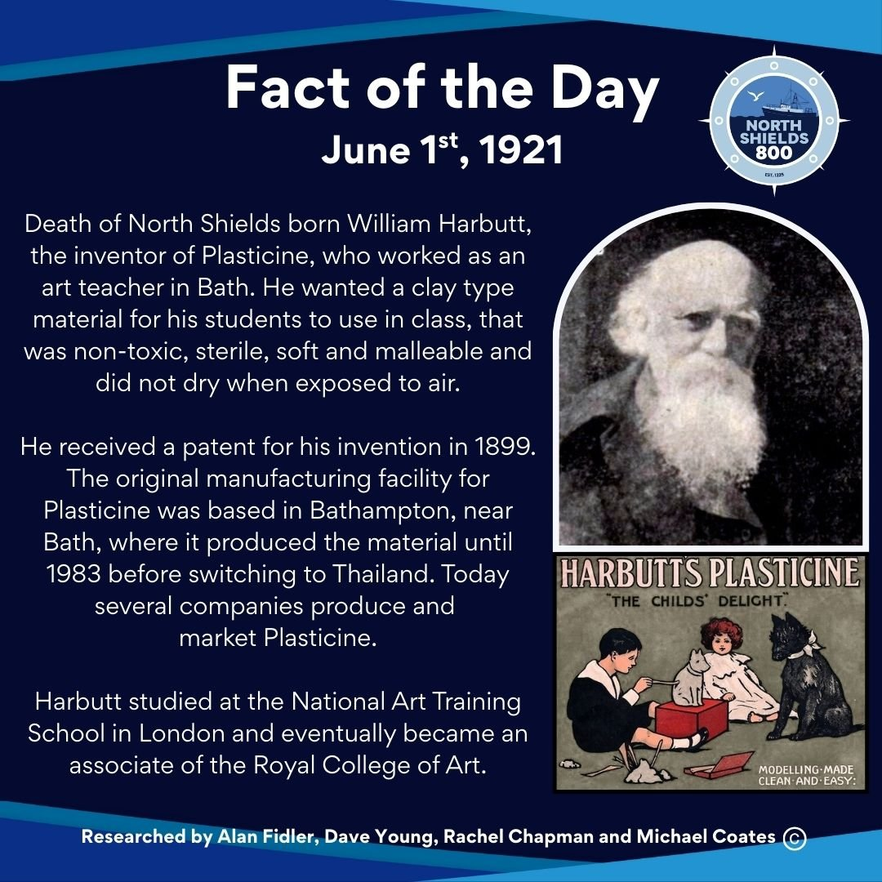
June 1st, 1921
Death of North Shields born William Harbutt, the inventor of Plasticine, who worked as an art teacher in Bath. He wanted a clay type material for his students to use in class, something that was non-toxic, sterile, soft and malleable and did not dry when exposed to air. He received a patent for his invention in 1899.
The original manufacturing facility for Plasticine was based in Bathampton, near Bath, where it produced the material until 1983 before switching to Thailand. Today several companies produce and market Plasticine.
Harbutt studied at the National Art Training School in London and eventually became an associate of the Royal College of Art.
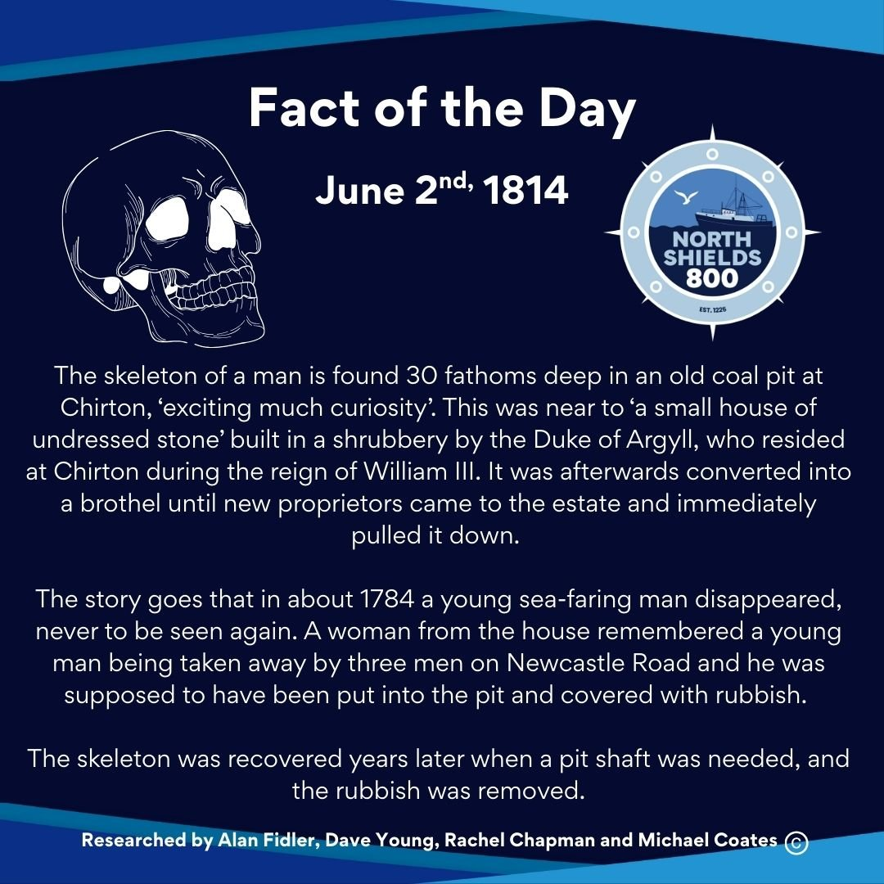
June 2nd, 1814
The skeleton of a man is found 30 fathoms deep in an old coal pit at Chirton, ‘exciting much curiosity’. This was near to ‘a small house of undressed stone’ built in a shrubbery by the Duke of Argyll, who resided at Chirton during the reign of William III. It was afterwards converted into a brothel until new proprietors came to the estate and immediately pulled it down.
The story goes that in about 1784 a young sea-faring man disappeared, never to be seen again. A woman from the house remembered a young man being taken away by three men on Newcastle Road and he was supposed to have been put into the pit and covered with rubbish.
The skeleton was recovered years later when a pit shaft was needed, and the rubbish was removed.
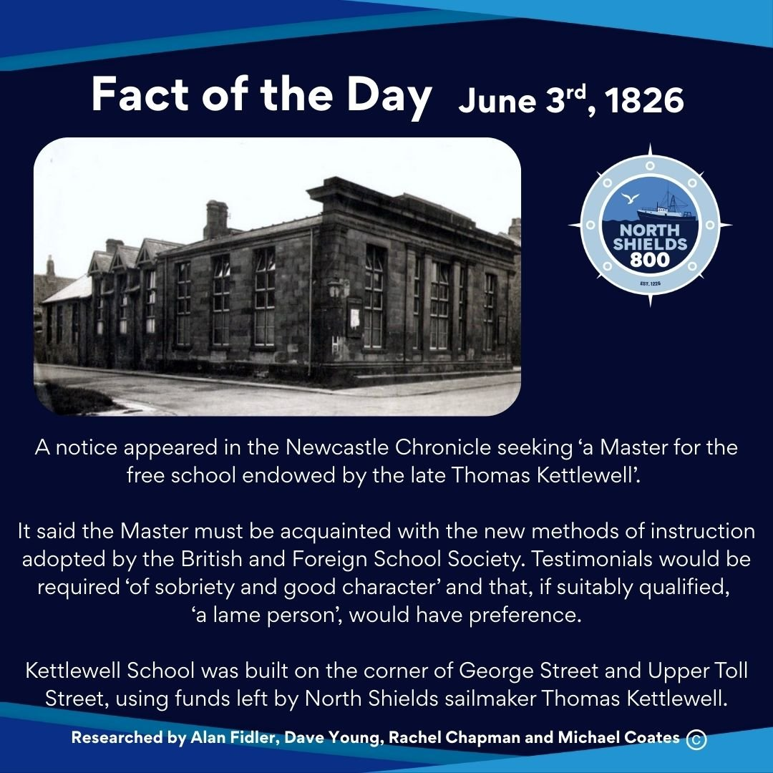
June 3rd, 1826
A notice appeared in the Newcastle Chronicle seeking ‘a Master for the free school endowed by the late Thomas Kettlewell’.
It said the Master must be acquainted with the new methods of instruction adopted by the British and Foreign School Society. Testimonials would be required ‘of sobriety and good character’ and that, if suitably qualified, ‘a lame person’, would have preference.
Kettlewell School was built on the corner of George Street and Upper Toll Street, using funds left by North Shields sailmaker Thomas Kettlewell.
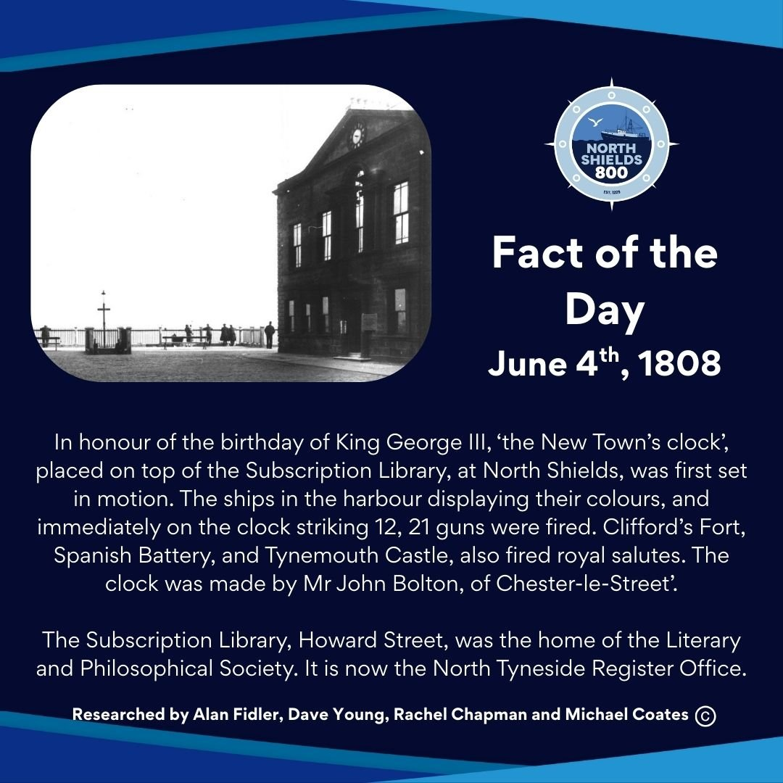
June 4th, 1808
In honour of the birthday of King George III, ‘the New Town’s clock’, placed on top of the Subscription Library, at North Shields, was first set in motion. The ships in the harbour displaying their colours, and immediately on the clock striking 12, 21 guns were fired. Clifford’s Fort, Spanish Battery, and Tynemouth Castle, also fired royal salutes. The clock was made by Mr John Bolton, of Chester-le-Street’.
The Subscription Library, Howard Street, was the home of the Literary and Philosophical Society. It is now the North Tyneside Register Office.
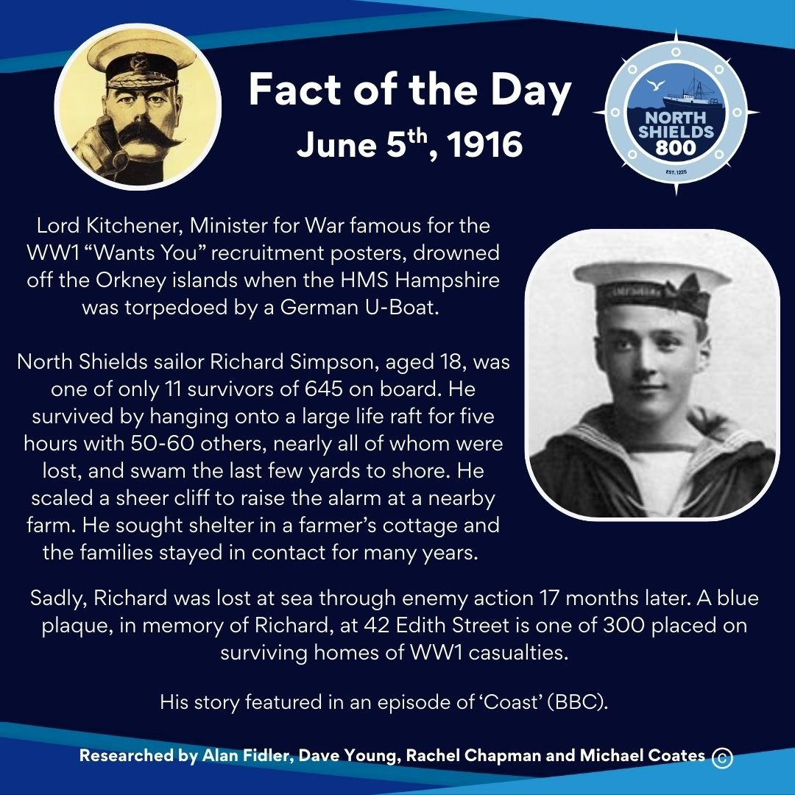
June 5th, 1916
Lord Kitchener, Minister for War famous for the WW1 “Wants You” recruitment posters, drowned off the Orkney islands when the HMS Hampshire was torpedoed by a German U-Boat.
North Shields sailor Richard Simpson, aged 18, was one of only 11 survivors of 645 on board. He survived by hanging onto a large life raft for five hours with 50-60 others, nearly all of whom were lost, and swam the last few yards to shore. He scaled a sheer cliff to raise the alarm at a nearby farm. He sought shelter in a farmer’s cottage and the families stayed in contact for many years.
Sadly, Richard was lost at sea through enemy action 17 months later. A blue plaque, in memory of Richard, at 42 Edith Street is one of 300 placed on surviving homes of WW1 casualties.
His story featured in an episode of ‘Coast’ (BBC).
See www.northumbriaworldwarone.co.uk for more.
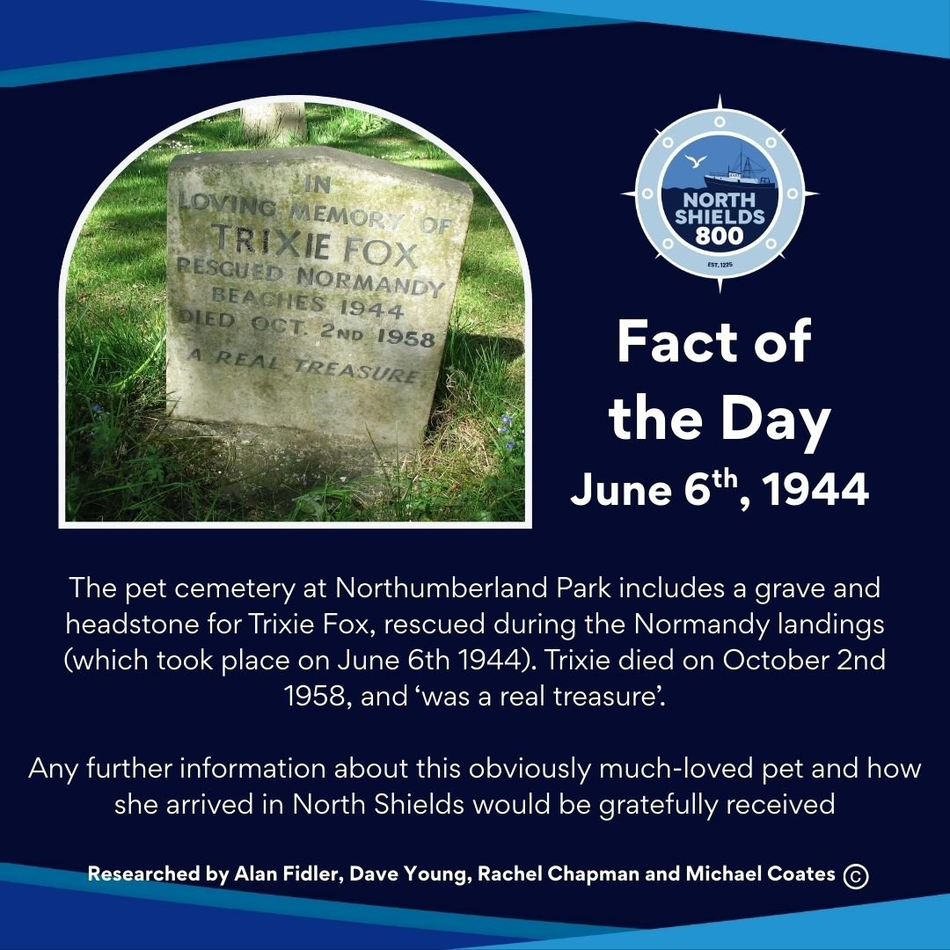
June 6th, 1944
The pet cemetery at Northumberland Park includes a grave and headstone for Trixie Fox, rescued during the Normandy landings (which took place on June 6th 1944). Trixie died on October 2nd 1958, and ‘was a real treasure’.
Any further information about this obviously much-loved pet and how she arrived in North Shields would be gratefully received.
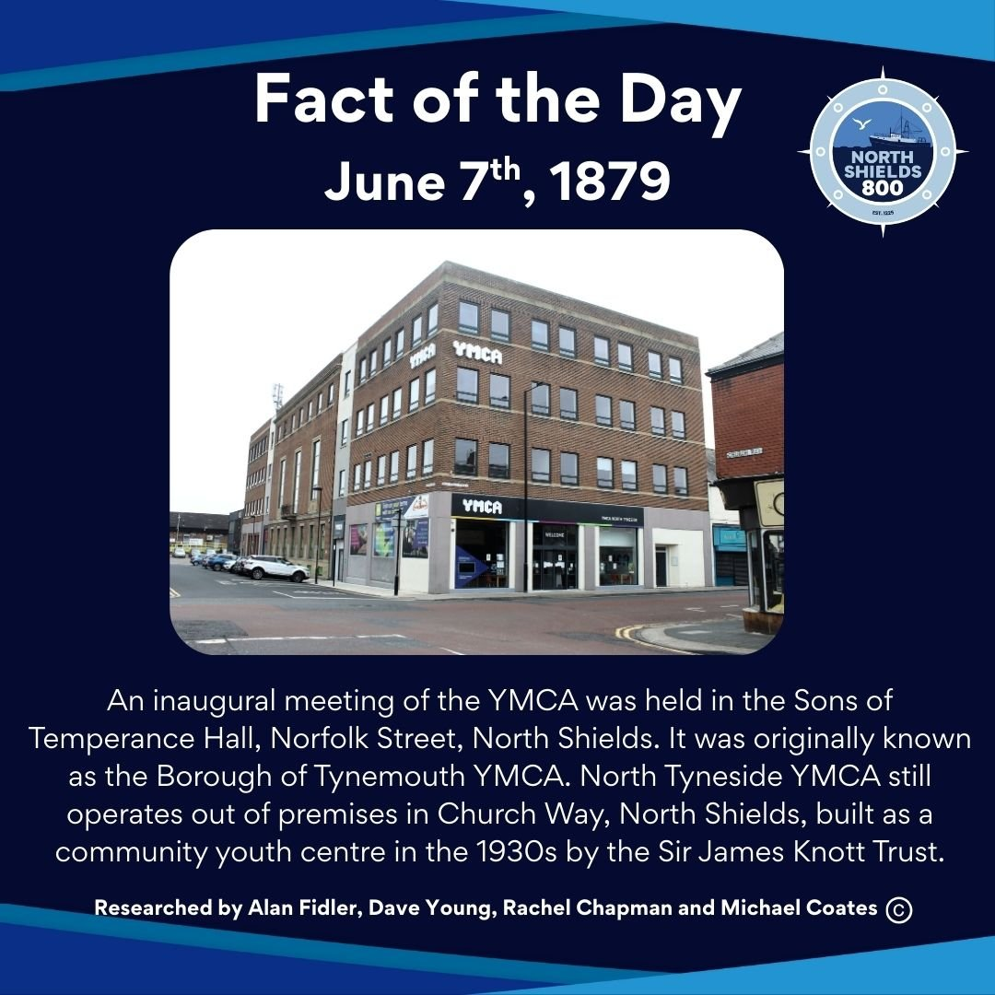
June 7th, 1879
An inaugural meeting of the YMCA was held in the Sons of Temperance Hall, Norfolk Street, North Shields. It was originally known as the Borough of Tynemouth YMCA.
YMCA North Tyneside still operates out of premises in Church Way, North Shields, built as a community youth centre in the 1930s by the Sir James Knott Trust.
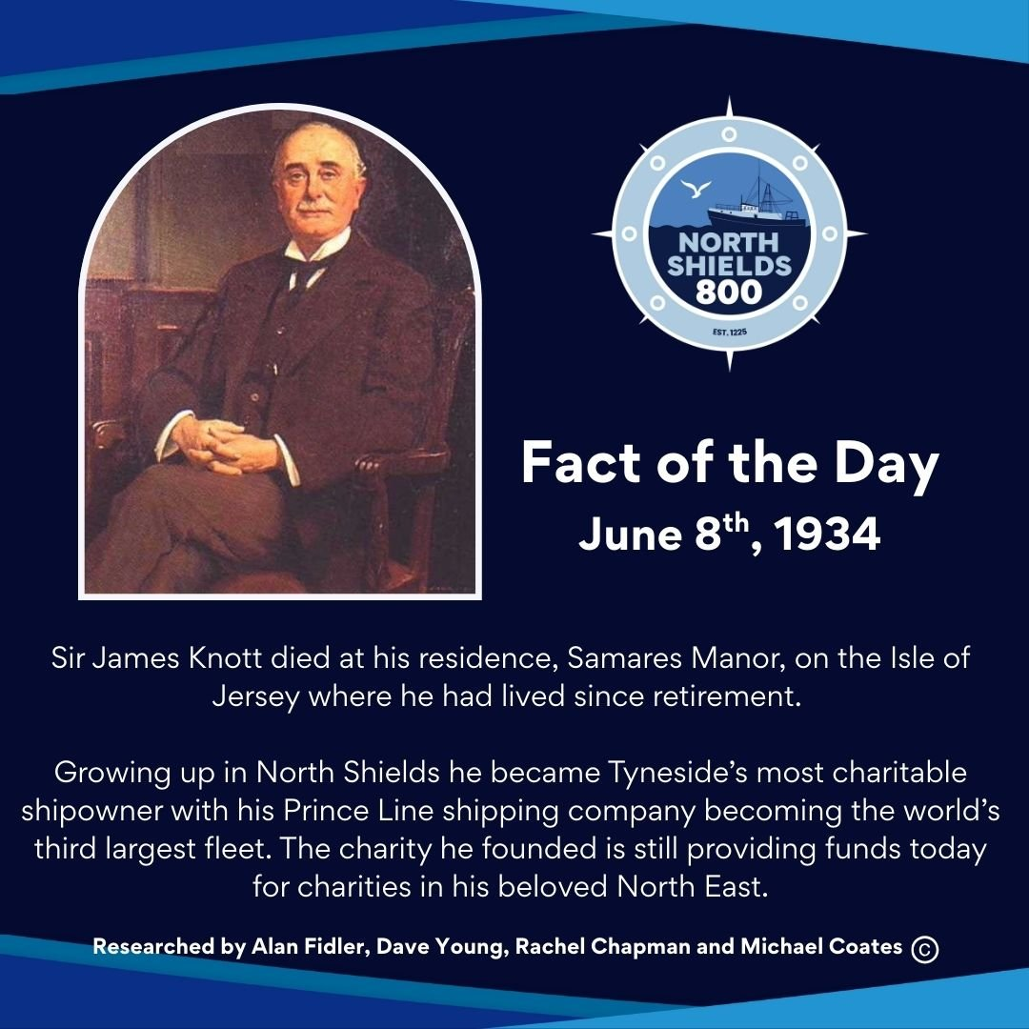
June 8th, 1934
Sir James Knott died at his residence, Samares Manor, on the Isle of Jersey where he had lived since retirement.
Growing up in North Shields he became Tyneside’s most charitable shipowner with his Prince Line shipping company becoming the world’s third largest fleet.
The charity he founded is still providing funds today for charities in his beloved North East.
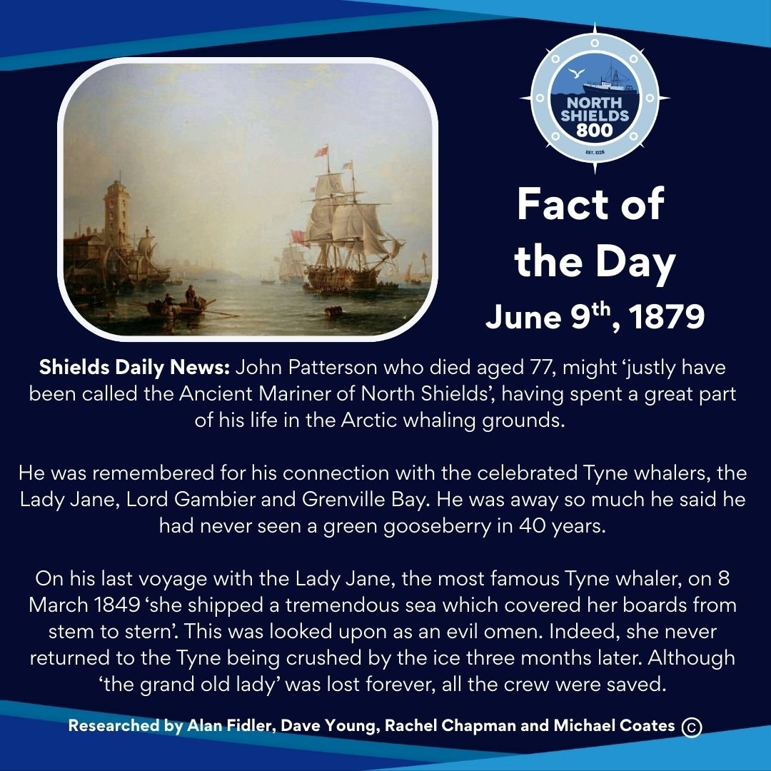
June 9th, 1879
Shields Daily News: John Patterson who died aged 77, might ‘justly have been called the Ancient Mariner of North Shields’, having spent a great part of his life in the Arctic whaling grounds.
He was remembered for his connection with the celebrated Tyne whalers, the Lady Jane, Lord Gambier and Grenville Bay. He was away so much he said he had never seen a green gooseberry in 40 years.
On his last voyage with the Lady Jane, the most famous Tyne whaler, on 8 March 1849 ‘she shipped a tremendous sea which covered her boards from stem to stern’. This was looked upon as an evil omen. Indeed, she never returned to the Tyne being crushed by the ice three months later. Although ‘the grand old lady’ was lost forever, all the crew were saved.
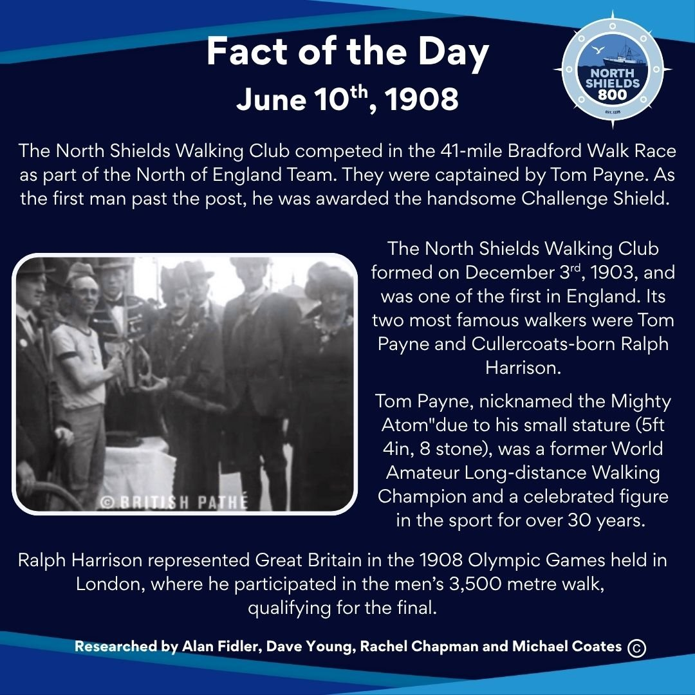
June 10th, 1908
The North Shields Walking Club competed in the 41-mile Bradford Walk Race as part of the North of England Team. They were captained by Tom Payne. As the first man past the post, he was awarded the handsome Challenge Shield.
The North Shields Walking Club formed on December 3rd, 1903, and was one of the first in England. Its two most famous walkers were Tom Payne and Cullercoats-born Ralph Harrison.
Tom Payne, nicknamed the Mighty Atom"due to his small stature (5ft 4in, 8 stone), was a former World Amateur Long-distance Walking Champion and a celebrated figure in the sport for over 30 years.
Ralph Harrison represented Great Britain in the 1908 Olympic Games held in London, where he participated in the men’s 3,500 metre walk, qualifying for the final.
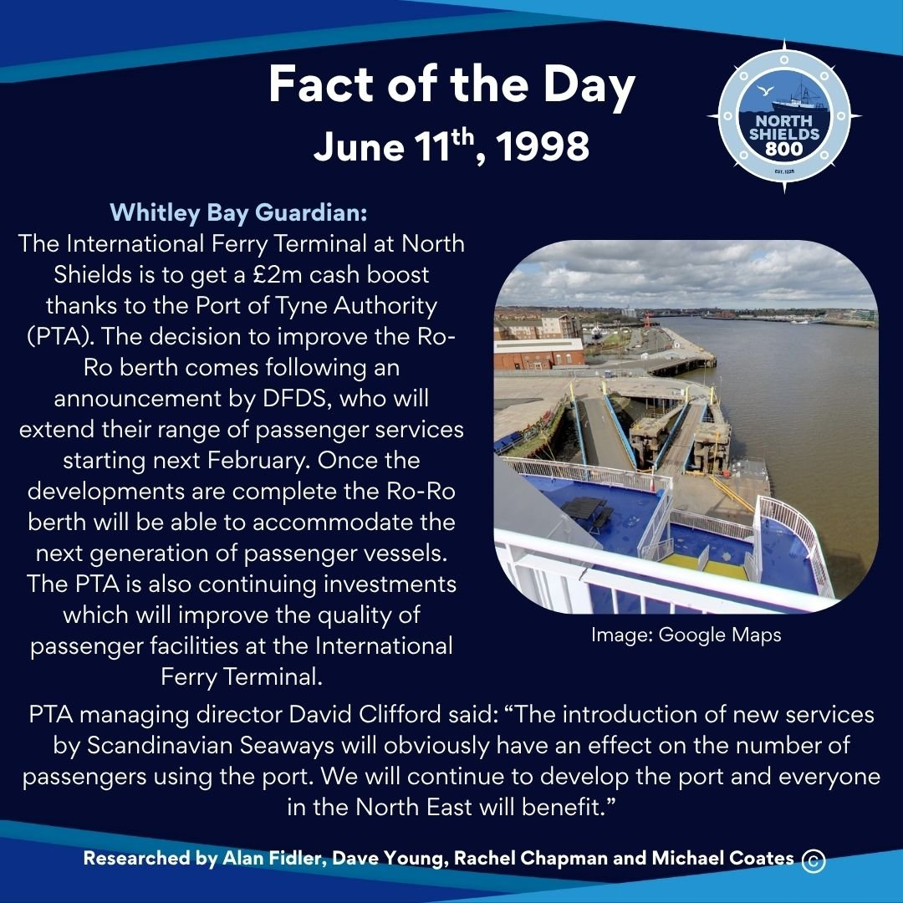
June 11th, 1998
Whitley Bay Guardian: The International Ferry Terminal at North Shields is to get a £2m cash boost thanks to the Port of Tyne Authority (PTA).
The decision to improve the Ro-Ro berth comes following an announcement by DFDS, who will extend their range of passenger services starting next February. Once the developments are complete the Ro-Ro berth will be able to accommodate the next generation of passenger vessels.
The PTA is also continuing investments which will improve the quality of passenger facilities at the International Ferry Terminal.
PTA managing director David Clifford said: “The introduction of new services by Scandinavian Seaways will obviously have an effect on the number of passengers using the port. We will continue to develop the port and everyone in the North East will benefit.”
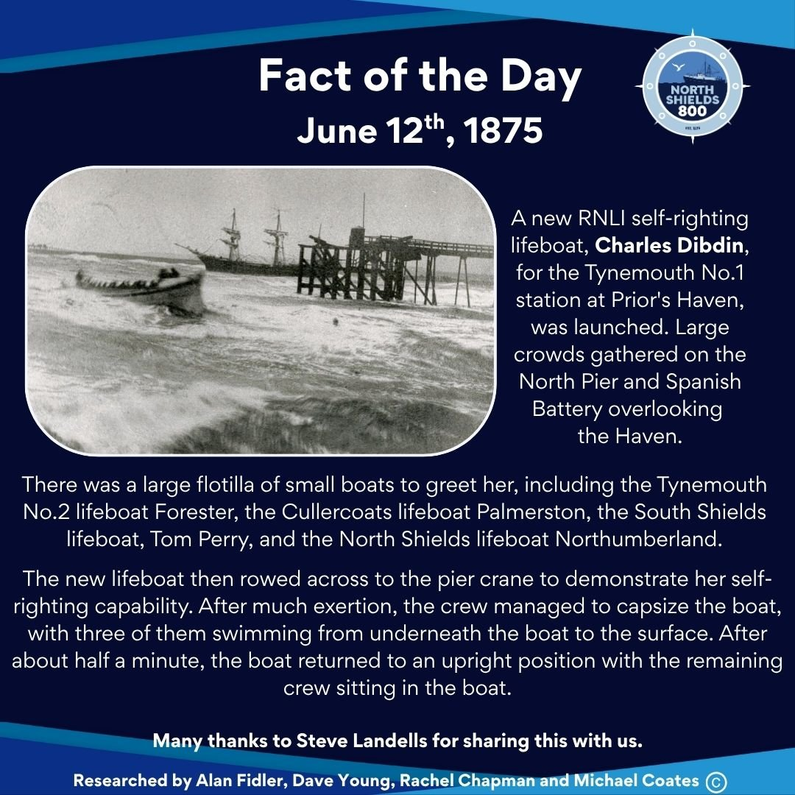
June 12th, 1875
A new RNLI self-righting lifeboat, Charles Dibdin, for the Tynemouth No.1 station at Prior's Haven, was launched. Large crowds gathered on the North Pier and Spanish Battery overlooking the Haven.
There was a large flotilla of small boats to greet her, including the Tynemouth No.2 lifeboat Forester, the Cullercoats lifeboat Palmerston, the South Shields lifeboat, Tom Perry, and the North Shields lifeboat Northumberland.
The new lifeboat then rowed across to the pier crane to demonstrate her self-righting capability. After much exertion, the crew managed to capsize the boat, with three of them swimming from underneath the boat to the surface. After about half a minute, the boat returned to an upright position with the remaining crew sitting in the boat.
Many thanks to Steve Landells for sharing this with us.
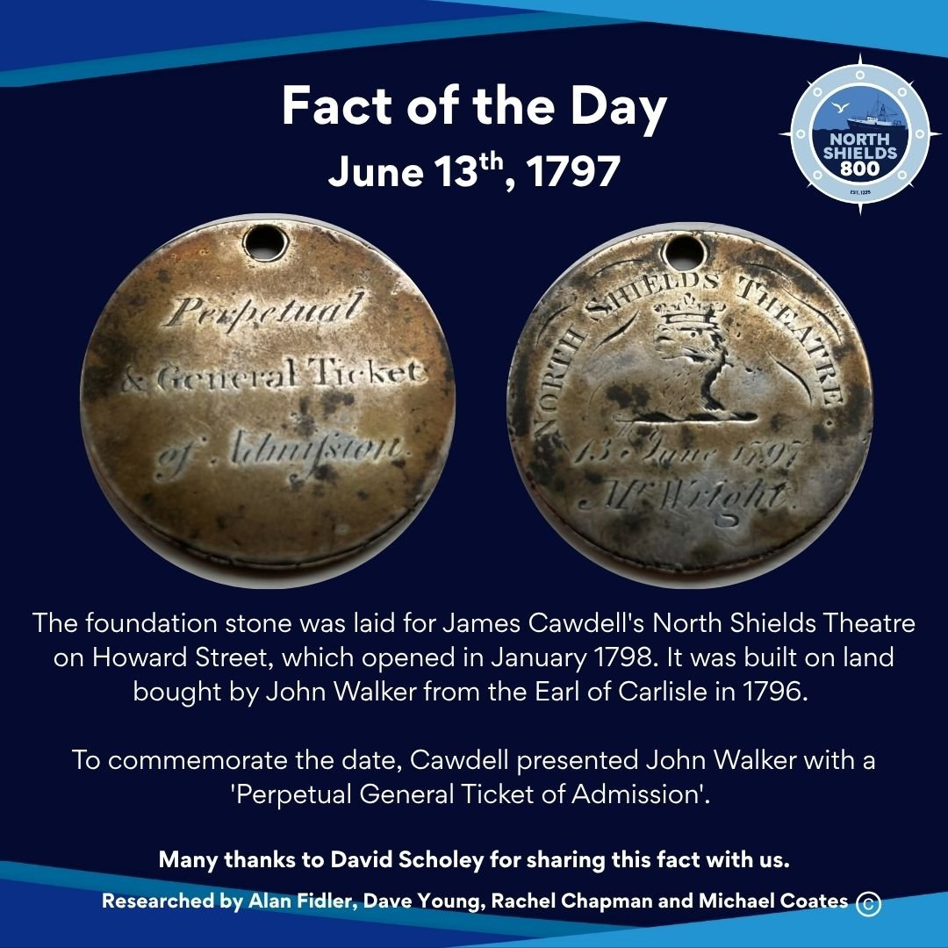
June 13th, 1797
The foundation stone was laid for James Cawdell's North Shields Theatre on Howard Street, which opened in January 1798. It was built on land bought by John Walker from the Earl of Carlisle in 1796.
To commemorate the date, Cawdell presented John Walker with a 'Perpetual General Ticket of Admission' (see attached photos).
Many thanks to David Scholey for sharing this fact with us.
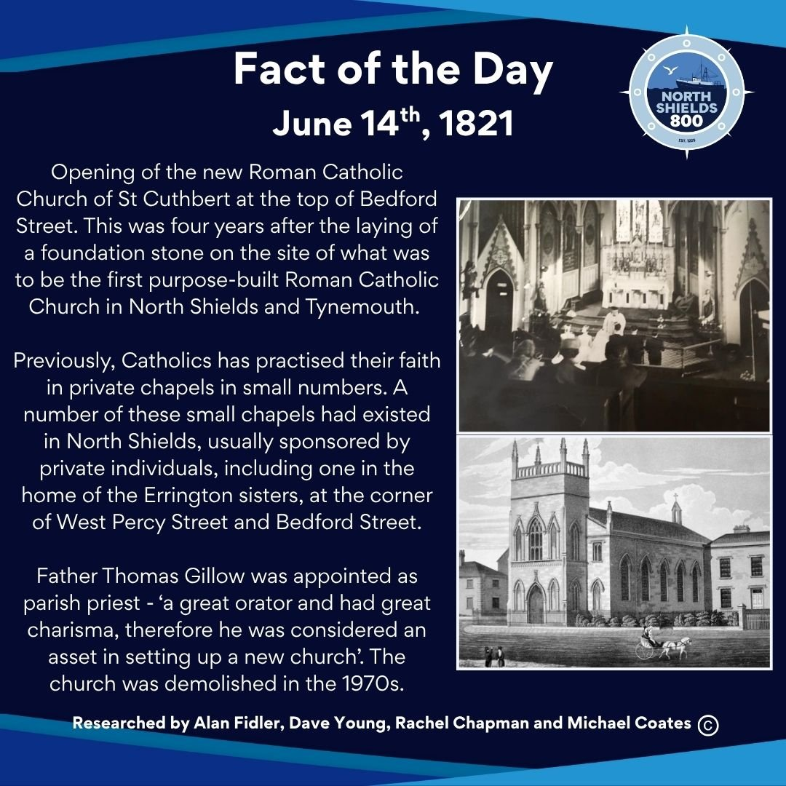
June 14th, 1821
Opening of the new Roman Catholic Church of St Cuthbert at the top of Bedford Street. This was four years after the laying of a foundation stone on the site of what was to be the first purpose-built Roman Catholic Church in North Shields and Tynemouth.
Previously, Catholics has practised their faith in private chapels in small numbers. A number of these small chapels had existed in North Shields, usually sponsored by private individuals, including one in the home of the Errington sisters, at the corner of West Percy Street and Bedford Street.
Father Thomas Gillow was appointed as parish priest - ‘a great orator and had great charisma, therefore he was considered an asset in setting up a new church’. The church was demolished in the 1970s.
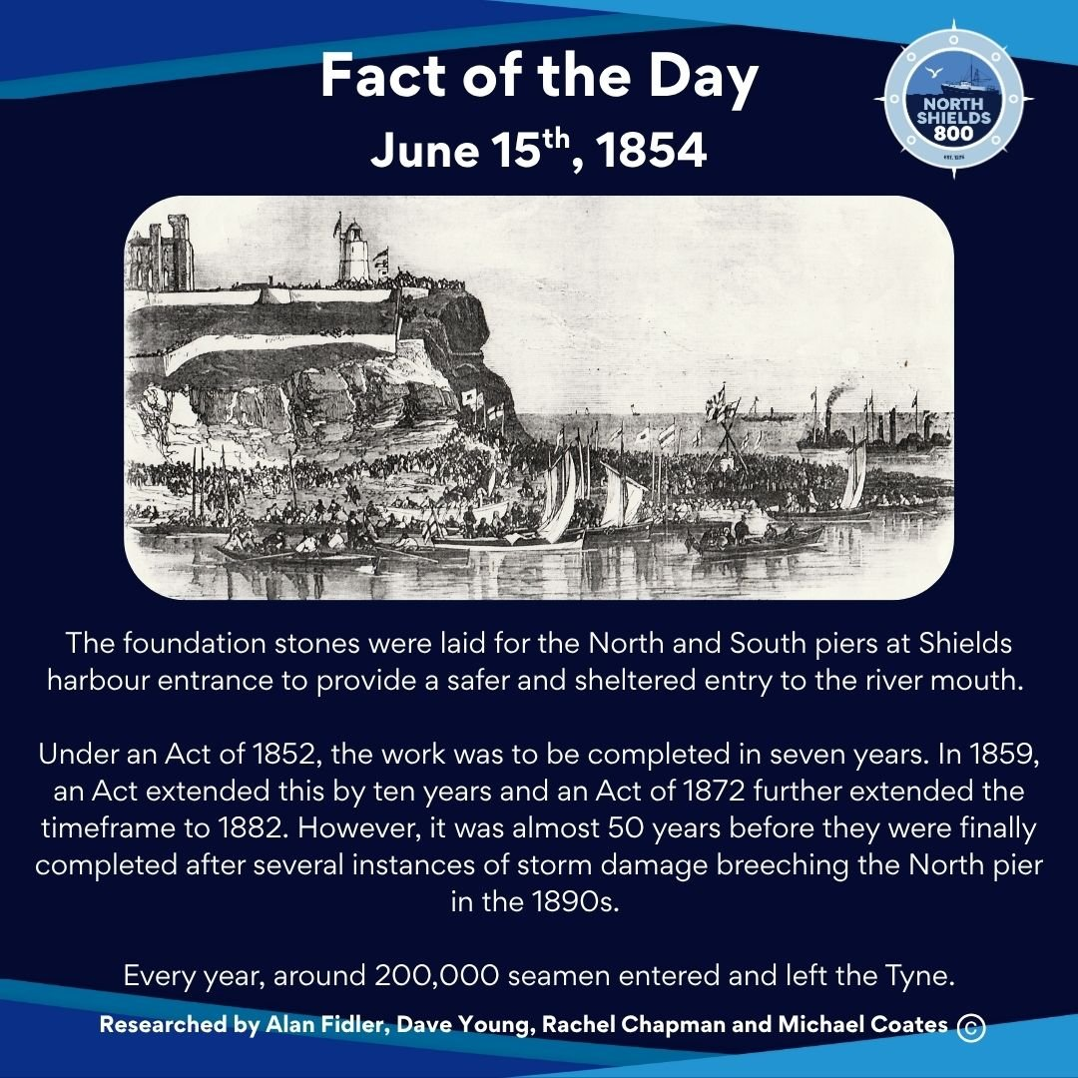
June 15th, 1854
The foundation stones were laid for the North and South piers at Shields harbour entrance to provide a safer and sheltered entry to the river mouth.
Under an Act of 1852, the work was to be completed in seven years. In 1859, an Act extended this by ten years and an Act of 1872 further extended the timeframe to 1882. However, it was almost 50 years before they were finally completed after several instances of storm damage breeching the North pier in the 1890s.
Every year, around 200,000 seamen entered and left the Tyne.
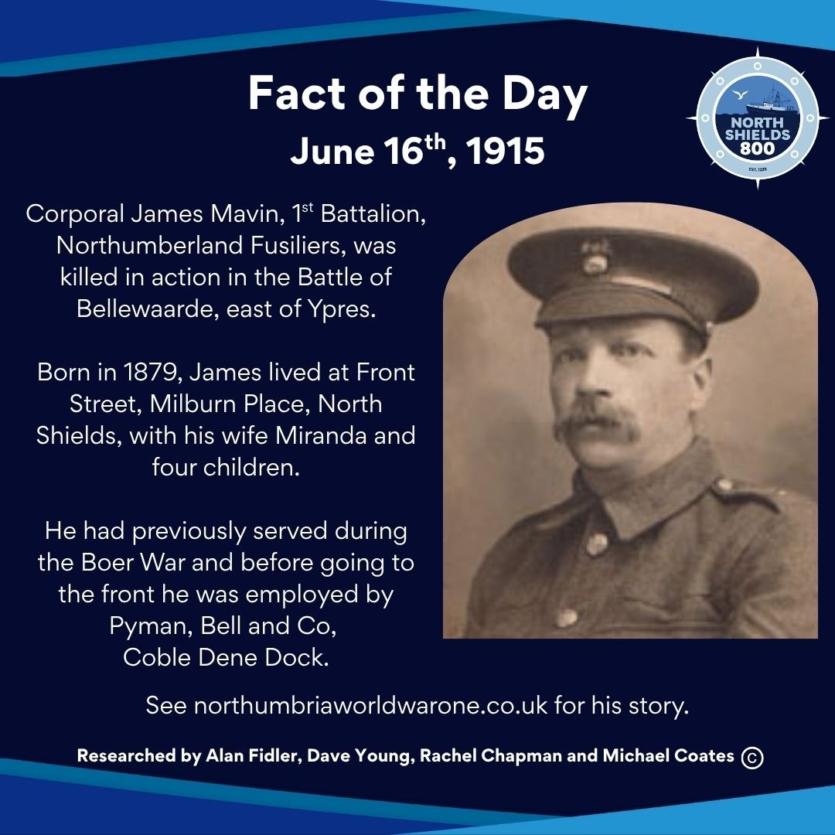
June 16th, 1915
Corporal James Mavin, 1st Battalion, Northumberland Fusiliers, was killed in action in the Battle of Bellewaarde, east of Ypres.
Born in 1879, James lived at Front Street, Milburn Place, North Shields, with his wife Miranda and four children.
He had previously served during the Boer War and before going to the front he was employed by Pyman, Bell and Co, Coble Dene Dock.
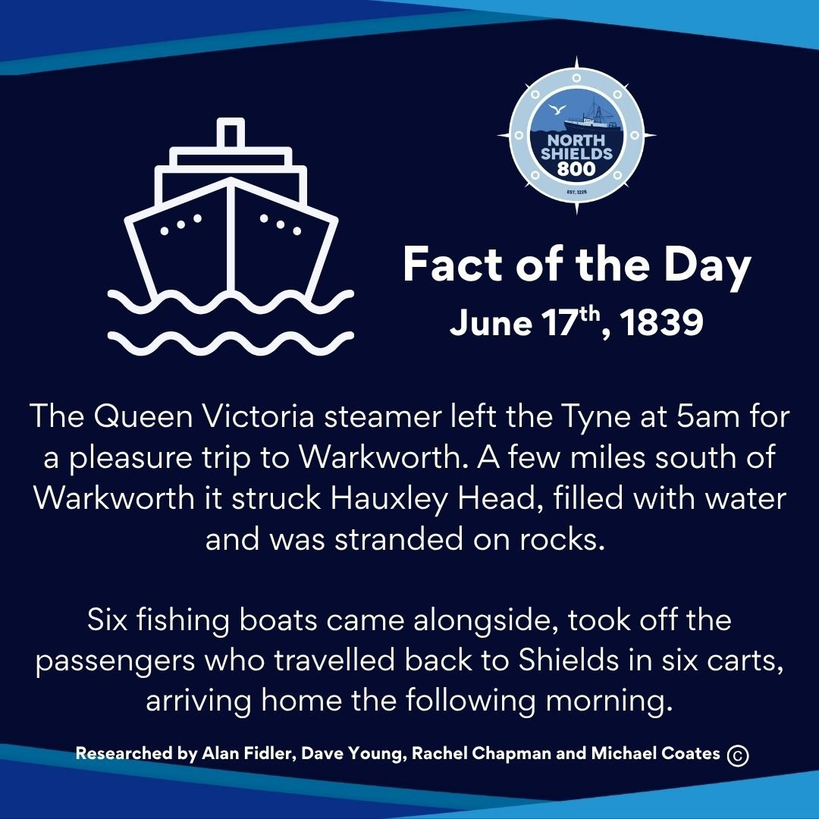
June 17th, 1839
The Queen Victoria steamer left the Tyne at 5am for a pleasure trip to Warkworth. A few miles south of Warkworth it struck Hauxley Head, filled with water and was stranded on rocks.
Six fishing boats came alongside, took off the passengers who travelled back to Shields in six carts, arriving home the following morning.
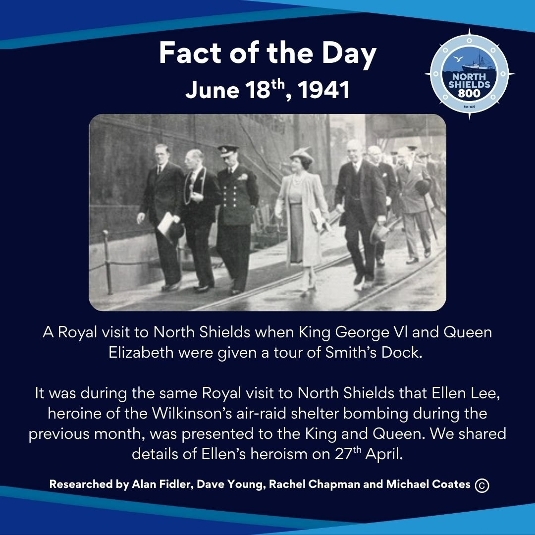
June 18th, 1941
A Royal visit to North Shields when King George Vl and Queen Elizabeth were given a tour of Smith’s Dock.
It was during the same Royal visit to North Shields that Ellen Lee, heroine of the Wilkinson’s air-raid shelter bombing during the previous month, was presented to the King and Queen. We shared details of Ellen’s heroism on 27th April.
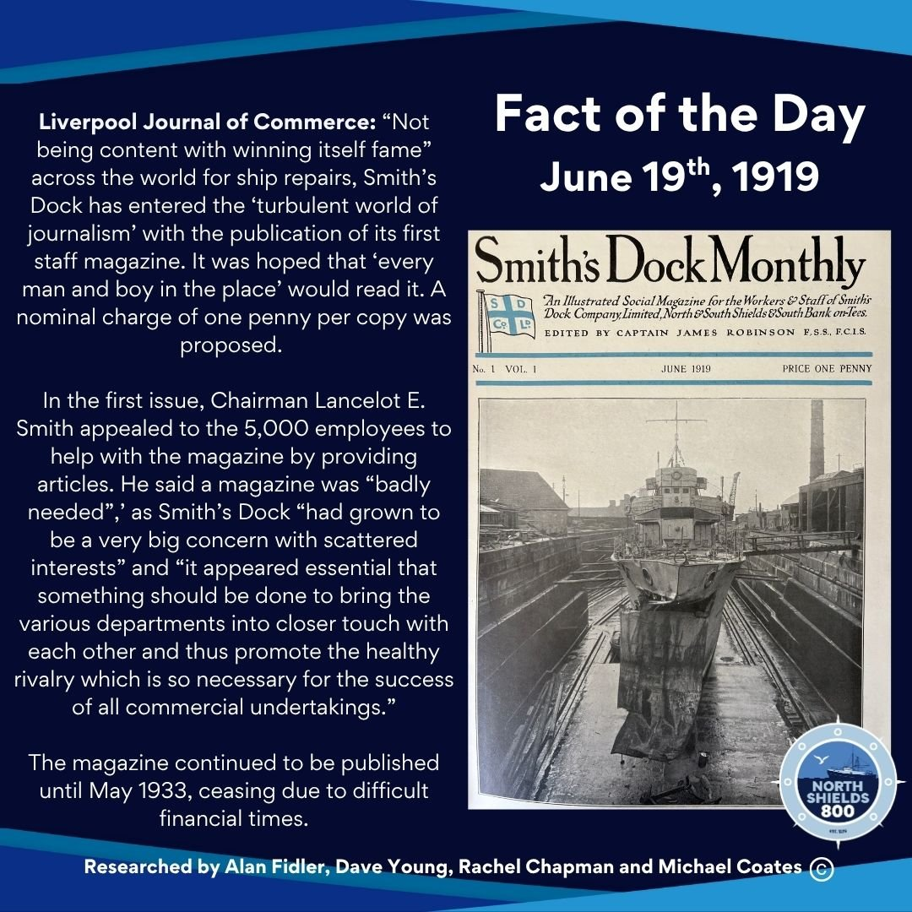
June 19th, 1919
Liverpool Journal of Commerce: “Not being content with winning itself fame” across the world for ship repairs, Smith’s Dock has entered the ‘turbulent world of journalism’ with the publication of its first staff magazine. It was hoped that ‘every man and boy in the place’ would read it. A nominal charge of one penny per copy was proposed.
In the first issue, Chairman Lancelot E. Smith appealed to the 5,000 employees to help with the magazine by providing articles. He said a magazine was “badly needed”,’ as Smith’s Dock “had grown to be a very big concern with scattered interests” and “it appeared essential that something should be done to bring the various departments into closer touch with each other and thus promote the healthy rivalry which is so necessary for the success of all commercial undertakings.”
The magazine continued to be published until May 1933, ceasing due to difficult financial times.
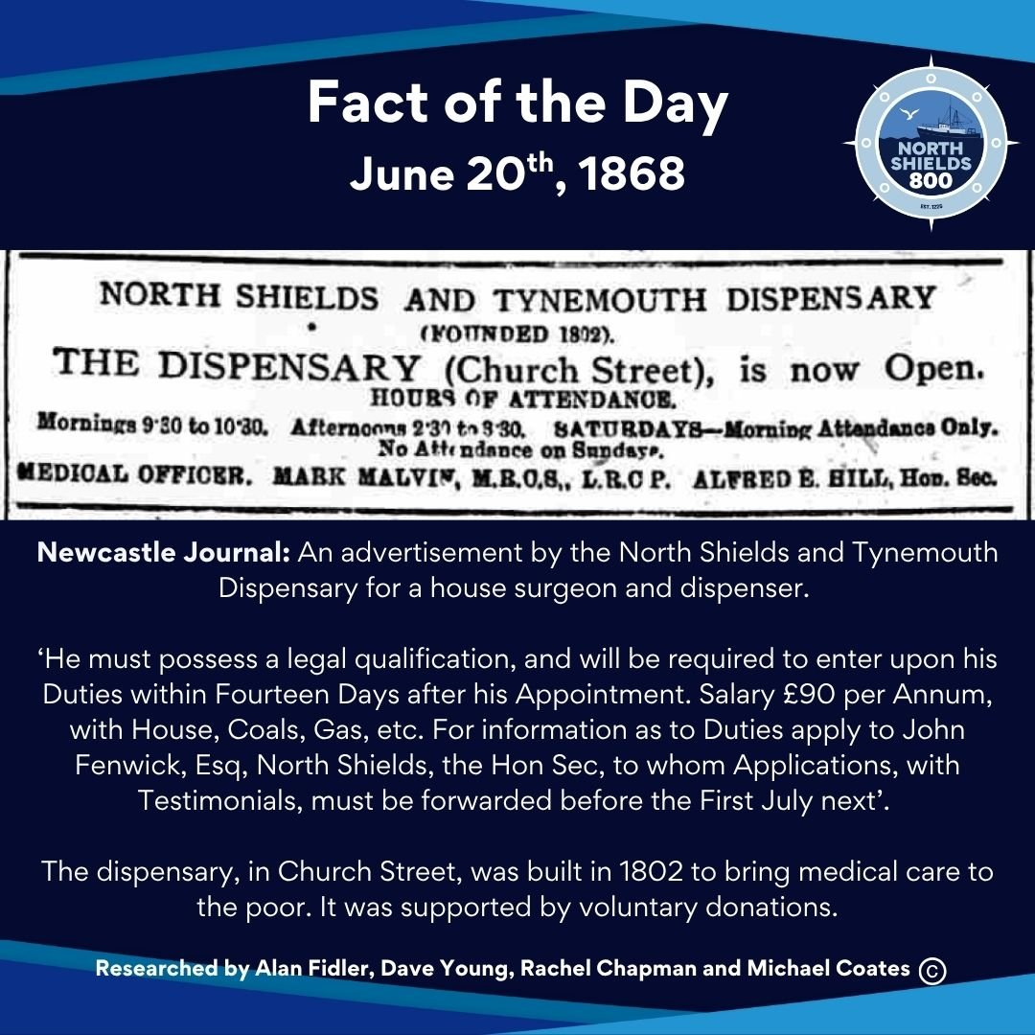
June 20th, 1868
Newcastle Journal: An advertisement by the North Shields and Tynemouth Dispensary for a house surgeon and dispenser.
‘He must possess a legal qualification, and will be required to enter upon his Duties within Fourteen Days after his Appointment. Salary £90 per Annum, with House, Coals, Gas, etc. For information as to Duties apply to John Fenwick, Esq, North Shields, the Hon Sec, to whom Applications, with Testimonials, must be forwarded before the First July next’.
The dispensary, in Church Street, was built in 1802 to bring medical care to the poor. It was supported by voluntary donations.
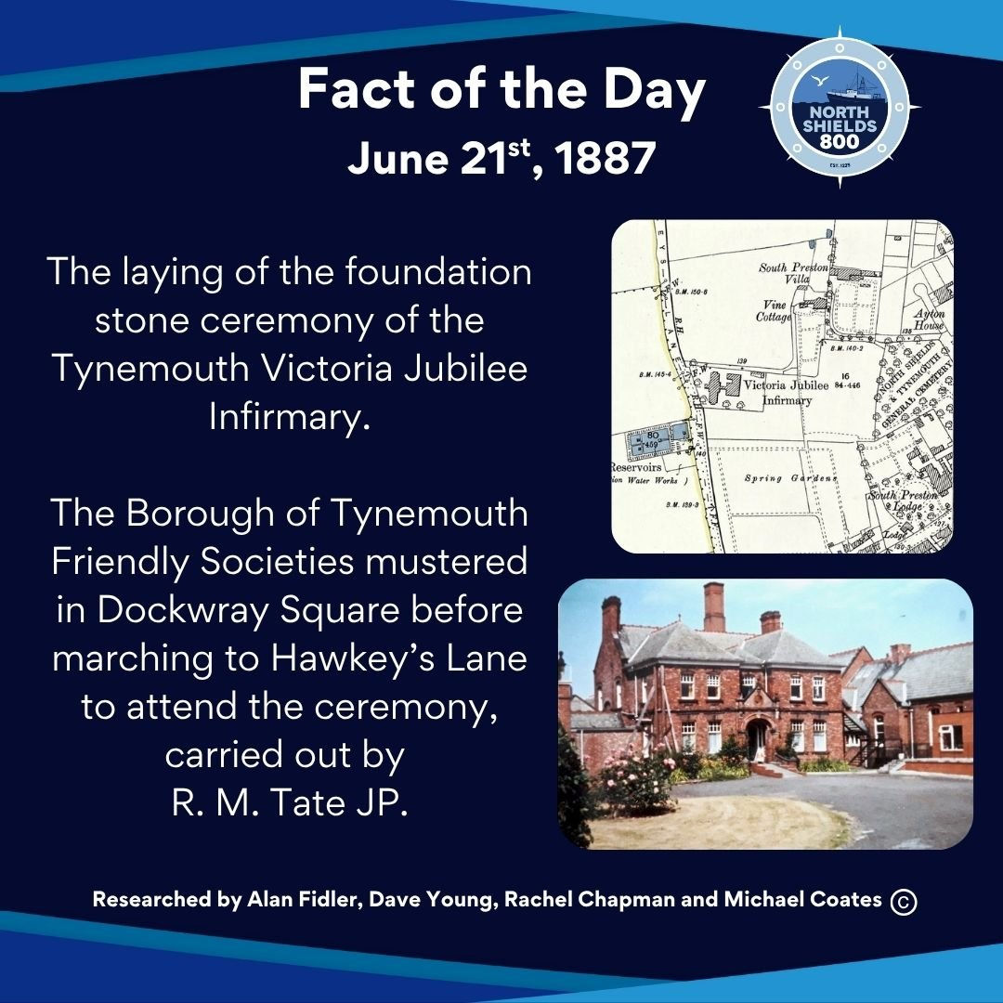
June 21st, 1887
The laying of the foundation stone ceremony of the Tynemouth Victoria Jubilee Infirmary.
The Borough of Tynemouth Friendly Societies mustered in Dockwray Square before marching to Hawkey’s Lane to attend the ceremony, carried out by R. M. Tate JP.
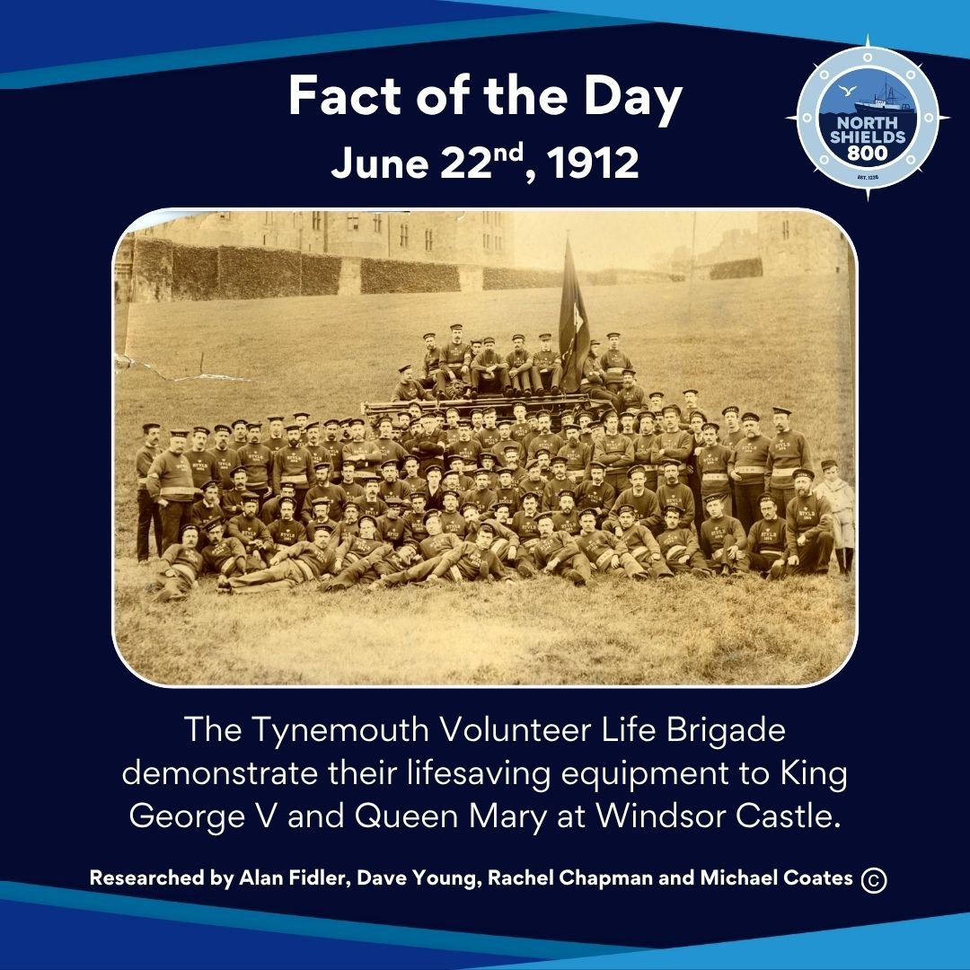
June 22nd, 1912
The Tynemouth Volunteer Life Brigade demonstrate their lifesaving equipment to King George V and Queen Mary at Windsor Castle.
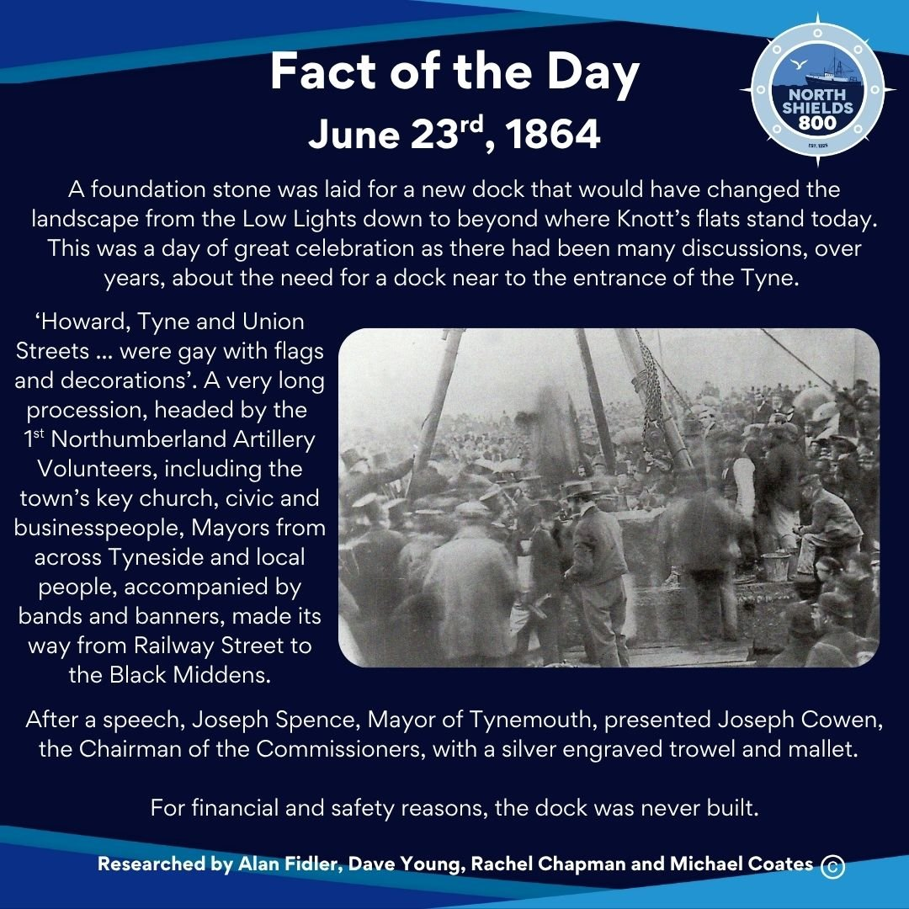
June 23rd, 1864
A foundation stone was laid for a new dock that would have changed the landscape from the Low Lights down to beyond where Knott’s flats stand today. This was a day of great celebration as there had been many discussions, over years, about the need for a dock near to the entrance of the Tyne.
‘Howard, Tyne and Union Streets ... were gay with flags and decorations’. A very long procession, headed by the 1st Northumberland Artillery Volunteers, including the town’s key church, civic and businesspeople, Mayors from across Tyneside and local people, accompanied by bands and banners, made its way from Railway Street to the Black Middens.
After a speech, Joseph Spence, Mayor of Tynemouth, presented Joseph Cowen, the Chairman of the Commissioners, with a silver engraved trowel and mallet.
For financial and safety reasons, the dock was never built.
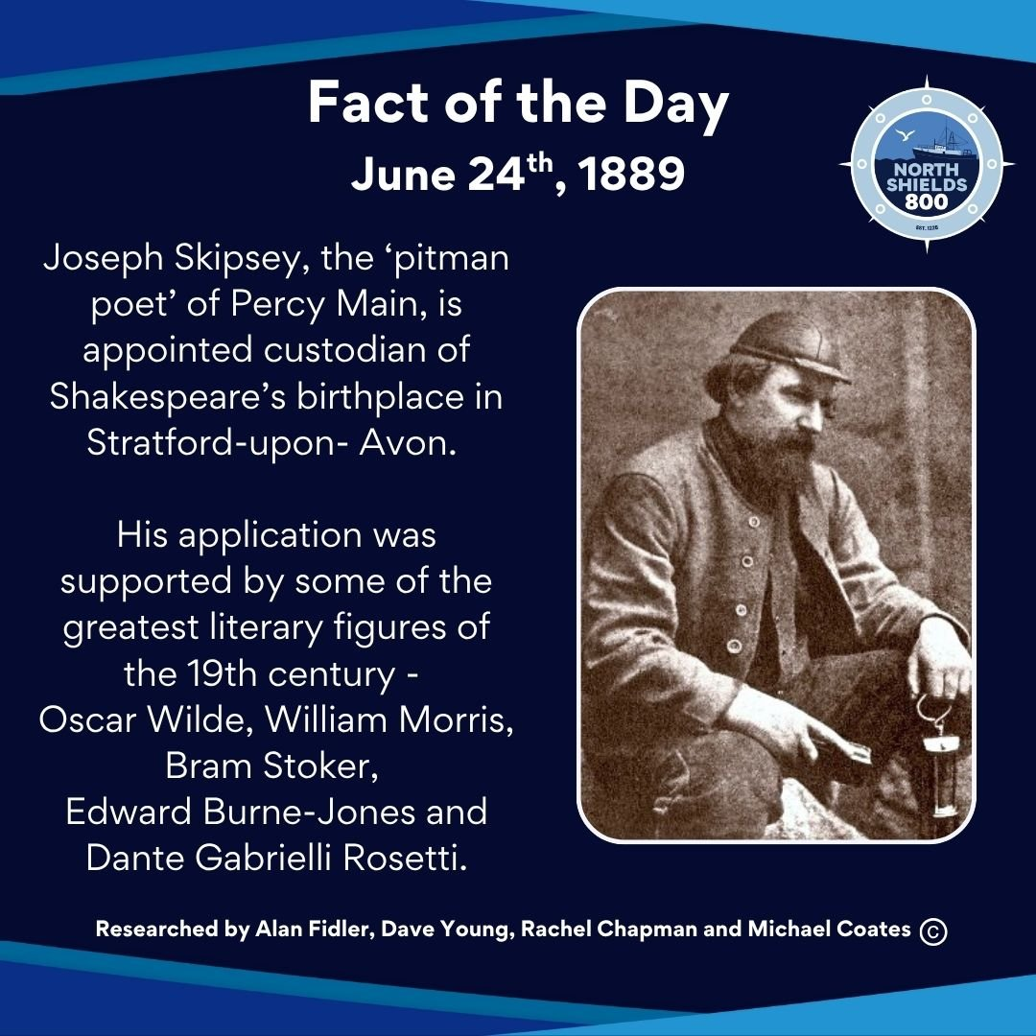
June 24th, 1889
Joseph Skipsey, the ‘pitman poet’ of Percy Main, is appointed custodian of Shakespeare’s birthplace in Stratford-upon- Avon.
His application was supported by some of the greatest literary figures of the 19th century - Oscar Wilde, William Morris, Bram Stoker, Edward Burne-Jones and Dante Gabrielli Rosetti.
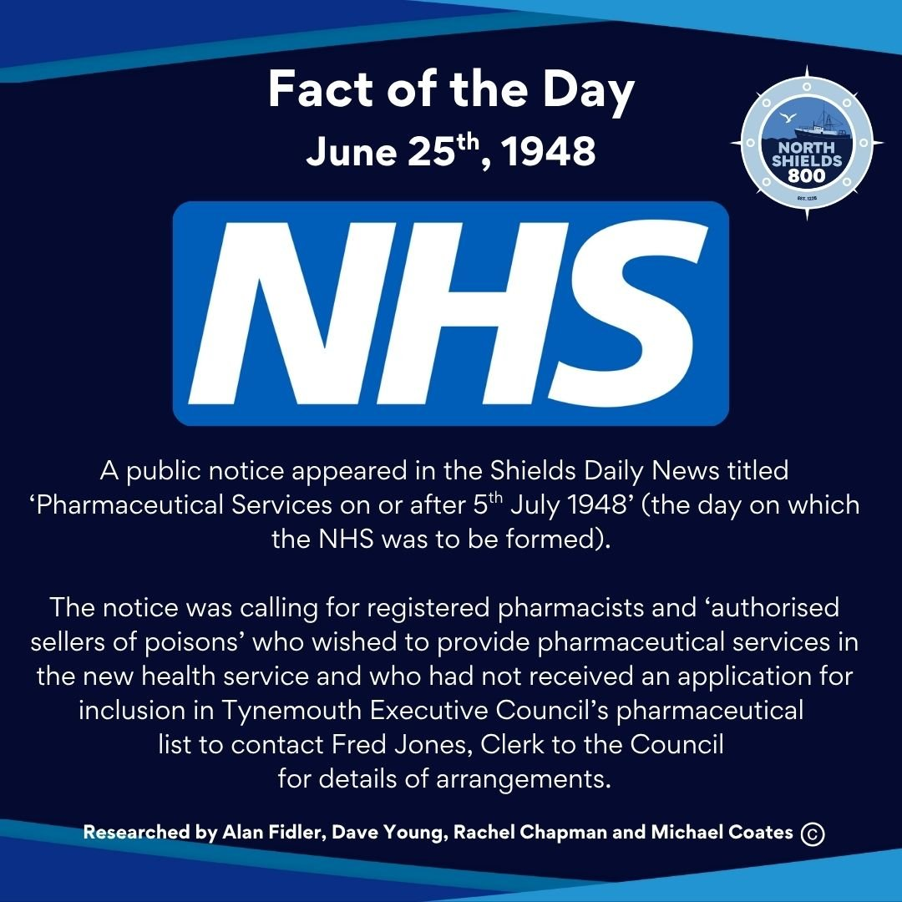
June 25th, 1948
A public notice appeared in the Shields Daily News titled ‘Pharmaceutical Services on or after 5th July 1948’ (the day on which the NHS was to be formed).
The notice was calling for registered pharmacists and ‘authorised sellers of poisons’ who wished to provide pharmaceutical services in the new health service and who had not received an application for inclusion in Tynemouth Executive Council’s pharmaceutical list to contact Fred Jones, Clerk to the Council for details of arrangements.
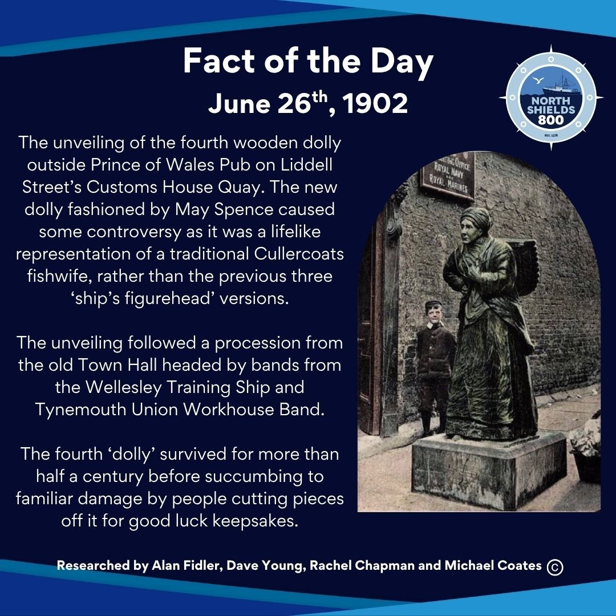
June 26th, 1902
The unveiling of the fourth wooden dolly outside Prince of Wales Pub on Liddell Street’s Customs House Quay. The new dolly fashioned by May Spence caused some controversy as it was a lifelike representation of a traditional Cullercoats fishwife, rather than the previous three ‘ship’s figurehead’ versions.
The unveiling followed a procession from the old Town Hall headed by bands from the Wellesley Training Ship and Tynemouth Union Workhouse Band.
The fourth ‘dolly’ survived for more than half a century before succumbing to familiar damage by people cutting pieces off it for good luck keepsakes.
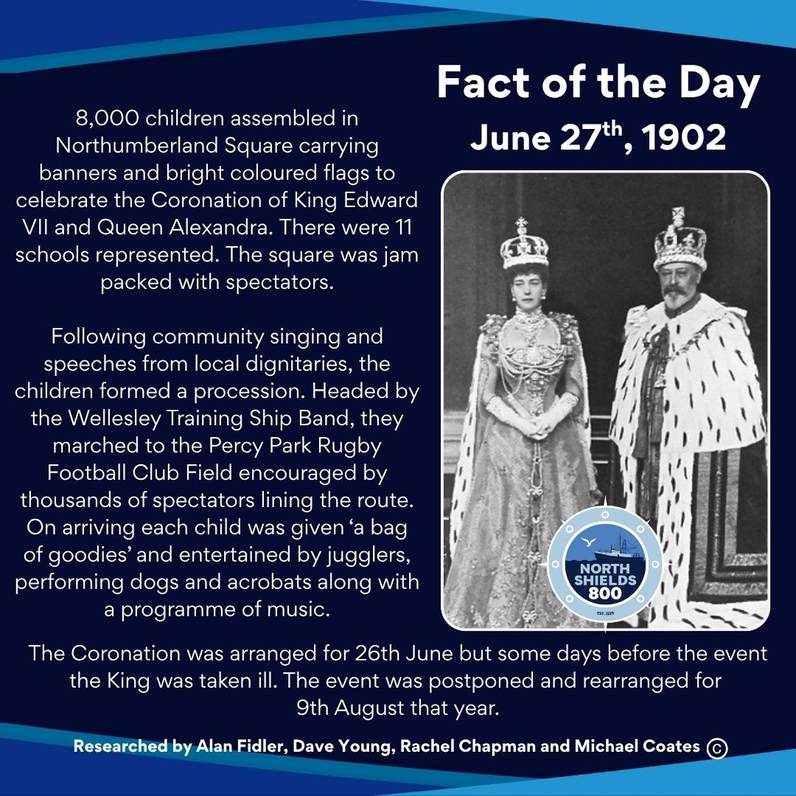
June 27th, 1902
8,000 children assembled in Northumberland Square carrying banners and bright coloured flags to celebrate the Coronation of King Edward VII and Queen Alexandra. There were 11 schools represented. The square was jam packed with spectators.
Following community singing and speeches from local dignitaries, the children formed a procession. Headed by the Wellesley Training Ship Band, they marched to the Percy Park Rugby Football Club Field encouraged by thousands of spectators lining the route. On arriving each child was given ‘a bag of goodies’ and entertained by jugglers, performing dogs and acrobats along with a programme of music.
The Coronation was arranged for 26th June but some days before the event the King was taken ill. The event was postponed and rearranged for 9th August that year.
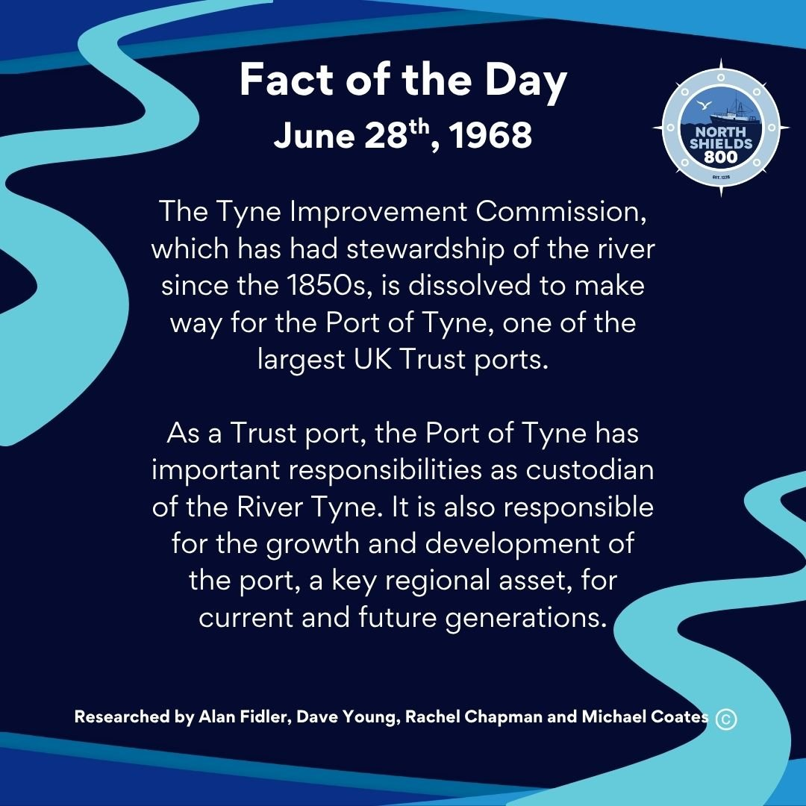
June 28th, 1968
The Tyne Improvement Commission, which has had stewardship of the river since the 1850s, is dissolved to make way for the Port of Tyne, one of the largest UK Trust ports.
As a Trust port, the Port of Tyne has important responsibilities as custodian of the River Tyne. It is also responsible for the growth and development of the port, a key regional asset, for current and future generations.
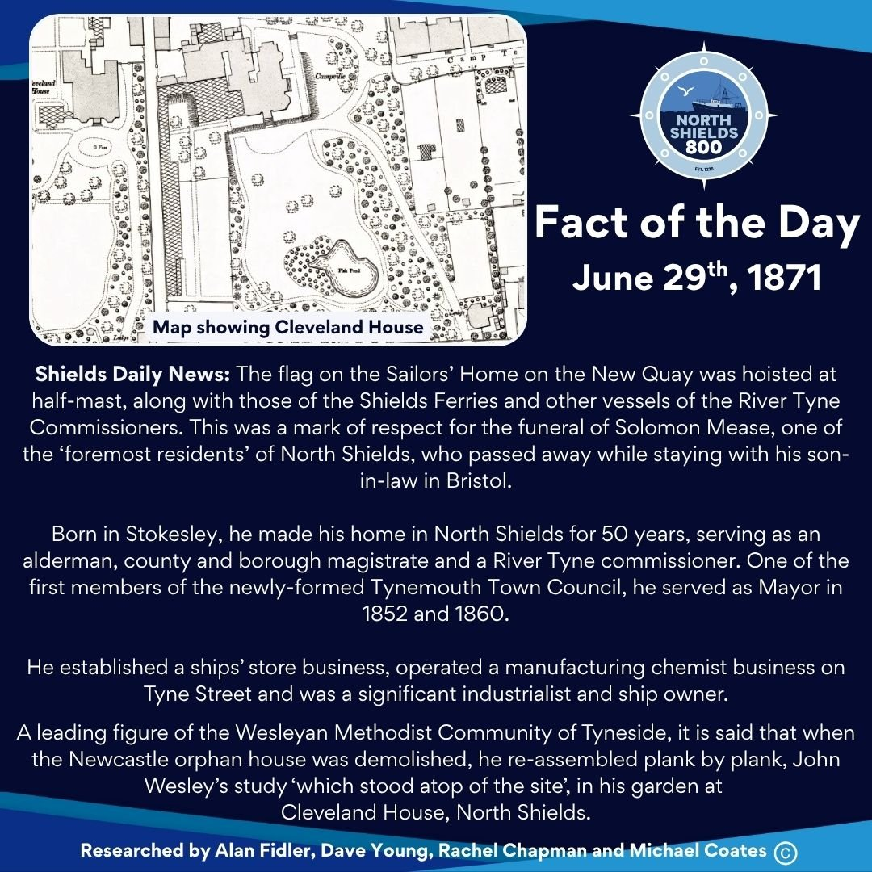
June 29th, 1871
Shields Daily News: The flag on the Sailors’ Home on the New Quay was hoisted at half-mast, along with those of the Shields Ferries and other vessels of the River Tyne Commissioners. This was a mark of respect for the funeral of Solomon Mease, one of the ‘foremost residents’ of North Shields, who passed away while staying with his son-in-law in Bristol.
Born in Stokesley, he made his home in North Shields for 50 years, serving as an alderman, county and borough magistrate and a River Tyne commissioner. One of the first members of the newly-formed Tynemouth Town Council, he served as Mayor in 1852 and 1860.
He established a ships’ store business, operated a manufacturing chemist business on Tyne Street and was a significant industrialist and ship owner.
A leading figure of the Wesleyan Methodist Community of Tyneside, it is said that when the Newcastle orphan house was demolished, he re-assembled plank by plank, John Wesley’s study ‘which stood atop of the site’, in his garden at Cleveland House, North Shields.
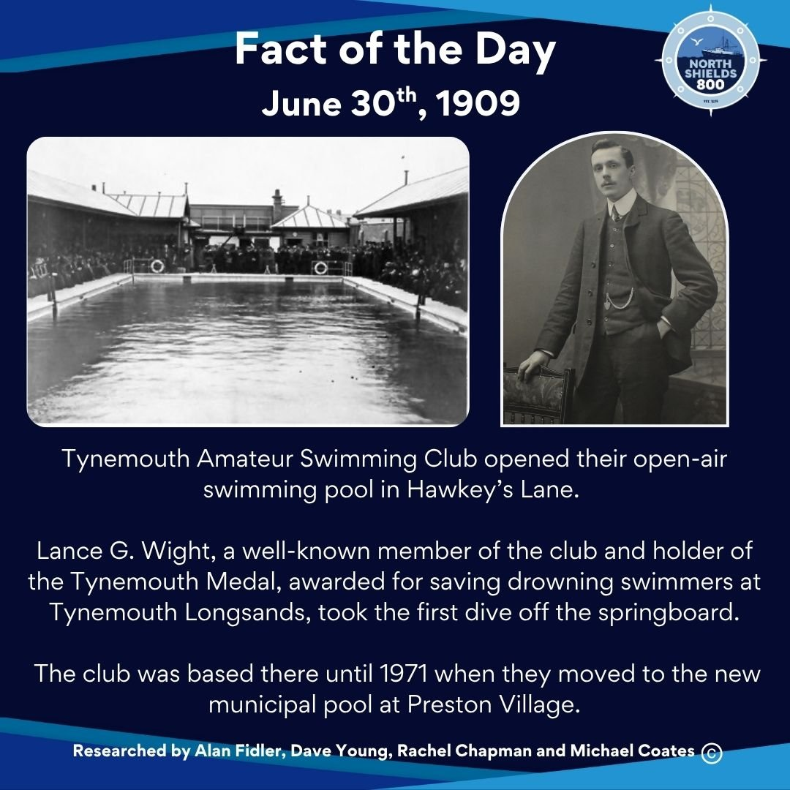
June 30th, 1909
Tynemouth Amateur Swimming Club opened their open-air swimming pool in Hawkey’s Lane.
Lance G. Wight, a well-known member of the club and holder of the Tynemouth Medal, awarded for saving drowning swimmers at Tynemouth Longsands, took the first dive off the springboard.
The club was based there until 1971 when they moved to the new municipal pool at Preston Village.

