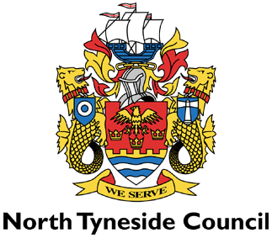

LICENSING ACT 2003

NOTICE OF APPLICATION FOR A PREMISES LICENCE

Premises | The Venue  134 - 136 Bewicke Road  Wallsend  Tyne And Wear  NE28 6NJ

Notice is hereby given that Melissa Marie Irene Armstrong applied on 24 March 2026 to North Tyneside Licensing Authority for a Premises Licence or Club Premise Certificate under the Licensing Act 2003.

The Licensable activities are:

The Sale of Alcohol - From:10:00 Until:23:00 Everyday

Regulated Entertainment - From:07:00 Until:23:00 Everyday

Any representations to this application must be made in writing to: The Licensing Section, The Killingworth Site, Harvey Combe, Killingworth, Newcastle upon Tyne NE12 6QQ or by e-mail to liquor.licensing@northtyneside.gov.uk. Representations must be received no later than 21 April 2026.

This application can be viewed at the above address between 9.30am and 4pm Monday to Friday or via www.northtyneside.gov.uk

It is an offence under Section 158 of the Licensing Act 2003, knowingly or recklessly to make a false statement in connection with an application and the maximum fine for which a person is liable on summary conviction for the offence is up to level 5 on the standard scale(£5000)

