
Former WC Block, Tynemouth

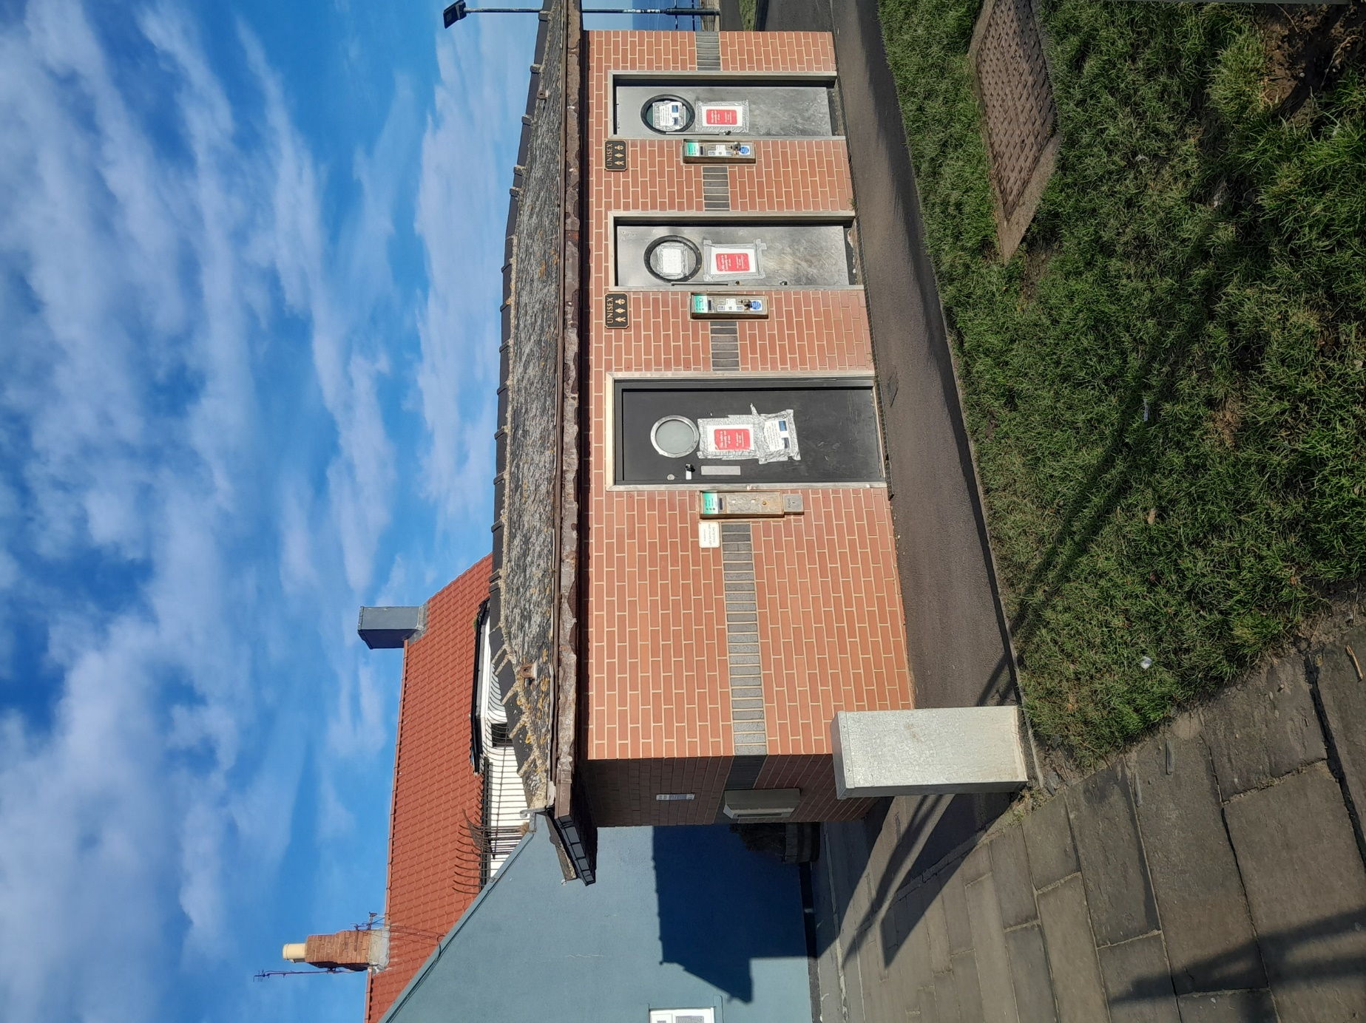

Disused WC Block, Front Street, Tynemouth

For further information please contact:-
Strategic Property, Quadrant,
Cobalt Business Park, The Silverlink North, North Tyneside, NE27 0BY

Tel. 0191 643 2142

or e-mail strategic.property@northtyneside.gov.uk

North Tyneside Council are delighted to invite offers for the Former WC block on Front Street, Tynemouth. The Council are looking for offers to let the premises by way of informal tender. Applicants should provide any information relevant to the questions outlined at the bottom of the document. Instructions on how to submit offers are also included below.

PROPERTY DESCRIPTION

The kiosk measures at 18 meters squared and holds a prominent position where East Street and Front Street meet in Tynemouth. The property is a detached single storey of steel frame construction with brick slips and a double hipped pitched slate roof. Internally, the property briefly comprises three unisex WC’s and a small plant room and the walls and floors are clad with ceramic tiles. Each WC area contains a stainless steel WC with integrated wash station, ceiling mounted light fittings and mechanical extractor fans. The WC areas have powder coated steel doors which are coin operated currently and the plant room has a ‘Euro’ style locking mechanism.

The property will be available in its current condition, with electricity and water supply. The successful applicant may fit the property out as they require, subject to Landlord approval and obtaining the relevent planning permission and subsequent licences and approvals.

USE

North Tyneside Council are open to the proposed use of the property, subject to the successful applicant applying for change of use and relevent consents. The Authority would require the successful applicant to provide and maintain one disabled access WC for use by the general public. North Tyneside Council would expect to see details of the proposed works, including plans, materials used and details of initial consultations with planning, if required.

Interested applicants are recommended to contact the Local Planning Authority to gain further advice on proposed uses.

Any applications which propose the sale of Alcohol and/or Hot Food will not be permitted.
INSURANCE

The Landlord will insure the premises in the full reinstatement value thereof against loss or damage by fire, lightning and explosion and the Tenant shall pay to the Landlord, by way of a further rent, a yearly sum equal to the sum or sums which the Landlord from time to time pays by way of a premium in respect of securing reinstatement insurance, together with any additional premium which may be payable by the Landlord in respect of the premises and adjoining premises which may be increased because of the tenants use of the demised premises. The tenant will be responsible for arranging their own contents cover.

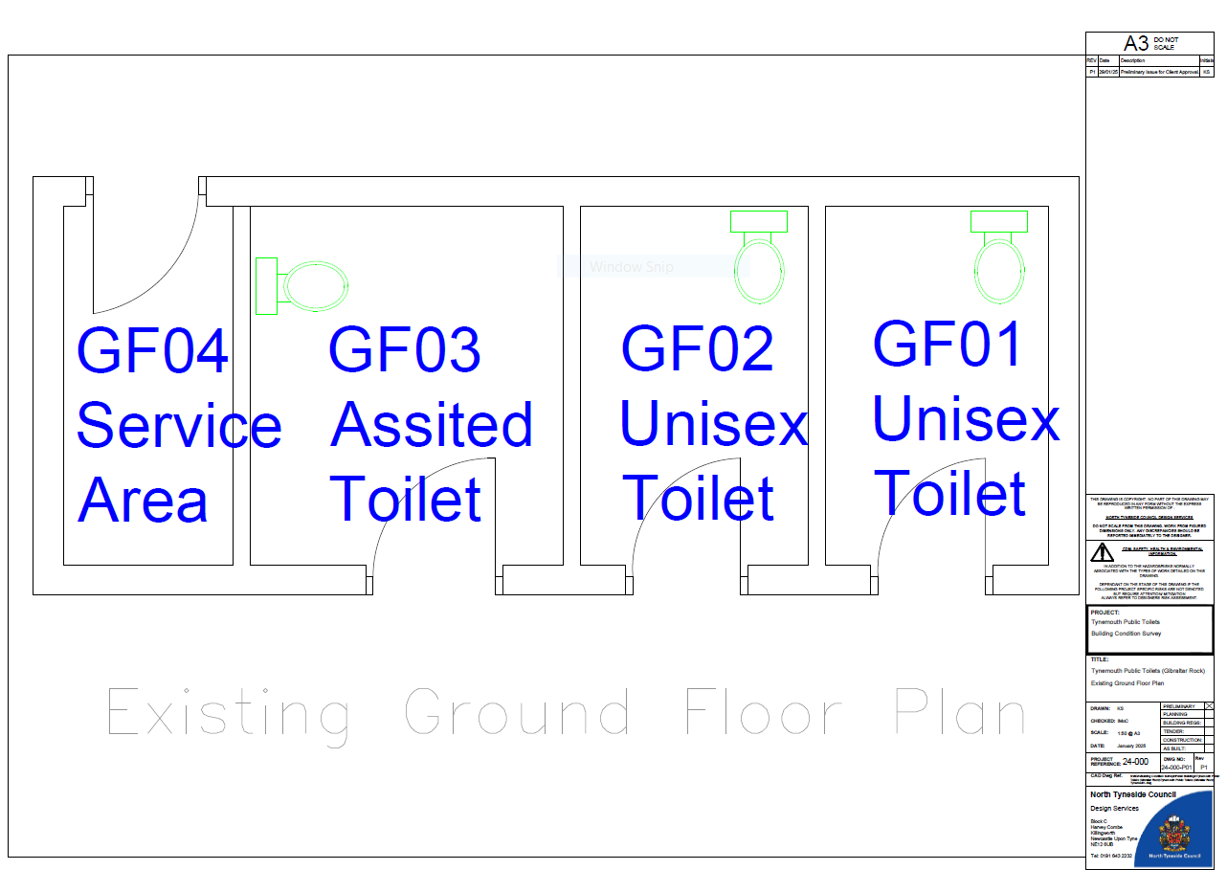

STATUTORY COMPLIANCE

Tenants shall comply, at their own expense, with any Bylaws, Notices, Building Regulations, Statutory Requirements, whether local or otherwise, including the Town and Country Planning Act and all other relevant Acts of Parliament. Consultation with the Council’s Environmental Health will be necessary to ensure all Animal By-Product and offal disposal regulations are adhered to, and tenants will be expected to disclose details of their methods on request.

RENT

Rental offers for the site are invited, with other lease terms to be proposed by the applicant.

The tenant shall be responsible for the payment of the ongoing annual rent. Rent is payable monthly in advance, and in equal sums. The rent is exclusive of utlitity bills such as electricity and water.

REQUIREMENTS

The Council is seeking submissions from relevant suitable applicants for the provision of a service based at Front Street, Tynemouth within the Former WC Block.

The applicant will be required to undertrake a small number of supervisory and maintenance roles as part of the agreement. These include:

- The tenant must open for business every day between 1st April and 30th September, no earlier than 9:00am and no later than 5pm (weather dependant). Trading times outside of these dates and times are available by agreement with the council.
- The tenant must provide, open and maintain a WC provision which will be open to the general public.
- During this period the tenant is responsible for opening and closing the public toilets each day.
- Ensure that the premises is swept daily during this period.

PLANNING COMMENTS

Predominant land use
The site –
Disused public toilets.

Surrounding area –
The site is within Tynemouth village centre close to the seafront. There is a public house to the north and open space associated with Tynemouth Priory to the southeast. To the west are a mixture of residential and commercial properties.

Layout
The site –
Comprises the toilet block which is surrounding by hard surfacing.

Surrounding area –
East and south – dominated by open space.
West – a mixture of commercial and residential properties.
North – a public house lies to the north.

Scale, setting and building types –
The site –
The site contains a single storey building. It is brick built with a tiled hipped roof and relatively modern.

Surrounding area –
Buildings within the immediate surroundings are typically 2-4 storeys and many are of architectural and historic significance. On Front Street there are a mixture of 3 and 4 storey properties while the adjacent public house is 2-storey. Residential properties to the west are 3-4 storey in height.

Architectural / Townscape / Streetscape / Open space quality
The site is located within Tynemouth Conservation Area adjacent to Tynemouth Priory Scheduled Monument. The land to the southeast is designated as Open Space within the Local Plan.

The quality of the streetscape and open space is high, and the site itself is prominent due to its location on the seafront.

Level of activity (Tranquil / Vitality)
The site –
Significant pedestrian activity and vehicular traffic on the adjacent highway

Surrounding area –
Traffic and pedestrian movements along Front Street and East Street.

Development Constraints
Tynemouth Conservation Area
Tynemouth District Centre
Hot food takeaway buffer zone
Wildlife Corridor
Impact risk zone for Northumbria Coast SPA/Ramsar site (0-6km)
Mineral safeguarding area
CIL Commercial Charging Zone B
Area of archaeological interest – Tynemouth Medieval Village
Contaminated Land Buffer Zone
Close to the ecological import sites – SSSI, Local Wildlife Site and Northumbria Coast SPA/Ramsar Site

Comments
The future operator would require planning permission to change the use of the building and for any external alterations.

Potential uses likely to be supported include retail, cold food and drink sales and uses associated with tourism (bike rental etc). The site is not appropriate for a hot food takeaway use.

External alterations would need to be carried out using high quality, traditional materials that reflect the historic importance of the surroundings.

Depending on the proposed use and the external alterations that are required, information required in support of a planning application may include a bat risk assessment and Habitat Regulations Assessment.

Relevant Policies
Relevant planning policies include:

Local Plan 2017

General Policies:
S1.4 General Development Principles
DM1.3 Presumption in Favour of Sustainable Development

Retail and Town Centres
DM3.5 Primary Shopping Area
DM3.7 Hot Food Take-aways

Design and Heritage
DM6.1 Design of Development
S6.5 Heritage Assets
DM6.6 Protection, Preservation and Enhancement of Heritage Assets
DM6.7 Archaeological Heritage

Pollution
DM5.18 Contaminated and Unstable Land
DM5.19 Pollution

Environment
DM5.2 Protection of Green Infrastructure
S5.4 Biodiversity and Geodiversity
DM5.5 Managing effects on Biodiversity and Geodiversity
DM5.6 Management of International Sites
DM5.7 Wildlife Corridors

Infrastructure
DM7.4 New Development and Transport
S7.7 Waste Management
DM7.9 New Development and Waste

Area policies –
AS8.15 The Coastal Sub Area
AS8.16 Tourism and Visitor Accommodation at the Coast
AS8.17 Visitor Attractions and Activities at the Coast

Other policies
Design Quality SPD
Transport and Highways SPD
Coastal Mitigation SPD
Tynemouth Conservation Area Management Strategy SPD

Community Infrastructure Charging Schedule 2019

LEGAL COSTS

The tenant shall be responsible for the landlord’s legal and surveyors costs incurred in granting and producing the license and associated costs and Stamp Duty. The landlord’s legal costs will be £800 and surveyors costs will be £650.

REFERENCES:

The grant of the agreement shall be subject to the receipt of a satisfactory financial reference and two trader's references. An Experian Credit check will also be carried out

ASSESSMENT OF OFFERS

All offers received will be scored on their suitability by the Council considering the following criteria:

A) The three criteria will be scored to a maximum of 100%
Each question will be scored from 0 to 10 as follows: -
0 = No evidence in the response at all how the proposal addresses the criteria
2 = Very minimal evidence about how the proposal addresses the criteria
5 = Satisfactory level of evidence about how the proposal addresses the criteria
8 = Good level of evidence about how the proposal addresses the criteria
10 = Excellent level of evidence about how the proposal addresses the criteria
Percentages are indicated against each individual question.

Quality Question | Evaluation Criteria | Weighting | Scoring
1 | Rental Offer  Please provide your rental offer including proposed lease terms and any other information relevent to your proposal. | 40% | 0% = No evidence in the response at all how the proposal addresses the criteria  10% = Very minimal evidence about how the proposal addresses the criteria  20% = Satisfactory level of evidence about how the proposal addresses the criteria  30% = Good level of evidence about how the proposal addresses the criteria  40% = Excellent level of evidence about how the proposal addresses the criteria
2 | Experience, Business Plan and Proposed Use  Please include any experience that you may have had which may show how this could be successful. This should be supported by a 5-year business plan.  Please explain the proposed use for the property, including drawings, elevations and a Method Statement for the proposed works within any submission. | 40% | 0% = No evidence in the response at all how the proposal addresses the criteria  10% = Very minimal evidence about how the proposal addresses the criteria  20% = Satisfactory level of evidence about how the proposal addresses the criteria  30% = Good level of evidence about how the proposal addresses the criteria  40% = Excellent level of evidence about how the proposal addresses the criteria
3 | Social Value  Please provide details of any aspects of Social Value that you can offer which would be of benefit to the local area its users, your employees or the local community in support of delivery of this Contract E.g. Locally sourced produce/recruitment from the local community, supporting local charities. | 10% | 0% = No evidence in the response at all how the proposal addresses the criteria  2.5% = Very minimal evidence about how the proposal addresses the criteria  5% = Satisfactory level of evidence about how the proposal addresses the criteria  7.5% = Good level of evidence about how the proposal addresses the criteria  10% = Excellent level of evidence about how the proposal addresses the criteria
4 | Environmental Management  Please confirm that you will work alongside the Council to help it achieve its own and national carbon neutral target and detail any measures that you will deploy from Day 1 to contribute to this.  Please note, the successful applicant should be responsible for their own waste. | 10% | 0% = No evidence in the response at all how the proposal addresses the criteria  2.5% = Very minimal evidence about how the proposal addresses the criteria  5% = Satisfactory level of evidence about how the proposal addresses the criteria  7.5% = Good level of evidence about how the proposal addresses the criteria  10% = Excellent level of evidence about how the proposal addresses the criteria

VIEWINGS

Viewings are strictly by appointment only please contact Katie Gallagher or Emily Joice to arrange a viewing.

Katie Gallagher – Assistant Property Surveyor
Katie.gallagher@northtyneside.gov.uk
Tel: (0191) 643 2142

Emily Joice– Property Surveyor
Emily.joice@northtyneside.gov.uk
Tel: (0191) 643 2142

TENDER PROCESS

Offers should be submitted on the enclosed Offer Form and submitted along with all supporting documentation. The Offer Form and supporting documentation should be sealed in an envelope with the applicant’s name, date and contact details.

The package should be submitted by to the following address, between the hours of 9am-16:00pm Monday to Friday, no later than midday on Friday 16th January 2025. Please note that the office will be closed for the Christmas break from 23rd December 2025 until 5th January 2026.
Quadrant East, The Silverlink North, North Tyneside, NE27 0BY.

A green adhesive address label should be adhered to the front of the envelope. These will be given to you when you hand in the submission. Tenders submitted without the correct label attached risk being opened prior to the closing date for offers and as such would need to be removed from the selection process. Late offers will not be considered and the council reserve the right to not accept the highest scoring offer.

If the applicant has any questions regarding the tender process, they should contact Katie Gallagher or Emily Joice– 0191 643 2142
katie.gallagher@northtyneside.gov.uk | emily.joice@northtyneside.gov.uk

CLOSING DATE FOR OFFERS

All offers are to be submitted with the green adhesive label attached to the envelope to the following:
Mrs Pamela McGorie, Manager of Estates and Property, Quadrant, The Silverlink North, Cobalt Business Park, Tyne and Wear, NE27 0BY.
The closing date for offers is:
12.00 noon on the 16th January 2025.

Any offers received after this deadline or not in accordance with the offers procedure outlined above will not be considered.

North Tyneside Council are not obligated to accept any offers and reserve the right to return to the market if satisfactory offers are not received.

Offer Form

Pamela McGorie
Manager of Estates and Property
North Tyneside Council
Quadrant East
Silverlink North
Cobalt Business Park
North Tyneside
NE27 0BY

SUBJECT TO CONTRACT

I (We) . . . . . . . . . . . . . . . . . . . . . . . . . of . . . . . . . . . . . . . . . . . . . . . . .
hereby make a firm annual rental offer for the Leasehold interest in the site known as the Former WC Block at Front Street, Tynemouth as described in the relevant Property Particulars and subject to the Conditions set out in the Particulars at the

price of £ . . . . . . . . . . . . . . . . . . . . . per annum.

It is understood and agreed that this offer may be accepted by or on behalf of the North Tyneside Council as Lessees of the said property by a letter of acceptance in that behalf signed by the Head of Commissioning and Investment or his nominee on behalf of the said Vendors addressed to (me) (us) (the company) at the above mentioned address.

It is further understood and agreed that the Vendors shall be under no obligation to accept this or any other offer, which may be made.

A S W I T N E S S my (our) hands

Signed | . . . . . . . . . . . . . . . . . . . . . . . . . . . . . . . . . . . . . . . . . . .
For and on behalf of | . . . . . . . . . . . . . . . . . . . . . . . . . . . . . . . . . . . . . . . . . . .
Date | . . . . . . . . . . . . . . . . . . . . . . . . . . . . . . . . . . . . . . . . . . .

