

PROPERTY FOR SALE

Garages at Albion Terrace, North Shields

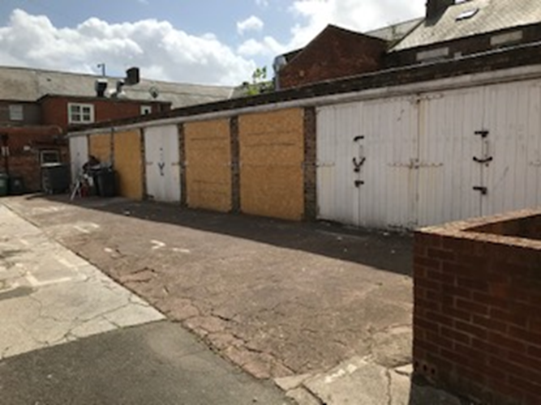



LOCATION

The garages are located at Albion Terrace in North Shields as shown shaded green on the plan below.

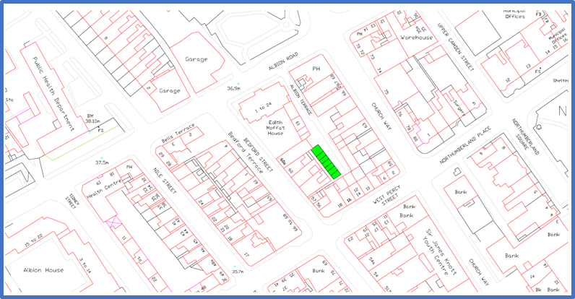

Description

The garages were built in 1975 and are of single brick construction with corrugated sheet roofing with timber doors and frames. There are 8 garages in total, all of which are currently vacant.

At present the brick walling is in an adequate condition, however the roofing panels are in a poor state of repair and need replacing. In addition, the timber doors and frames are also in a poor state of repair and need replacing.

USE

The garages are currently available for refurbishment for garage or storage use. Alternatively the garages could be demolished and the site redeveloped for a use compatible with this town centre location and the planning guidelines detailed below.

PLANNING GUIDELINES

The site is located within an area of the town centre which contains a mixture of commercial and residential uses. The garages are surrounded closely by buildings on all sides. For this reason, the site does not lend itself to residential development.

The garages are considered suitable for refurbishment and re-use or conversion. Potentially suitable uses include storage, light industrial and commercial. A noise assessment would be required for commercial and industrial uses to demonstrate that the impact on nearby residents is acceptable. The site is not suitable for hot food takeaway uses.

The site could also be cleared and redeveloped with buildings of a similar scale. A 2-storey building is unlikely to be acceptable due to the impact on first floor residential flats. Suitable uses would be those described above.

Any development should ensure the following are complied with:

- No encroachment on or obstruction of adopted highway (adoption plan attached & extract below – Adopted footpaths/highways shown shaded grey)
- No doors opening out over adopted highway
- Condition survey of highway agreed with Highway Maintenance prior to demolition, refurbishment, or reconstruction

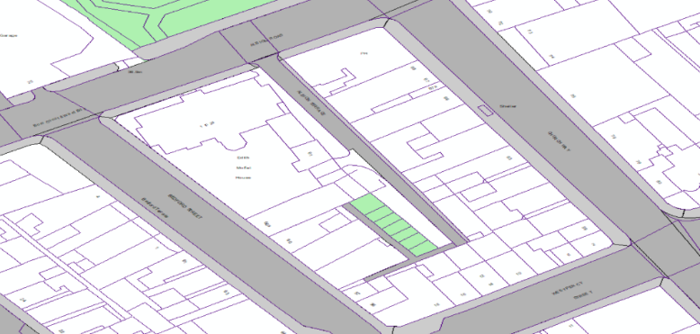
Key Site Constraints
North Shields Town Centre Primary Shopping Area
Within the Impact Risk Zone for Northumbria Coast SPA and Ramsar site (0-6km)
CIL Commercial charging Zone A
Coal Mining Standard Advice Area
Contaminated Land

Planning Policies
National Planning Policies
National Planning Policy Framework (NPPF) (December 2024)
National Planning Practice Guidance (NPPG) (As amended)

Local Planning Policy
Local Plan (2017)
General Policies –
S1.1 Spatial Strategy for Sustainable Development
DM1.3 Presumption in Favour of Sustainable Development
S1.4 General Development Principles

Economy –
S2.1 Economic Growth Strategy
DM3.5 Primary Shopping Area
DM3.7 Hot Food Takeaways

Natural Environment -
S5.4 Biodiversity and Geodiversity
DM5.5 Managing Effects on Biodiversity and Geodiversity
DM5.12 Development and Flood Risk
DM5.18 Contaminated and Unstable Land
DM5.19 Pollution

Built and Historic Environment –
DM6.1 Design of Development

Infrastructure –
S7.3 Transport
DM7.4 New Development and Transport
DM7.9 New Development and Waste

Supplementary Planning Documents (SPDs)
Design Quality
Transport and Highways
Coastal Mitigation

Community Infrastructure Levy (CIL)
North Tyneside Council has adopted its Community Infrastructure Levy (CIL) Charging Schedule.

The Planning Department welcome and encourage discussion before planning applications are submitted, and provide a Pre-application Advice Service. Details of this can be found here: Pre-application advice

TITLE INFORMATION
The property is registered at the Land Registry under Title Number TY435527. The office copy entry is available at Appendix 1 and the Title Plan is available at Appendix 2.

ASSESMENT OF OFFERS

Intrerested parties should provide details of their proposed use of the property and confirmation of where the funds will come from to complete the refurbishment or clearance and redevelopment of the site. The council will include a buy back provison if the refurbishment/redevelopment is not successfully completed within 24 months of completion.

Offers should be submitted on the Offer Form available with these particulars and with all supporting documentation. The Offer Form and supporting documentation should be sealed in an unmarked envelope.

A green adhesive address label that is available on request from the Strategic Property Team should be adhered to the front of the envelope. Tenders submitted without the correct label attached risk being opened prior to the closing date for offers and as such would need to be removed from the selection process. Late offers will not be considered and the council reserve the right to not accept the highest offer.

CLOSING DATE FOR OFFERS

All offers are to be submitted with the green adhesive label attached to the envelope to the following:

Mrs Pamela McGorie, Manager of Estates and Property, Quadrant East, The Silverlink North, Cobalt Business Park, Tyne and Wear, NE27 0BY.

Alternatively, the offer can be hand delivered to Quadrant East reception with the adhesive green label attached.

The closing date for offers is:

12 Noon on Friday 27th March 2026.

Any offers received after this deadline or not in accordance with the offers procedure outlined above will not be considered.

VIEWING

The garages are accessible for viewing externally from Albion Terrace

FOR FURTHER INFORMATION

Please contact Niall Cathie, Strategic Property Manager

Tel: 07897 436413

Email: niall.cathie@northtyneside.gov.uk

Or, Strategic Property

Tel: 0191 643 2142

Email: strategic.property@northtyneside.gov.uk

