



Residents’
Survey 2024
Contents
1 Introduction 5
1.1 Background and objectives 5
1.2 Approach 6
2 Summary of key findings 10
2.1 Overview 10
2.2 Main findings for North Tyneside 10
2.3 A Thriving North Tyneside 13
2.4 A Secure North Tyneside 14
2.5 A Family Friendly North Tyneside 16
2.6 A Caring North Tyneside 16
2.7 A Green North Tyneside 17
2.8 Satisfaction with the council 18
3 A Thriving North Tyneside 21
3.1 Section summary 22
3.2 Overview satisfaction with the local area 23
3.3 What issues are most important? 24
3.4 Key drivers of satisfaction with the local area 28
3.5 Frequency of using sports and cultural services 30
3.6 Satisfaction with sports and cultural facilities 31
3.7 Purpose of visits to town centres 34
3.8 Satisfaction with town centres 34
3.9 Current employment and location 35
4 A Secure North Tyneside 37
4.1 Section summary 38
4.2 Perceptions of safety 39
4.3 Satisfaction with choice and quality of housing 43
4.4 Personal financial circumstances in the last 12 months 44
4.5 Financial well-being 46
4.6 Self-reported health 48
4.7 Exercise 49
4.8 Mental health and well-being 49
4.9 Loneliness and isolation 51
4.10 Satisfaction with employment opportunity 52
5 A Family Friendly North Tyneside 54
5.1 Section summary 54
5.2 Use of Children’s services 54
6 A Caring North Tyneside 56
6.1 Section summary 57
6.2 Feeling of belonging 58
6.3 Community cohesion 59
6.4 Pulling together to improve the local area 59
6.5 Provide help or support to others 61
6.6 Use of Adult Social care 62
7 A Green North Tyneside 64
7.1 Section summary 65
7.2 Satisfaction with waste and recycling 66
7.3 The council’s action on climate change 67
7.4 Willingness to change behaviours 67
8 Satisfaction with the council 74
8.1 Section summary 74
8.2 General satisfaction with North Tyneside Council 76
8.3 Key drivers of council satisfaction 77
8.4 The most important services delivered by the council 79
8.5 Value for money 80
8.6 Key drivers of value for money 81
8.7 Changes to local services 82
8.8 Advocacy 84
8.9 Contacting the council 86
8.10 The Council’s website 87
8.11 Why contact was made, how and with whom? 88
Satisfaction with contact experience 91
8.12 Expectations of customer contact experience 92
8.13 Information provision 93
8.14 Sources of information 93
9 Technical report 95
9.1 Respondent profile 95
9.2 Sample frame and design 96
9.3 Weighting 97

Introduction

Background and objectives
Since 2012, North Tyneside Council has undertaken an annual residents’ survey to assess residents’ perceptions of, and satisfaction with, their local area, council services and health and well-being issues. The survey also includes questions on other key topics, such as the economy and the environment.

This report outlines the key findings from the 2024 residents’ survey and where relevant makes comparison with previous years of the study. When comparing the 2024 results against previous surveys, it is important to note the following context:

- Due to the COVID-19 pandemic, the residents’ survey did not take place in 2020. The survey was subsequently reintroduced in 2021.

- In 2022, there were several changes in the run up to the fieldwork which included changes in government leadership, a budget U-turn and strike action for a number of public services including the NHS, rail unions and postal strikes.

- In 2024, there were also significant events including a general election/change of Government and concerns amongst several local councils about budget cuts. For example, in November 2024, (during the fieldwork period for this survey), North Tyneside Council were in the local press with headlines regarding the potential loss of 200 jobs within the council (see: North Tyneside Council set to cut 200 jobs amid budget pressures - BBC News ).
The content of the 2024 survey was designed to support the ‘Our North Tyneside Plan 2021 to 2025’. The plan is structured around five themes – a North Tyneside that is ‘Thriving, ‘Family-Friendly, ‘Caring’, ‘Secure’ and ‘Green’.
To enable comparability with previous surveys, the questionnaire has remained unchanged in 2024.

Approach
In previous years, the resident survey was conducted through a postal survey of residents across the borough. In 2024, it was agreed with North Tyneside Council that the approach would change to a ‘push to web’ methodology. This methodology gives respondents the option of completing the survey via a paper (postal) copy enclosed with the survey invite, or completing the survey online (via a survey link or QR code shown on the invite).
A ’push to web’ approach is often recommended as a more sustainable approach (involving less printing and the associated CO2 emissions of posting/transporting paper questionnaires). Experience has also shown that offering an online method of completion, which residents can access via any internet-enabled device (including their phone or tablet) helps to boost representation from younger residents in particular.
DJS Research drew a random sample of 5,000 residential addresses from the Royal Mail Postcode Address File (PAF). Ahead of the full roll-out of the survey, a ‘soft’ launch was undertaken. This involved posting the survey to 500 addresses from the sample first, to allow initial survey completions to be returned and reviewed before the remaining sample was distributed.
A 12-page questionnaire and covering letter, providing details of how to complete the survey on paper or online (see Appendices) were sent out to each address in the sample. One reminder mailing (again including a paper copy of the survey) was sent out to households who had not responded to the initial mail-out. The fieldwork took place between 25th October 2024 and 11th December 2024.
There were 1,128 valid responses from the original sample, which equates to a response rate of 23%, in line with the previous year (24%).
Responses to the survey were weighted back to the known population profile of the area to counteract non-response bias. Data was weighted by age within gender bands and ethnicity. The weighting profile was based on 2021 Census information and. This approach is consistent with previous waves of the survey.
The data has also been analysed by four small areas. The wards which sit within these four areas are detailed below:

Figure 1: Area definitions
Area | Ward
Central | Backworth & Holystone  Battle Hill  Forest Hall  Killingworth  New York & Murton  Shiremoor
Eastern | Cullercoats & Whitley Bay South  Monkseaton  Preston with Preston Grange  St Mary's  Tynemouth  Whitley Bay North
Southern | Chirton & Percy Main  Howdon  North Shields  Wallsend Central
Western | Camperdown  Longbenton & Benton  Wallsend North  Weetslade
Source: DJS Research/North Tyneside Council
When considering the statistically significant differences in resident opinion amongst these four areas, it is worth noting the differing profiles of the participants within each area. For example, residents in the Eastern area are more likely to own their home outright (57% vs. 42% overall). Whereas those in the Southern area are more likely to be social tenants (27% vs. 12% overall).
Please note: Due to ward boundary changes that took place in 2024, the four areas outlined above are no longer comparable with previous surveys. This means we can only include analysis at an area level using 2024 data.
Where possible, North Tyneside’s data has been compared to National benchmarks from the Local Governments Associations’ (LGA) tracker (October – November 2024) and the Community Life survey (2023-2024).
Statistical reliability and margins of error
A total of 1,128 responses were obtained overall for the 2024 residents’ survey. This equates to a margin of error of +/-2.91% based on a statistic of 50% at the 95% confidence interval. This means that if we found a satisfaction level of 50%, we can be 95% confident that this figure lies between 47.09% and 52.9% if every resident in North Tyneside had completed the survey.
Notes on the analysis
To provide further insight into the results, sub-group analysis is provided by different demographics and specific variables (e.g. area, age and gender). The results for these sub-groups have been discussed where they are statistically significant (at the 95% confidence level) compared with the total for North Tyneside Council and if the base sizes are 30 or more. Where there is a statistically significant difference between groups, this has been noted in the report as a ‘significant’ difference.
To allow meaningful comparisons, ‘ethnicity’ has been grouped into the following two categories (in line with Government guidance):
- White (White: English, Welsh, Scottish, Northern Irish or British, White: Irish, White: Gypsy or Irish Traveller, White: Roma, White: Other White).

- Ethnic Minority Groups (Asian, Asian British or Asian Welsh, Black, Black British, Black Welsh, Caribbean or African, Mixed or Multiple ethnic groups and Other ethnic groups).
Results throughout this report are based on ‘valid’ responses and therefore where a respondent has selected ‘not applicable’ or did not answer a question, these have been excluded from analysis for that question. The base size therefore shows the total number of respondents included in the analysis for each question.
Owing to the rounding of numbers, percentages displayed on graphs may not always add up to 100% and may differ slightly to the text.
The survey data presented is based on weighted data. Small weights by
age and gender and ethnicity were applied to the data to ensure the findings are fully representative of the North Tyneside population. The weighting efficiency for the sample is 70.2% ,which indicates that our sample matched the North Tyneside population reasonably well and is greater than the cut-of-point of 70%, hence the weighting is fit for purpose.

Acknowledgements
DJS Research would like to thank Robert Dixon at North Tyneside Council for his assistance throughout this project.
We would also like to thank the 1,128 residents who took the time to complete the survey.
Structure of the report
Each section of the report is based around the following five priorities outlined in the ‘Our North Tyneside Plan 2021-2025. These are: A ‘Thriving’ North Tyneside, A ‘Secure’ North Tyneside, A ‘Family’ Friendly’ North Tyneside, A ‘Caring’ North Tyneside and A ‘Green’ North Tyneside.

Summary of key findings

Overview
Between 25th October 2024 and 11th December 2024, DJS Research carried out a ‘push to web’ survey amongst residents living in North Tyneside.
The push to web methodology, increases accessibility and inclusivity of the survey, by providing all participants the option of completing the survey either by post (using the paper copy enclosed with the invite), or online (via the link or QR code on the letter). This combined methodology, which marks a change compared with previous years when the survey was conducted entirely via a postal survey, tends to generate a more balanced sample compared with when just one methodology is used. It is also considered to be a more sustainable approach (involving less printing and the associated CO2 emissions of posting back paper questionnaires).
The survey was sent to a random sample of 5,000 residential addresses across North Tyneside and completed by 1,128 adults aged 18 and over; this represents a response rate of 23%.

Main findings for North Tyneside
Figure 2 indicates that most KPIs are broadly consistent with the 2022 survey. The largest decreases relate to whether the council ‘Acts on the concerns of local residents’ and satisfaction with the local area; both measures have dropped by three percentage points. Although, neither of these decreases are statistically significant.
Figure 2: Key performance measures for North Tyneside over time (%)
KPI | 2014 | 2015 | 2016 | 2017 | 2018 | 2019 | 2021 | 2022 | 2024
Satisfaction with the way the council runs things | 51 | 52 | 57 | 57 | 52 | 51 | 56 | 49 | 48
Council keeps residents informed | 59 | 62 | 63 | 65 | 60 | 56 | 55 | 53 | 54
VFM provided by the Council | 40 | 44 | 47 | 47 | 39 | 41 | 43 | 40 | 39
Council acts on residents’ concerns | 50 | 48 | 50 | 50 | 46 | 50 | 49 | 44 | 41
Satisfaction with local area as place to live | 76 | 79 | 81 | 79 | 79 | 78 | 81 | 77 | 74

Figure 3 highlights that for ‘Keeping residents informed’ the North Tyneside results are significantly more positive than the LGA benchmark (October 2024). In contrast, for ‘Acting on the concerns of local residents’ and satisfaction with the council the 2024 survey results for North Tyneside are significantly lower than the national averages (LGA benchmark).
Figure 3: Key performance indicators – North Tyneside and LGA comparisons
KPI | North Tyneside (2024) | LGA  (Oct 2024) | Difference between North Tyneside and LGA
Satisfaction with the way the council runs things | 48 | 56 | -8
Council keeps residents informed | 54 | 47 | +7
VFM provided by the Council | 39 | 36 | +3
Council acts on residents’ concerns | 41 | 53 | -12
Satisfaction with local area as place to live | 74 | 74 | 0
Where the North Tyneside results are significantly higher than the LGA results they have been highlighted in green/statistically lower than the LGA results, they have been highlighted in red.

Figure 4 indicates some mixed results when comparing the North Tyneside results with the latest LGA benchmarks (October 2024). Satisfaction with library services and sports and leisure services are both significantly higher than the LGA benchmarks. Although, for pavement maintenance and street cleaning results are significantly lower than the national average (LGA benchmarks).
Figure 4: Satisfaction with public services – North Tyneside and LGA comparisons
Public service | North Tyneside (2024) | LGA  (Oct 2024) | Difference between North Tyneside and LGA
Refuse and waste collection | 73% | 76% | -3
Parks and green spaces | 72% | 73% | -1
Street cleaning | 48% | 57% | -9
Library services | 61% | 53% | +8
Sport and leisure services | 62% | 50% | +12
Pavement maintenance | 22% | 44% | -22
Road maintenance | 26% | 30% | -4
Where the North Tyneside results are significantly higher than the LGA results they have been highlighted in green/statistically lower than the LGA results, they have been highlighted in red.

A Thriving North Tyneside
To measure progress against the ‘Thriving’ element of the Our North Tyneside Plan we examined residents’ perceptions and priorities of their local area, as well as their views on sports and cultural facilities and economic priorities.
As mentioned earlier, there has been a continued drop in the proportion of residents stating that they are satisfied with their local area as a place to live, from 80% in 2021 and 77% in 2022, to 74% this year.
Linked to area satisfaction, while the majority of residents think their local area has remained unchanged in the last 12 months, consistent with 2022, more residents believe their area has gotten worse (31%) than improved (12%).
By area, dissatisfaction with residents’ local area is significantly greater amongst those living in the Southern area of the borough, as is the proportion that believe their area has deteriorated in the last 12 months.
When asked which aspects are important when making somewhere a good place to live, the top three relate to the level of anti-social behaviour, clean streets and health services. These priorities are consistent with previous years, although since 2022 health services have moved from first to third position.
In terms of improvements, as in the 2022 survey, road and pavement repairs (53%) are deemed to be the biggest issue requiring improvement. This is followed by the level of anti-social behaviour (49%) and clean streets (35%). Compared with 2022, significantly greater proportions of residents believe improvements are needed to anti-social behaviour and levels of crime.
Further analysis to understand what is driving satisfaction with the local area (and its decline) shows that the issues coming through most this year, relate to the council providing value for money, community cohesion and safety.
Regarding sports and cultural facilities, usage of parks and open spaces, beaches and play areas have remained stable compared to 2022. Further analysis by sub-group shows the more vulnerable and less affluent groups within the population are less likely to use these facilities than others.
Satisfaction with sports and cultural facilities is also generally consistent with previous surveys, with beaches and parks and green spaces continuing to be rated most favourably. The most notable change since 2022 has been an increase in satisfaction for local libraries.
Satisfaction levels among North Tyneside residents are significantly more positive than the LGA benchmarks for libraries (61% vs. 53% LGA benchmark) and sports and leisure services (62% vs. 50% LGA benchmark).
When looking at usage and satisfaction with the four town centres within North Tyneside: Whitley Bay, North Shields, Wallsend and Killingworth, Whitley Bay has the highest footfall. The key draw of each town centre is to shop. Compared to the 2022 survey however, the proportion of residents visiting North Shields, Wallsend and Killingworth for shopping has decreased significantly. Whilst in Whitley Bay there has been a sharp decline in the proportions visiting bars/restaurants, professional services or for health care.
Satisfaction with town centres is highest for Whitley Bay (64%), followed by Killingworth (52%), and remains considerably lower for North Shields (32%) and Wallsend (24%).
Work locations have remained fairly consistent with the 2022 survey, with the largest proportion of working residents (43%) remaining within the borough for work.

A Secure North Tyneside
This element of the Our North Tyneside Plan examines residents’ perceived safety in their local area, their satisfaction with roads and pavements, the quality and choice of housing, as well as socio-economic and health inequalities.
The proportion of residents who feel safe during the day (88%) remains consistent with the 2022 survey. In contrast, only half of residents (49%) feel safe after dark and residents in the Southern area are significantly less likely to. Overall, however, following the downward trend in this measure from 2015 to 2021, it now looks like the trend for feeling safe after dark has started to move in a more positive direction.
Residents’ satisfaction with environmental services remains consistent with 2022. However, satisfaction with street cleaning, road and pavement maintenance within North Tyneside are all significantly lower than the LGA benchmarks.
Satisfaction with the choice and quality of housing remains relatively stable (60% and 61% respectively). Although, satisfaction levels for both measures are significantly lower amongst residents living in the Southern area and significantly higher than average in the Eastern area.
When asked about their income, the majority of residents state that they are living comfortably or coping on their present income, although 17% are finding it difficult. Since 2022, the proportion of residents who consider themselves to be comfortable or coping financially has improved significantly, by four percentage points (from 79% to 83%).
Despite some decrease (four percentage points to 40% this year) in the proportion of residents affected by the current economic climate, at least nine in ten residents are taking action to make savings. The most common changes relate to spending less on non-essentials (61%), shopping around more (56%) and using less fuel (such as gas or electricity) to heat their homes (51%). However, it does appear that the proportions taking several of these measures has declined since 2022. This is particularly the case for using less fuel, such as gas or electricity to heat their homes, which has decreased by 26 percentage points to 51% (vs. 77% in 2022).
Younger residents, those with an illness or disability and those in Southern or Central areas are among those more likely than North Tyneside residents on average to be facing challenges because of the current economic climate.
The results also indicate other effects of the current economic climate, with 20% not being able to afford a holiday. This is closely followed by 19% experiencing difficulties with paying fuel and energy bills. More positively, compared with 2022, significantly fewer residents are facing these challenges, which is consistent with the significant improvement in the proportion of residents managing on their current income.
Since 2022, little change has been noted in self-reported health, with 65% claiming that have either good or very good health. However, the results indicate that residents in vulnerable groups are much more likely to have poor self-reported health, including those who are unemployed (43% vs. 9% on average) and social tenants (33%).
In terms of exercise levels, 44% of North Tyneside residents state that they do the recommended 150 minutes of exercise or more per week. Residents aged 18-34 however, are significantly less likely to be doing the recommended amount of exercise per week (36% vs. 44% overall).
With regards to mental wellbeing overall, the majority of residents score between 21-30 points out of a maximum of 35 points, with 3% scoring above 30 points; indicating a high level of mental well-being. Scores of 20 or less indicate a low level of mental well-being, with 41% of residents falling within this range. The average well-being score amongst all residents in 2024 is 22.3 out of a maximum of 35 points.
Overall, 8% of survey respondents stated that they feel lonely or isolated where they currently live most or all of the time. Residents aged 18-34 (16%) and those who are unemployed (33%) are more likely than North Tyneside residents on average to feel isolated most/all of the time.
Maintaining a secure North Tyneside also includes ensuring that there is a sufficient supply of jobs and apprenticeships for residents. Overall, of those that provided a rating, perceptions continue to be low. Satisfaction is highest for the availability of jobs, with just over a quarter of residents (26%) stating they are satisfied with this aspect, yet around one third are dissatisfied. This compares to only 14% of residents satisfied with the opportunities for work placements, apprenticeships and training for 16-24 year olds and more than two fifths are dissatisfied.

A Family Friendly North Tyneside
High quality education and support is the core of the ‘Family Friendly’ element of the Our North Tyneside Plan. Service usage of Children’s Services remains consistent with previous years, with just over a quarter of residents (26% vs. 28% in 2022) using the service at least once a month and 41% of residents over the past year (37% in 2022).
User satisfaction with Children’s services however, has decreased significantly since 2022, from 57% to 48% this year.

A Caring North Tyneside
This element of the Our North Tyneside Plan focuses on community cohesion, such as the extent to which people belong to the area, mix with other residents, volunteer and how well they feel that different groups of people get on well together. This section also reports on those who care for others and satisfaction with Adult Social Care Services.
Almost three quarters of residents (72%) feel a sense of belonging to North Tyneside. This result has remained consistent with the 2022 survey (71%). It is also significantly higher than the 2023-24 Community Safety survey benchmark of 61%. However, residents in the Southern area of the borough are less likely to have such a sense of belonging.
Perceptions of local community cohesion (i.e. whether residents believe their local area is a place where people from different backgrounds get on well together) remains fairly stable, at 61%, although this is significantly below the national benchmark (81%). Disagreement levels for this measure are also significantly higher than average in the Southern area and in the most deprived areas (IMD 1) of North Tyneside.
Overall, 42% of residents believe people pull together to improve their local community, which again is a stable measure but below the national benchmark (56%).
Both formal (17%) and informal (25%) volunteering are in line with 2022 and are in line with the national averages, as measured by the Community Life Survey (16% and 24% respectively). There has been an upward trend in formal volunteering since 2021 within North Tyneside.
Overall, almost a quarter of residents (22%) provide help or support to a family member, friend or neighbour because of ill health or old age. This is identical to the 2022 survey.
Usage of Adult Social Care services remains in line with 2022, with 23% using this service at least once in the past year. All residents who have used Adult Social Care Services were asked how satisfied or dissatisfied they are with this service. Similar to 2022, a higher proportion of users are dissatisfied (41%) than satisfied (35%).

A Green North Tyneside
This element of the Our North Tyneside Plan focuses on resident satisfaction with waste and recycling services, perceptions of the council’s actions on climate change and willingness of residents to make changes to help reduce their carbon footprint.
Around three quarters of residents (73%) are satisfied with the refuse and waste collection service provided by the council. This represents a four-percentage point decrease since 2022 (77%), though it remains in line with the LGA benchmark (76%).
Satisfaction levels are much lower when it comes to doorstep/kerbside recycling, with 62% stating they are satisfied. This measure has also significantly dropped compared with the 2022 survey, as has satisfaction with local tips/recycling centres, by five percentage points to 57%.
Overall, residents’ views on whether the council is taking action on climate change are unchanged since the 2022 survey and continue to highlight the need for the council to increase awareness of what is being done in this regard. Just over a quarter of residents agree that the council is taking action while a fifth disagree. The remaining 51% are ambivalent.
When looking at current and planned behaviour to reduce carbon footprint, the majority of residents claim to be already recycling and reducing waste (97%) and shopping locally (91%).
The results indicate some notable shifts in behaviour compared to 2022, especially concerning planned behaviour. For example, the differences between the proportions who are willing and not willing to generate energy at home over the next five years has narrowed from +24 percentage points in 2022 (56% willing vs. 32% not willing) to just +12 percentage points in 2024 (51% willing vs. 39% not willing).
We also see a similar trend with regards to future willingness to replace a typical car with an electric or hybrid alternative. While the proportions currently doing so have increased, the differences between the proportions who are willing and not willing to take this action over the next five years has also narrowed significantly, from +22 percentage points in 2022 (53% willing vs. 31% not willing) to just +2 percentage points in 2024 (40% willing vs. 38% not willing).
In both cases, this signals a general change in mood that residents’ intentions on both actions (generating energy at home and switching to an electric or hybrid car) are looking less positive than in the last survey.
As in 2022, in 2024 when residents were asked what is stopping them from reducing their carbon footprint, the majority (59%) of residents say that cost is the main factor. Men are significantly more likely to cite expense as a barrier to behaviour change (67% vs. 54% of women). The same is also true when looking at the younger age groups, with those aged 18-34 significantly more likely than average to mention cost as a barrier (83% vs. 59% overall), as are those who are finding it difficult or very difficult to manage on their present income. The second most commonly mentioned barrier to reducing their carbon footprint is poor public transport provision (34%).

Satisfaction with the council
This final section focuses on the council’s performance on several key indicators which measure overall performance. It also looks at the customers’ experience when contacting the council and whether that experience meets their expectations.
In terms of overall satisfaction, there has been a continued decrease in the proportion of residents who say they are either very satisfied or fairly satisfied with how the council runs things, from 56% in 2021, to 49% in 2022 and now to 48% in 2024. This figure is significantly lower than the latest LGA benchmark figure of 56%. Compared with 2022, there has also been a significant increase in dissatisfaction with the council, up to 28%.
Consistent with several measures, overall satisfaction with the council is significantly lower than average in the Southern area of the borough and significantly higher in the Eastern area.
As in 2022, residents’ perceptions of the extent to which the council provides value for money is the most important factor in the key driver analysis on council satisfaction.
Refuse and waste collection remains the number one most important service offered by the council (23%). Given the importance of these services to residents, the significant decreases in satisfaction noted for these services, in the ‘Green North Tyneside’ section of the report, may be significant, in terms of contributing to the downward trend in satisfaction with the council. Children’s services (17%) are considered the second most important service.
Almost four in ten (39%) residents agree that the council provides good value for money. This figure is almost identical to last year’s findings and remains higher than the LGA benchmark (36%).
Similar to 2022, ‘Acting on the concerns of residents’ continues to be the strongest driver of the council’s perceived value for money, and almost twice as influential as the second highest driver, satisfaction with the local area.
The proportion of residents who have not noticed any changes to services delivered by the council has reduced significantly, to 72% this year. Disagreement levels have increased significantly and are higher than average amongst residents living in the Eastern area (34% vs. 28%).
Only four in ten residents (41%) think the ‘Council acts on the concerns of local residents’. This measure, which we have noted above is the strongest driver of perceptions related to value for money, is significantly lower than the LGA benchmark of 53%.
In addition, while there are no significant changes in this measure since 2022, when comparing the results to 2021, we can see there is a widening negative gap, between those who do and do not think the council acts on residents’ concerns. In 2021 there was a net difference of just -2 percentage points, between those who think the council acts ‘A great deal or fair amount’ on residents’ concerns and those that selected ‘Not very or not at all’. In 2022 the gap widened to -12 percentage points and has now widened further to -18 percentage points (41% vs. 59%).
Overall, 38% of residents would be advocates of the council, either spontaneously or if asked. This figure has remained unchanged since the 2022 survey. However, looking back to 2021, when there was a positive difference of + 15 percentage points between those who would (44%) and would not (29%) advocate for the council, this gap has now reduced significantly, to just +1 percentage point (38% and 37% respectively).
Almost six in ten residents (57%) have contacted the council in the last 12 months; a significant decrease of five percentage points since 2022 (62%). The telephone remains the most popular method, with 50% selecting this method, which represents a significant increase since the last survey. Residents more likely to contact the council by telephone include social tenants, residents in bad health and the unemployed.
On a positive note, there has been a significant improvement in the proportion of residents able to do everything themselves online when they last accessed a council service online, via the council website. However certain sub-groups of residents, including social tenants and retired individuals, are less likely to have accessed any council services online.
When looking at the nature of contact, environment, waste and recycling services (38%) still accounts for the largest proportion of resident contact with the council. It should be noted that contact for this reason has increased by fourteen percentage points since 2022; which is a significant difference and consistent with the significant decline seen in satisfaction levels for refuse and waste collection, local tips/recycling centres and doorstep recycling reported earlier in the report.
Just under six in ten residents who have contacted the council say their overall experience was positive (59% vs. 57% in 2022).

Finally, when looking at information provision, over half (54%) of residents feel informed about the services and benefits provided by the council. This figure is significantly higher than the LGA benchmark (47%).

A Thriving North Tyneside
The ‘Our North Tyneside Plan 2021-2025’ outlines that a ‘Thriving North Tyneside’ will consist of the following:
- We will regenerate the high streets of North Shields and Wallsend, and in addition to the Master Plan for North Shields, we will bring forward Master Plans for Wallsend and Whitley Bay town centre areas. We will also bring investment and improvements to the North West area of the borough and ensure that regeneration delivers ambition, opportunity and benefits for all of our residents.
- We will bring more good quality jobs to North Tyneside – by helping local businesses to grow and making it attractive for new businesses to set up or relocate in the borough.
- We will invest in adult education and to support apprenticeships to make sure people have the right skills for the job.
- We will keep our libraries and leisure centres open as part of a vibrant range of cultural and sporting activities to support the health and wellbeing of our residents.
- We will continue to be the destination of choice for visitors through the promotion of North Tyneside’s award-winning parks, beaches, festivals and seasonal activities.
- We will reduce the number of derelict properties across the borough
- We will review how the council purchases and contracts for goods and services to maximise value for money, social value and environmental sustainability.
This section of the report examines residents’ perceptions and priorities for their local area, as well as their views on sports and cultural facilities and economic opportunities.

Section summary
There has been a continued fall in the proportion of residents stating that they are satisfied with their local area as a place to live, from 77% in 2022 to 74% this year. Satisfaction is lowest in the Southern area of the borough.
Linked to this, while the majority of residents (57%) think their local area has remained unchanged in the last 12 months, consistent with 2022, more residents believe their area has got worse (31%) than improved (12%). Residents living in the Southern area are significantly more likely than the average to say their local area has deteriorated.
When asked about which aspects are important when making somewhere a good place to live, the top three continue to relate to the level of anti-social behaviour, clean streets and health services.
Road and pavement repairs (53%) remain the biggest issue requiring improvement. This is followed by the level of anti-social behaviour (49%) and clean streets (35%).
Since 2022, there have been significant increases in the proportions of residents that feel that improvements are needed with anti-social behaviour and the level of crime.
Further analysis to understand what is driving satisfaction with the local area (and therefore declining satisfaction levels) shows that the issues coming through most this year, relate to the council providing value for money, community cohesion and safety.
With regards to sports and cultural facilities offered by the council, usage of parks and open spaces, beaches and play areas have remained stable compared to 2022. Further analysis by sub-group shows the more vulnerable and less affluent groups within the borough are less likely to use these facilities than others.
Satisfaction with sports and cultural facilities remains generally consistent with previous years of the study, with beaches and parks and green spaces continuing to be rated most favourably. The most notable change since 2022 has been the increased satisfaction in local libraries.
Residents living in the Western area are less likely than residents on average to be satisfied with local libraries and sports and leisure facilities, while residents living in the Southern area are more likely to be dissatisfied with parks and green spaces and play areas.

Satisfaction levels among North Tyneside residents are significantly higher than the LGA benchmarks for libraries (61% vs. 53% LGA benchmark) and sports and leisure services (62% vs. 50% LGA benchmark).
There are four town centres within North Tyneside: Whitley Bay, North Shields, Wallsend and Killingworth, Whitley Bay has the highest footfall. The key draw for each town centre is to shop. Although, significant proportions of residents appear to visit Whitley Bay town centre for other reasons, including for bars/restaurants and entertainment and leisure. Compared to the 2022 survey, the proportion of residents visiting North Shields, Wallsend and Killingworth for shopping has decreased significantly, whilst in Whitley Bay there has been a sharp decline in the proportions visiting bars/restaurants, professional services or for health care.
Satisfaction with town centres is highest for Whitley Bay (64%), followed by Killingworth (52%), and remains considerably lower for North Shields (32%) and Wallsend (24%).
The largest proportion of working residents do so within the borough (43%) and a quarter (28%) travel to Newcastle-upon-Tyne. Work locations have remained fairly consistent with the 2022 survey.

Overview satisfaction with the local area
There has been a continued fall in the proportion of residents stating that they are satisfied with their local area as a place to live, from 77% in 2022 to 74% this year, although this proportion is in line with the latest LGA national benchmark (74%).
Figure 5: Satisfaction with the local area as a place to live
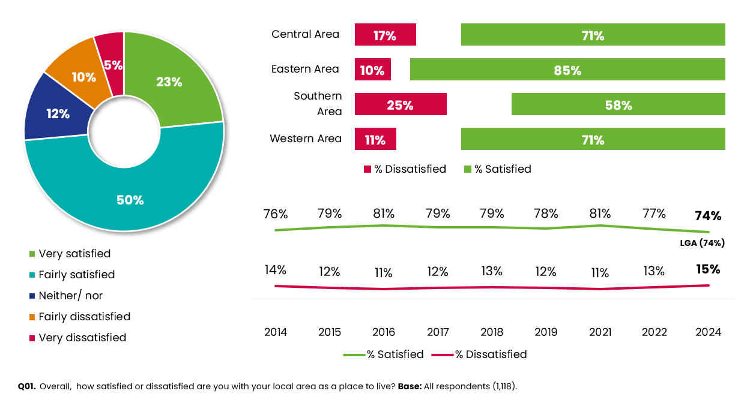
By area, dissatisfaction with their local area is greatest amongst those living in the Southern area (25%). Dissatisfaction also corresponds with deprivation, with dissatisfaction highest amongst those living in the most deprived communities (28% in IMD 1) and lowest in the least deprived communities (8% and 9% respectively in IMD 4 and 5).
Looking at other profiles of residents, those who have a life limiting illness or disability who are also less positive (18% are dissatisfied with their local area vs. 11% without a disability).
Positivity in other key council performance indicators also influences local area satisfaction, with those who are satisfied with the council, who feel informed, or think the council provides value for money all more likely to speak more highly of their local area.

What issues are most important?
All residents were provided with a list of factors and asked which ones are most important in making somewhere a good place to live. The top three priorities for 2024 are as follows:
- The level of antisocial behaviour (49%)
- Clean streets (44%)
- Health services (42%)
The results show that the three top priorities are consistent with previous surveys, although compared with 2022, health services have moved from first to third position and for two issues importance has increased significantly since 2022:
- The level of antisocial behaviour (increased by 7 percentage points)
- Clean streets (increased by 6 percentage points)
In contrast, the importance of education provision/schools (35% in 2022 vs 30% in 2024), care and support for older people (29% in 2022 vs. 24% in 2024), care and support for the disabled (18% in 2022 vs. 13% in 2024) and job prospects (13% in 2022 vs. 8% in 2024), have all fallen by five percentage points since 2022. Please note: the 2022 figures are different to the ones quoted in the 2022 report, as we have used the tables based on five responses only.
Residents were provided with the same list of factors and asked to rate the five which they consider are most in need of improvement in their local area. In order to determine how this aligns with residents’ priorities, we have contrasted these questions into one chart below:

Figure 6: Important aspects in making somewhere a good place to live
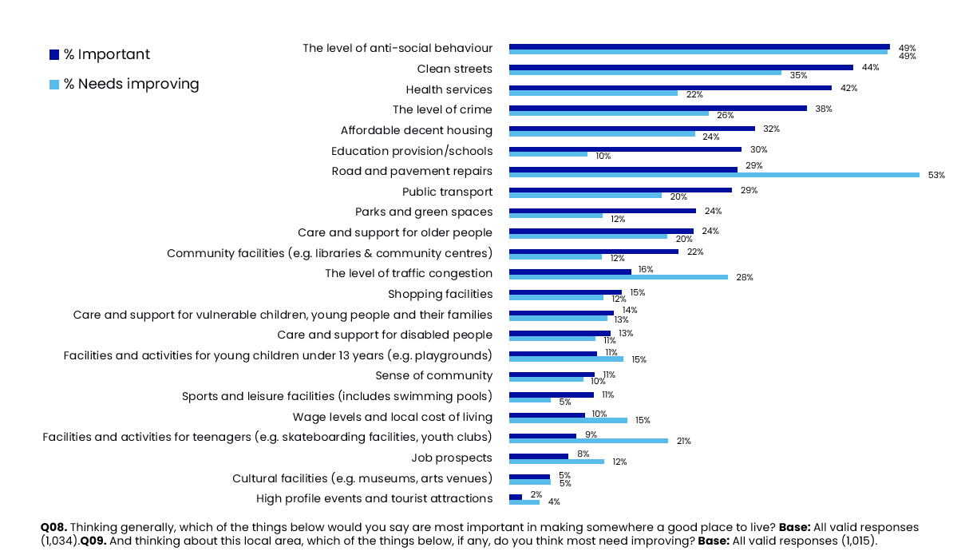
Road and pavement repairs continues to be deemed as the biggest issue requiring improvement (53%), followed by the level of anti-social behaviour (49%) and clean streets (35%).
When comparing the results to the 2022 survey, there have been significant increases in the proportion of residents that feel that improvements are needed with anti-social behaviour (up 7 percentage points) and potentially linked to this, the level of crime (up 5 percentage points).
Conversely, there has been a significant reduction in the proportion of residents who feel that the following aspects of their local area need improving:
- Wage levels and local cost of living (down six percentage points to 15%)
- Job prospects (down five percentage points to 12%)
- Shopping facilities (down three percentage points to 12%)
- Education provision/schools (down four percentage points to 10%)

Figure 7: Aspects in most need of improvement 2022 vs. 2024
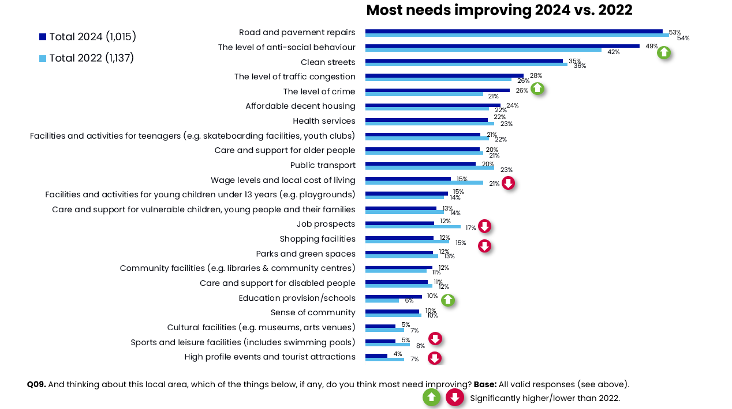
The following quadrant analysis helps to highlight priorities more clearly. The issues closest to the top right-hand corner are priority areas to focus on because they are identified as both ‘most important’ but also most in need of ‘improvement’. As Figure 8 indicates the key areas for the council to focus on are: anti-social behaviour, clean streets and road and pavement repairs.
Figure 8: Residents’ priorities - importance vs. improvement
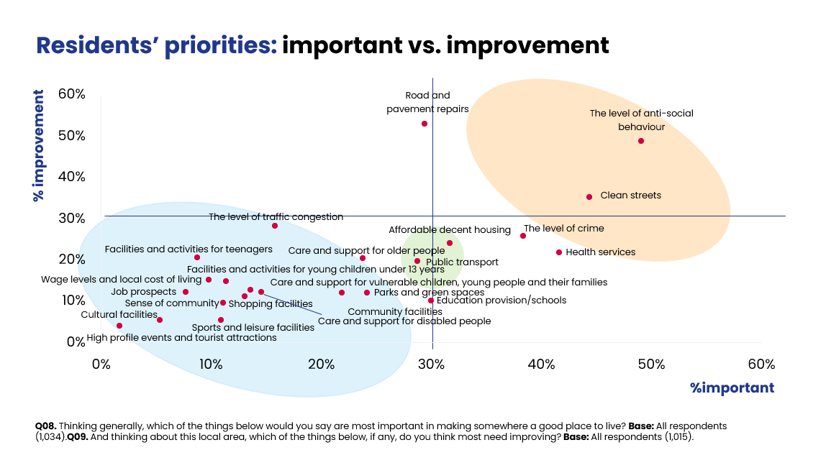
The map below shows differences in perceived improvement priorities by area. The most notable differences relate to the Southern area, with residents placing greater priority on tackling anti-social behaviour, clean streets and level of crime. Residents living in the Western area are significantly more likely to highlight public transport as an issue compared to the overall average.
Figure 9: Issues more likely to need improving by area
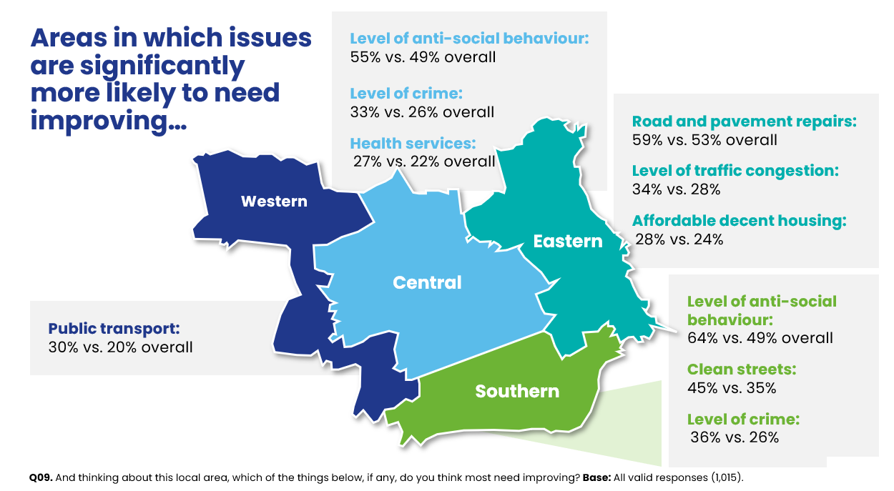

Changes to the local area in the last 12 months
All residents were asked to state whether they think their local area has got better, worse or not changed much over the last 12 months. The majority of residents (57%) think their local area has remained unchanged, although, more residents believe it has got worse (31%) than improved (12%), representing a net difference of -19 percentage points. This net difference has remained consistent with 2022 (net difference of -18 percentage points).

Figure 10: Changes to the local area over the last 12 months
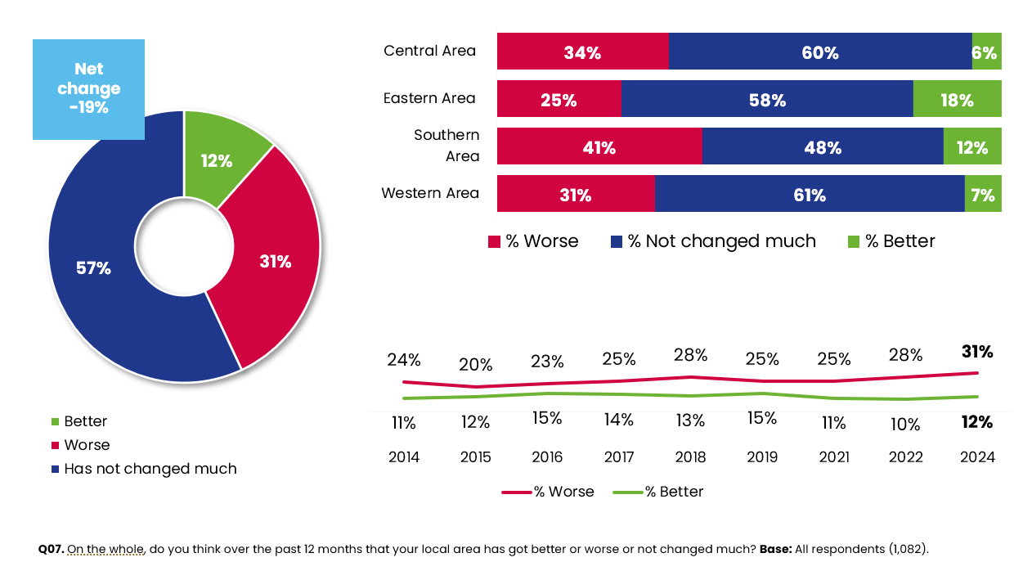

At an area level, residents living in the Southern area are significantly more likely than the average to say their local area has deteriorated (41% vs. 31% overall).
Once again, residents who are satisfied with the council’s key performance indicators (satisfaction with the council, consider the council to provide value for money and feel it keeps residents informed) are more likely than their counterparts to think their area has improved over the last 12 months.

Key drivers of satisfaction with the local area
A statistical technique called Multiple Regression was undertaken to identify the questions in the questionnaire, which together have the most influence on residents’ satisfaction with the local area. The overall goodness of fit for this model is moderate, with an R-square of 50.3%. This means that the 10 key drivers listed in Figure 11 explain 50.3% of the variance in satisfaction with the local area.
Similar to the 2022 survey, ‘The council provides value for money’ is once again the most influential factor. People who agree with this statement tend to be more satisfied with their local area and those who disagree tend to be less satisfied.
The relative importance of ‘The Council provides value for money’ is 16%. This means that it is almost twice as influential on satisfaction with the local area than the seventh driver ‘Satisfaction with parks and green spaces’ which has relative importance of 8% and nearly three times as important as ‘Refuse and waste collection’ which has relative importance of 6%.

The driver ‘Refuse and waste collection’ is ranked 10th. This means it is the least influential of all the key drivers, but it still contributes significantly to the model and has significant influence on satisfaction with the local area.

The performance scores come directly from the survey data. For example, 88% of residents agree they feel safe during the day. This is a high-performance score with the majority of residents reporting they feel safe. Ratings of value for money and agreement that people in the local area ‘pull together to improve things’ both have low performance scores, with just 39% and 42% of residents agreeing. Making improvements in both areas could potentially lead to significant improvements in residents’ satisfaction with their local area.
Figure 11: Key Drivers Analysis: Satisfaction with the local area
Rank | Question | Relative importance (%) | Performance
1 | The council provides good value for money | 16% | 39%
2 | People in the local area pull together to improve the local area | 13% | 42%
3 | Feel safe during the day | 12% | 88%
4 | Local area is a place where people from different backgrounds get on well together | 11% | 61%
5 | Satisfaction with Street cleaning | 10% | 48%
6 | I haven’t really noticed any changes to the services provided by my local council | 9% | 72%
7 | Satisfaction with parks and green spaces | 8% | 72%
8 | Satisfaction with Local libraries | 7% | 61%
9 | Satisfaction with Whitley Bay | 7% | 64%
10 | Satisfaction refuse and waste collection | 6% | 73%

Frequency of using sports and cultural services
As part of thriving North Tyneside, the Council needs to provide residents with a wide range of facilities that could be beneficial to their health and well-being, but also encourage visitors to the borough’s parks and beaches. It is therefore important to measure usage and satisfaction with each of these services.
As Figure 12 below indicates usage of parks and green spaces, beaches and play areas are broadly in line with the 2022 figures.
Figure 12: Frequency of public space usage
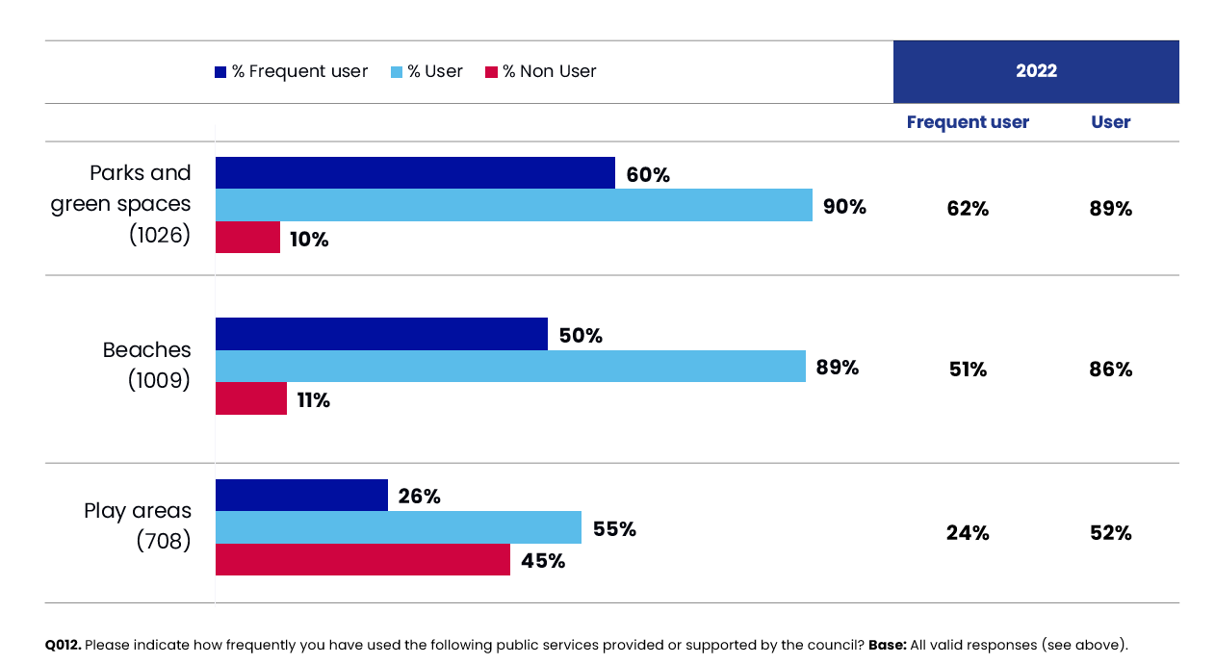
When considering these results, it should be noted that the more vulnerable and less affluent groups are less likely to use these facilities.
The key statistically significant differences are shown in Figure 13 below.

Figure 13: Sub group analysis by facility
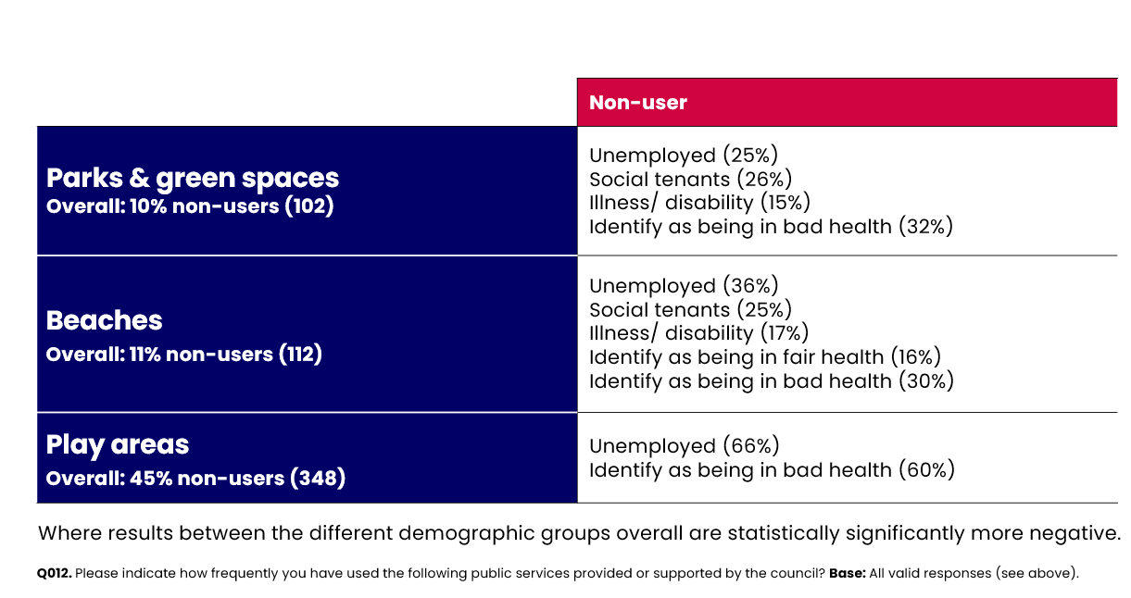
Source: DJS Research/North Tyneside Council
Base: All responses excluding It does not apply/Don’t know

Satisfaction with sports and cultural facilities
Residents were provided with a list of sports and cultural services and asked how satisfied or dissatisfied they are with each one. As can be seen in the trend lines in the chart below, beaches and parks and green spaces continue to be rated most favourably, with satisfaction levels generally consistent with 2022. The most notable change since 2022, is that satisfaction has increased significantly for local libraries from 56% in 2022 to 61% this year.
Satisfaction levels among North Tyneside residents are significantly higher than the LGA benchmarks for libraries (61% vs. 53% LGA benchmark) and sports and leisure services (62% vs. 50% LGA benchmark).
Figure 14: Satisfaction with sports and cultural facilities over time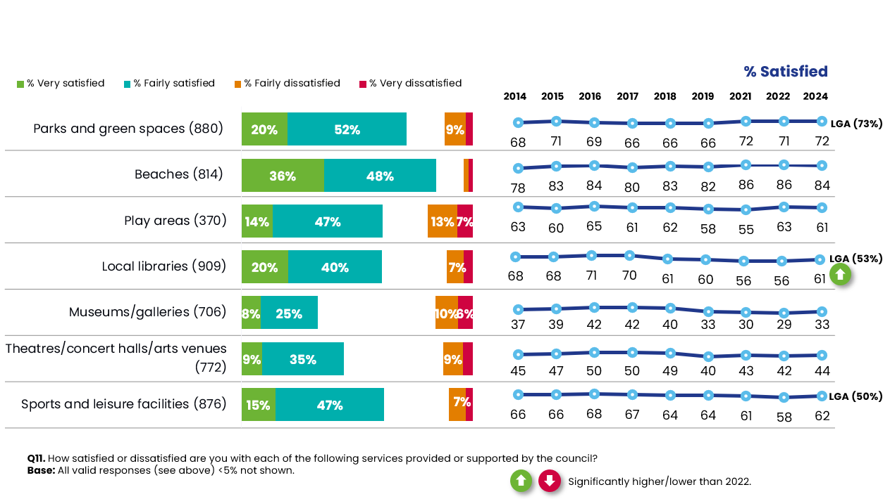
Residents living in the Eastern area are more likely to be satisfied with a number of facilities including parks and green spaces (80% vs. 72% overall), play areas (70% vs. 61% overall) and sports and leisure services (69% vs. 62% overall).
Residents living in the Western area are less likely to be satisfied with local libraries (52% vs. 61%) and sports and leisure facilities (51% vs. 62%).
When looking at dissatisfaction levels, residents living in the Southern area are more likely to be dissatisfied with parks and green spaces (17% vs. 12% overall) and play areas (34% vs. 19% overall).
There are no significant differences amongst residents living in the Central area.
Town centres
Frequency of visits to the town centre
There are four towns within the borough of North Tyneside. Whitley Bay in the East, North Shields in the South, Killingworth in the West and Wallsend in the Centre.
The survey asked residents how often they visited each of these four town centres. Whitley Bay has the highest footfall, with more residents visiting at least once a week (27%). In total, 20% have never visited Killingworth and 14% have never been to Wallsend. This compares to 6% and 3% respectively for North Shields and Whitley Bay.
Figure 15: Frequency of visits to the town centres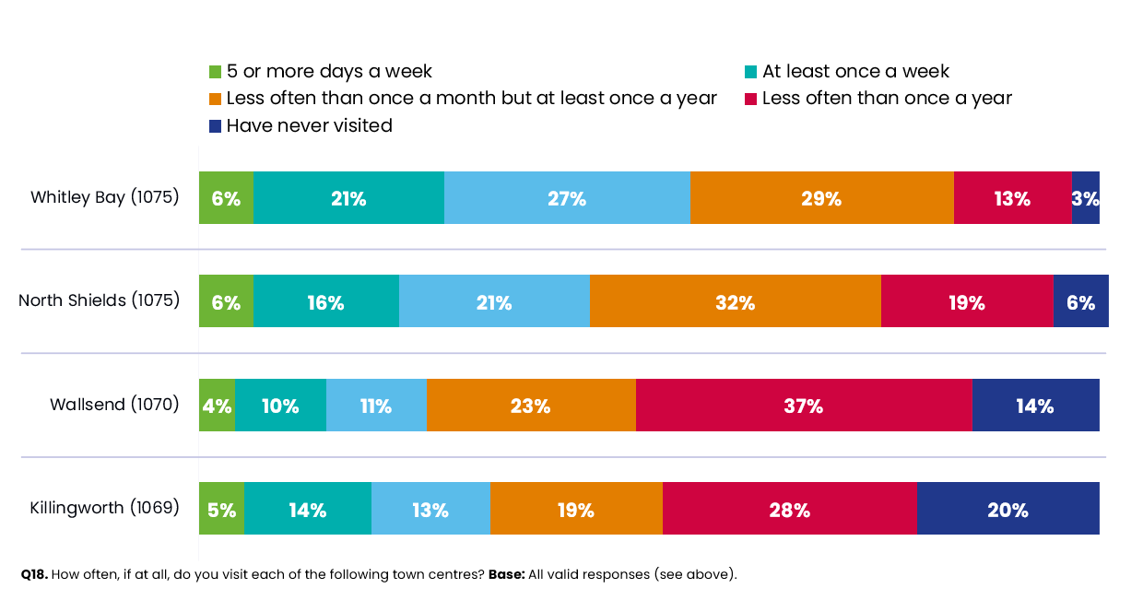
Although, it should be noted that proximity to these town centres is likely to play a part as demonstrated in Figure 16 below. For example, weekly visitors to Whitley Bay are more likely to live in the Eastern part of the borough.
Figure 16: Visitor locations
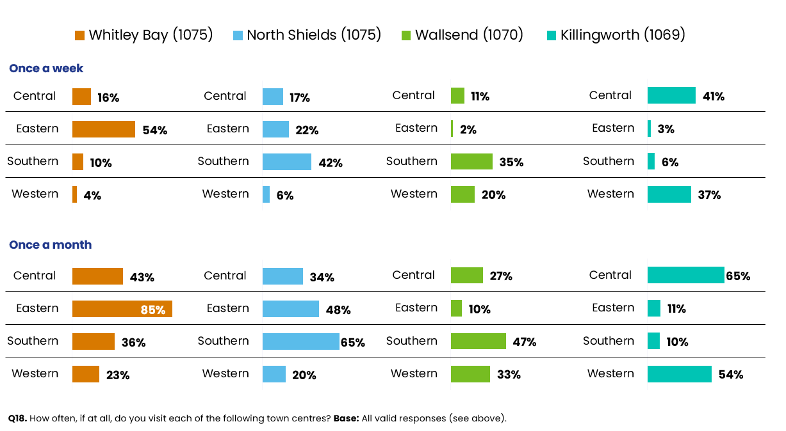

Purpose of visits to town centres
The main reason for visiting each of the four town centres is for shopping. Although, in Whitley Bay in particular, significant proportions of residents appear to visit the town centre for other reasons. For example, 65% visit the town centre for its bars, restaurants and other venues. 44% also choose to visit Whitley Bay for entertainment and leisure.
Compared to the 2022 survey, the proportion of residents visiting North Shields, Wallsend and Killingworth for shopping has decreased significantly. Whilst in Whitley Bay there has been a sharp decline in the proportions visiting bars/restaurants, professional services or for health care.
Figure 17: Purpose of visit to town centre
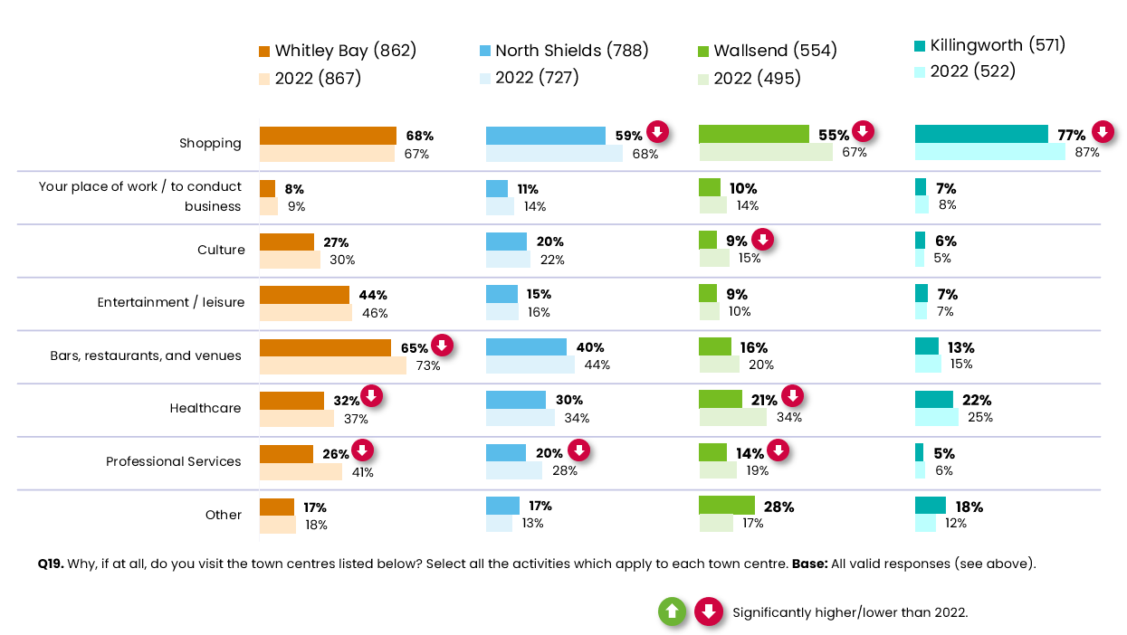

Satisfaction with town centres
Residents were asked how satisfied or dissatisfied they are with the town centres they have visited.
Satisfaction levels are highest for Whitley Bay, with almost two thirds of residents (64%) stating they are satisfied. Around one half of residents (52%) are satisfied with Killingworth. Satisfaction levels are lowest for North Shields (32%) and Wallsend (24%).

Figure 18: Satisfaction with the town centres
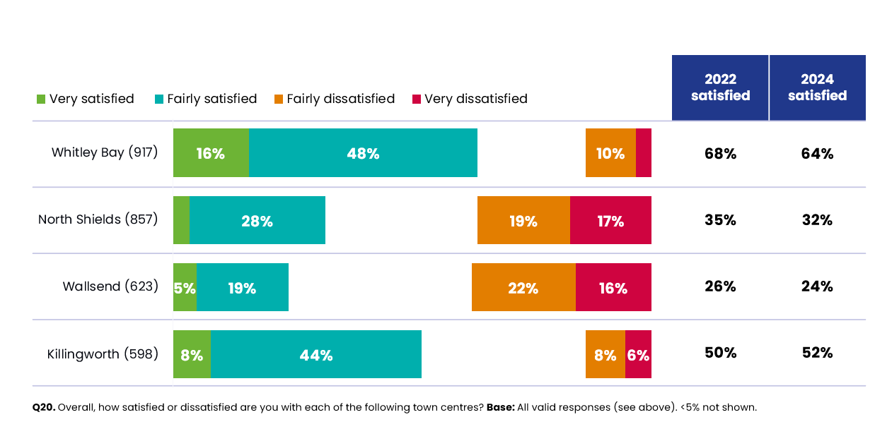
Economic opportunity

Current employment and location
Overall, 59% of survey respondents are in employment. Of these, the largest proportion (44%) work full time, a further 9% work part time, 1% are on zero hours’ contracts and the remaining 5% are self-employed. In addition, 3% are unemployed and 32% are retired. This profile is very similar to the 2022 survey.
When asking those in employment for more details, the largest proportion of survey respondents (27%) work in professional occupations (e.g. solicitors, teachers, doctors, accountants). A further 18% are managers and senior officials. This is closely followed by 16% working in associate professional and technical occupations (e.g. science and engineering technicians, estate agents, journalists).
Around four in ten (43%) work within the borough and a quarter (28%) travel to Newcastle-upon-Tyne. Work locations have remained fairly consistent with the 2022 survey.

Figure 19: Types and location of employment
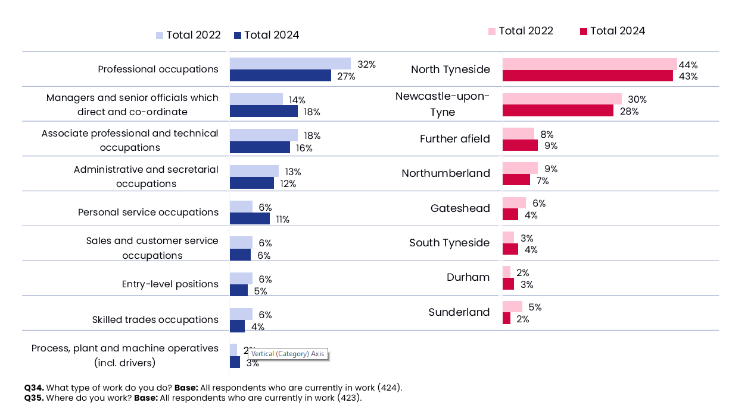

A Secure North Tyneside
The ‘Our North Tyneside Plan 2021-2025’ outlines that a ‘Secure North Tyneside’ will consist of the following:
- Council wardens will work in partnership with Northumbria Police to prevent and tackle all forms of antisocial behaviour.
- We will continue to invest £2m per year in fixing our roads and pavements.
- We will maintain the Council Tax support scheme that cuts bills for thousands of households across North Tyneside.
- We will tackle health and socio-economic inequalities across the borough including through our Poverty Intervention Fund to tackle food poverty.
- We will provide 5,000 affordable homes.
This section of the report focuses on residents’ perceived safety in their local area and their satisfaction with certain aspects (such as roads and pavements and housing). This section also covers socio-economic and health inequalities.

Section summary
All residents were asked how safe or unsafe they feel when outside in their local area during the day and after dark. The proportion of residents who feel safe during the day (88%) remains consistent with the 2022 survey. In contrast, only half of residents (49%) feel safe after dark and residents in the Southern area are significantly less likely to feel safe. Overall, following the downward trend in this measure from 2015 to 2021, it now looks like the trend has started to move in a more positive direction.
Residents’ satisfaction with environmental services remains consistent with 2022. However, satisfaction with street cleaning, road and pavement maintenance within North Tyneside are all significantly lower than the LGA benchmarks.
Satisfaction with the choice and quality of housing remains relatively stable (60% and 61% respectively). Although, satisfaction levels for both measures are significantly lower amongst residents living in the Southern area and higher than average in the Eastern area.
When asked about their income, the majority of residents state that they are living comfortably or coping on their present income but 17% are finding it difficult. Since 2022, the proportion of residents who consider themselves to be comfortable or coping financially has increased by four percentage points (from 79% to 83%). This is a significant improvement.
Despite a slight decrease (four percentage points to 40% this year) in the proportion of residents affected by the current economic climate, at least nine in ten residents are taking action to make savings. Younger residents, those with an illness or disability and those in Southern or Central areas are among those more likely than residents on average to be facing challenges because of the current economic climate.
The most common changes relate to spending less on non-essentials (61%), shopping around more (56%) and using less fuel (such as gas or electricity) to heat their homes (51%), although this does appear to be due to the proportions taking several of these measures declining since 2022. This is particularly the case for using less fuel such as gas or electricity to heat their homes. This has decreased by 26 percentage points to 51% (vs. 77% in 2022).
The results also indicate other effects of the current economic climate, with 20% not being able to afford a holiday. This is closely followed by 19% experiencing difficulties with paying fuel and energy bills. However, compared with 2022, significantly fewer residents are facing these challenges, which is consistent with the significant improvement in the proportion of residents managing on their current income.

Since 2022, little change has been noted in self-reported health, with 65% claiming they have either good or very good health. The results indicate that residents in vulnerable groups are much more likely to have poor self-reported health, particularly those who are unemployed (43% vs. 9%) and social tenants (33%). Similarly with exercise level scores, 44% of North Tyneside residents state that they do the recommended 150 minutes of exercise or more per week. Residents aged 18-34 are doing significantly less than the recommended amount of exercise per week (36% vs. 44% overall).
In terms of wellbeing, the majority of residents score between 21-30 points out of a maximum of 35 points, with 3% scoring above 30 points; indicating a high level of mental well-being. Scores of 20 or less indicate a low level of mental well-being, with 41% of residents falling within this range. The average well-being score amongst all residents in 2024 is 22.3 out of a maximum of 35 points.
Overall, 8% of survey respondents stated that they feel lonely or isolated where they current live most or all of the time. Residents aged 18-34 (16% vs. 8% overall) and unemployed (33%) are more likely to feel isolated most/all of the time.
Maintaining a secure North Tyneside also includes ensuring that there is a sufficient supply of jobs and apprenticeships for residents. Overall, of those that provided a rating, satisfaction is highest for the availability of jobs, with just over a quarter of residents (26%) stating they are satisfied with this aspect, yet around one third are dissatisfied. This compares to only 14% of residents satisfied with the opportunities for work placements, apprenticeships and training for 16-24 year olds and more than two fifths dissatisfied.

Perceptions of safety
All North Tyneside residents were asked how safe or unsafe they feel when outside in their local area during the day and after dark. The proportion of residents who feel safe during the day (88%) remains consistent with the 2022 survey.
In contrast, only half of residents (49%) feel safe after dark. Following a downward trend in this measure from 2015 to 2021, it now looks like the trend has started to move in a more positive direction.

Figure 20: Feeling safe in your local area
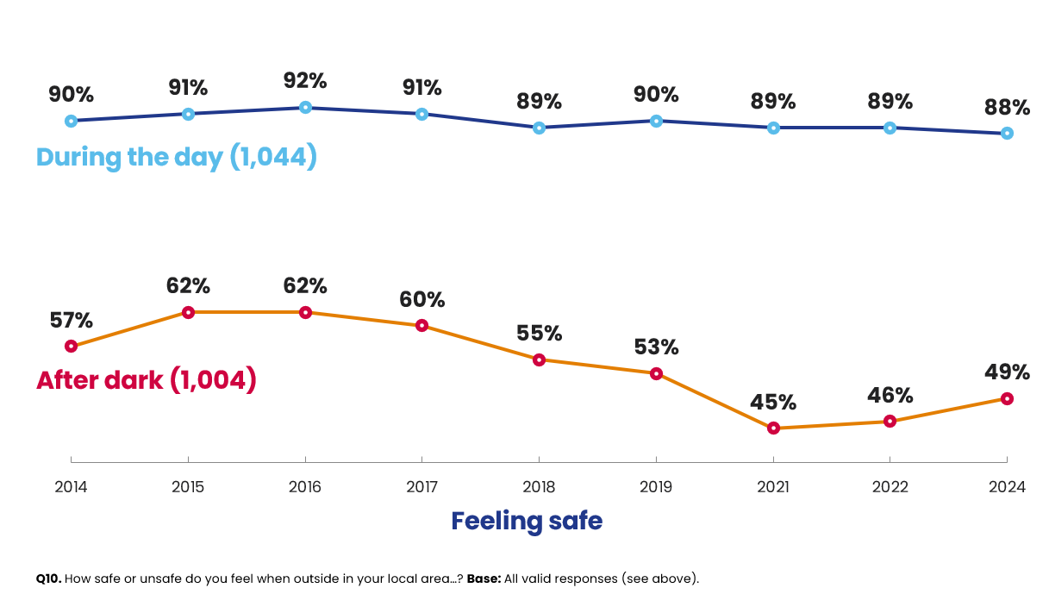
Similar to previous surveys, residents living in the Southern area (46% vs. 31% overall) are significantly more likely than average to feel unsafe after dark.
When looking at the differences in the proportions that feel unsafe after dark by sub group, the 2024 results indicate the following significant differences:
- Females (37% vs. 24% of men).
- Those with a self-reported illness or disability (36% vs. the borough average of 31%).

Figure 21: Feelings of safety after dark by area
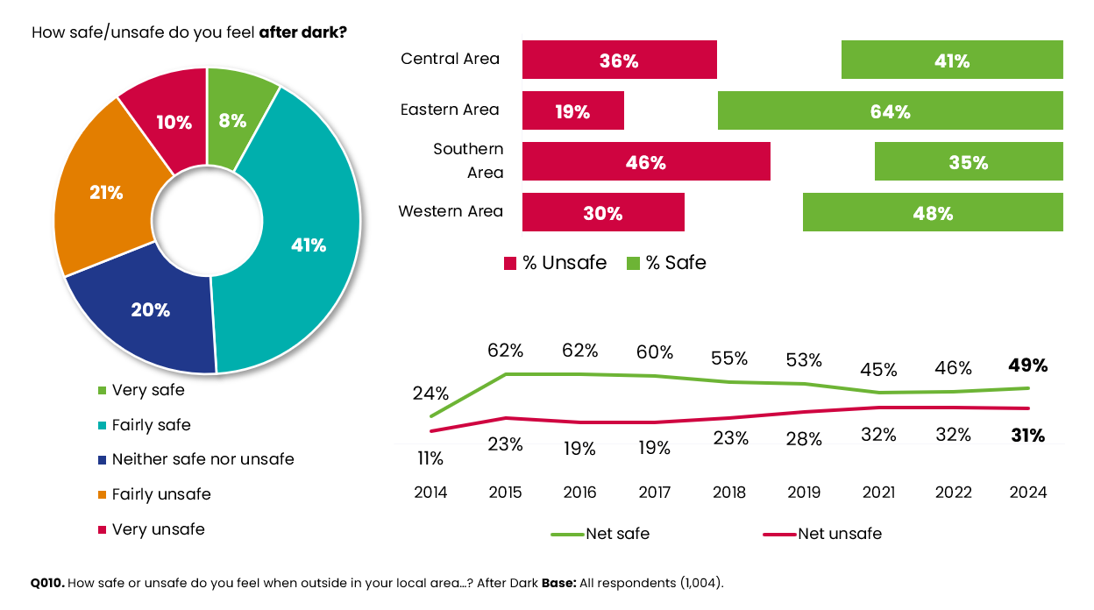
Roads and Pavement Maintenance
Ensuring there is sufficient investment in roads and pavements is another key objective of a ‘Secure’ North Tyneside.
Satisfaction with environmental services
For the purposes of this section, environmental services consists of the following:
- Street lighting
- Upkeep of grass verges
- Street cleaning
- Winter maintenance
- Road maintenance
- Pavement maintenance
When looking at the above aspects of environmental services, the latest survey results indicate a similar picture to the 2022 survey, with relatively low levels of satisfaction with both road and path maintenance and no significant changes in any measures since 2022.
Only 22% of residents are satisfied with pavement maintenance; which is significantly lower than the LGA benchmark figure of 44%.
Whilst satisfaction with road maintenance is slightly higher (26%) it is also slightly lower than the latest LGA figure of 30%.
Under a half of residents (45%) are satisfied with winter maintenance. This is on par with that of street cleaning (48%), which also remains well below the LGA benchmark (57%).
Figure 22: Satisfaction with environmental services
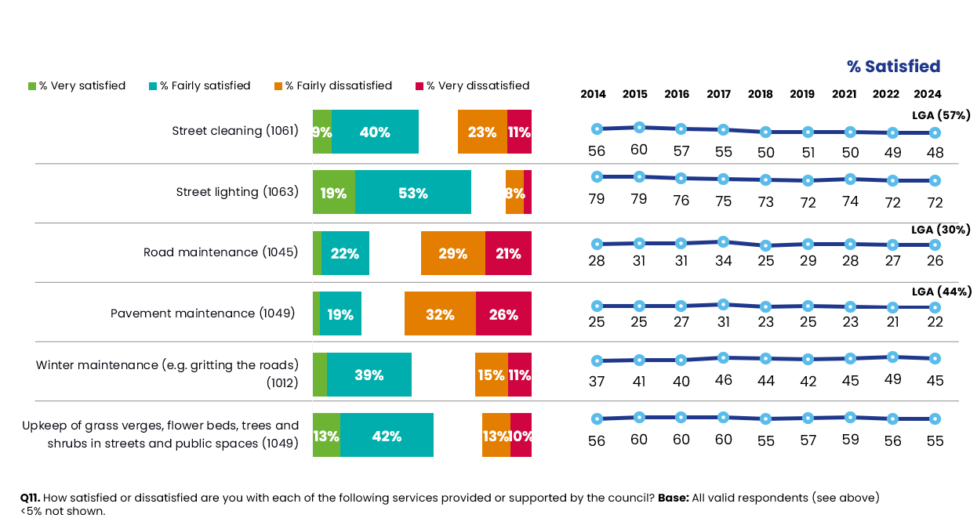
Analysis by area indicates some significant differences with environmental services:
- Residents living in the Southern area are significantly less satisfied with street cleaning compared to the overall borough (36% vs. 48% for the overall borough). Those living in the Eastern area are notably more satisfied with this service (53%).
- There is also a similar picture when looking at street lighting, with 77% satisfied in the Eastern area but this drops to 61% amongst those living in the Southern area (overall average is 72%).
- Residents living in the Eastern area are significantly more likely to be satisfied with the upkeep of grass verges, flower beds, trees and shrubs in streets and public places (62% vs. 55% overall). Satisfaction levels are significantly lower amongst residents living in the Southern part of the borough (45%).
- Residents in the Central area are significantly more likely to be satisfied with pavement maintenance (27% vs. 22% overall). In contrast, residents living in the Eastern area are significantly less likely to be satisfied (18%).

Housing
As the cost-of-living crisis continues to put pressure on household incomes, affordable housing is growing as a priority across the UK. The council is committed to building 5,000 affordable homes this year (2025).

Satisfaction with choice and quality of housing
The latest results indicate that housing status has remained fairly consistent since 2022. The only notable change is the proportion of homeowners (either owning their home outright or on a mortgage) has increased by four percentage points to 79% since 2022.
Social tenants account for 12% of survey respondents (9% from the council and 3% from a Housing Association/Trust) and almost one in ten (8%) are private tenants. These results are similar to previous years.
Analysis by area indicates that residents living in the Eastern area are significantly more likely to be home owners (90% vs. 79% overall). The Southern area continues to have a higher proportion of social tenants at 27%, compared to 12% overall.
All residents were asked how satisfied or dissatisfied they are with the choice and quality of their housing. Six in ten state they are satisfied with the choice (60%) and quality (61%) of the housing in their local area. Both of these figures are consistent with the 2022 survey.
Figure 23: Satisfaction with choice and quality of housing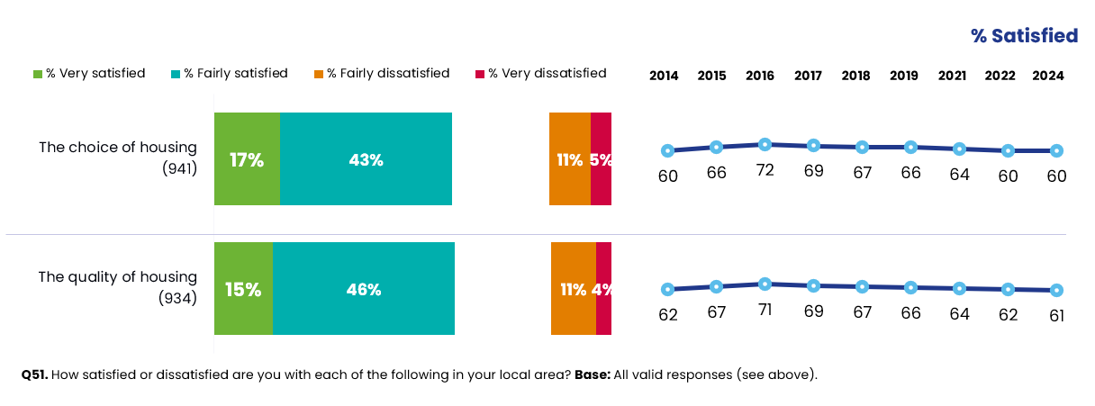
Analysis by subgroup indicates some statistical differences by area:
- As in previous surveys, residents living the Southern area feel the most negative about the choice (41% vs. 60% overall) and the quality of housing (40% vs. 61% overall) in their local area.

- In contrast, satisfaction is significantly higher than average amongst residents living in the Eastern area, with 70% satisfied with the choice and 73% satisfied with the quality.

- Private tenants are more likely to be dissatisfied with the choice of housing available (35% vs. 16% overall). Social tenants are also less likely than the overall population to be satisfied with housing choice (48% vs. 60%). Owner-occupiers remain significantly more satisfied than the general borough population (64% vs. 60% overall).

- Those who feel most satisfied with the choice of housing are also more satisfied with the council in general (74% vs. 60%), feel more informed about the council’s activities (67%) and consider the council to provide value for money (75%).
Socio-economic inequalities
Tackling social inequality remains a core focus for the ‘Our North Tyneside Plan 2021-2025’.

Personal financial circumstances in the last 12 months
Overall, four in ten residents appear to be affected by the current economic climate. This has decreased slightly since the last survey from 44% in 2022 to 40% in 2024.
The effects of the current economic climate have been particularly noticed by residents not being able to afford a holiday (20%), this is closely followed by 19% experiencing difficulties with paying fuel and energy bills. Both of these have decreased by four percentage points since 2022; which are both signifiTgcant differences.

Figure 24: Personal circumstances over the last 12 months
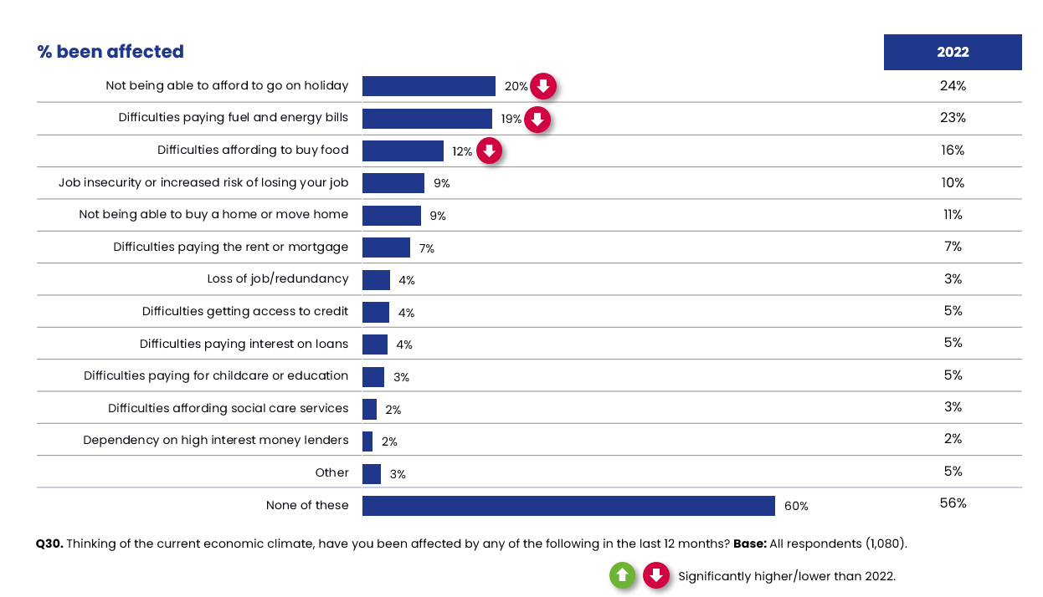
Figure 25 indicates that certain demographic groups have been significantly more affected by the economic climate than others. These demographic groups include: those aged 18-44, have a long term illness or disability, live in either the Southern or Central areas or have children.
Figure 25: Demographic groups most affected by the economic climate in the last 12 months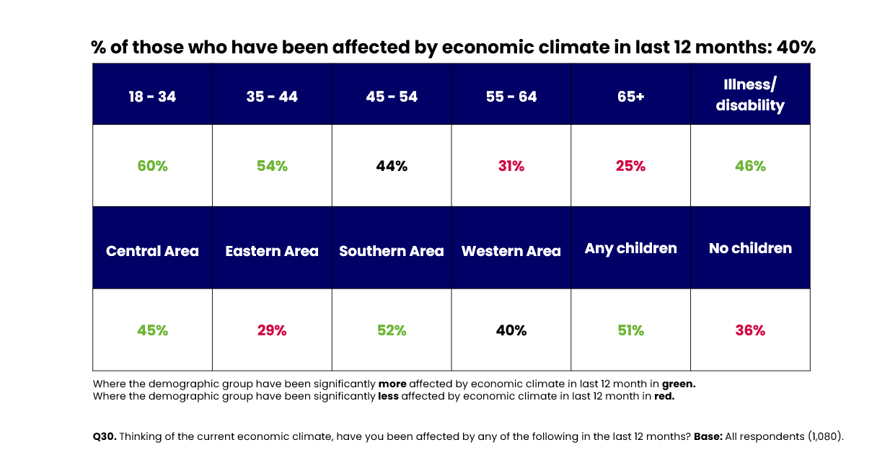

When exploring these differences in more detail, we see that:
- Residents aged 18-34 are more likely to be struggling financially compared to the average. In particular, these residents have been more negatively impacted by job insecurity or increased risk of losing their jobs (19% vs. 9% overall), difficulties affording to buy food (17% vs. 12%) and not being able to go on holiday (31% vs. 20%).

- Households with children are more likely to not be able to afford to go on holiday (32% vs. 20% overall), have difficulties paying fuel and energy bills (23% vs. 19% overall), have difficulties affording to buy food (15% vs. 12%) and experiencing job insecurity or an increased risk of losing their job (13% vs. 9%).
Figure 26: Challenges experienced as a result of the current economic climate by demographic group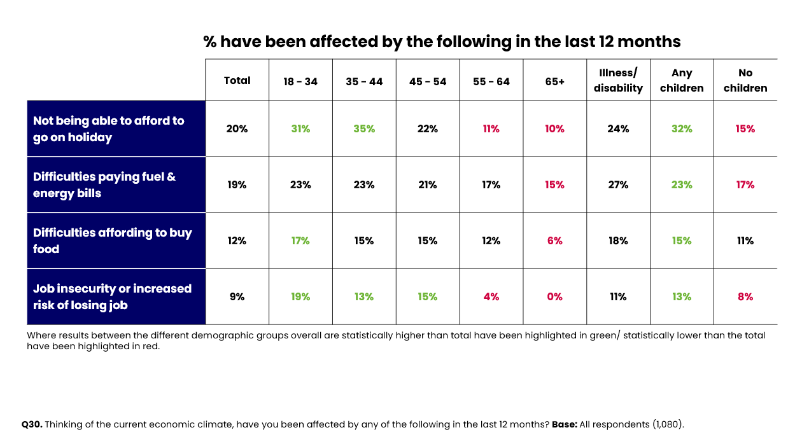
Source: DJS Research/North Tyneside Council
Base: All responses excluding It does not apply/Don’t know. Significant differences compared to the overall average are shown in red.

Financial well-being
Due to the cost-of-living challenges that the country continues to face, the survey included some questions relating to residents’ financial well-being.
Firstly, residents were asked how they felt about their current level of income. The majority of residents (83%) consider themselves to be living comfortably or coping on their present incomes. The remaining 17% are finding it difficult or very difficult. Since 2022, the proportion of residents who consider themselves to be comfortable or coping financially has increased by four percentage points (from 79% to 83%). This is a significant improvement.
As a result of the increased cost of living, at least nine in ten residents are taking steps to make savings if possible. The most common changes relate to spending less on non-essentials (61%), shopping around more (56%) and using less fuel (such as gas or electricity) to heat their homes (51%).
Just under four in ten (38%) are spending less on food shopping and essentials. Around a quarter (28%) are cutting back on non-essential journeys in their vehicles.
Although, it does appear that the proportions taking several of these measures has declined since 2022. This is particularly the case for using less fuel such as gas or electricity to heat their homes. This has decreased by 26 percentage points to 51% (vs. 77% in 2022).
Figure 27: Present income and actions due to the cost of living
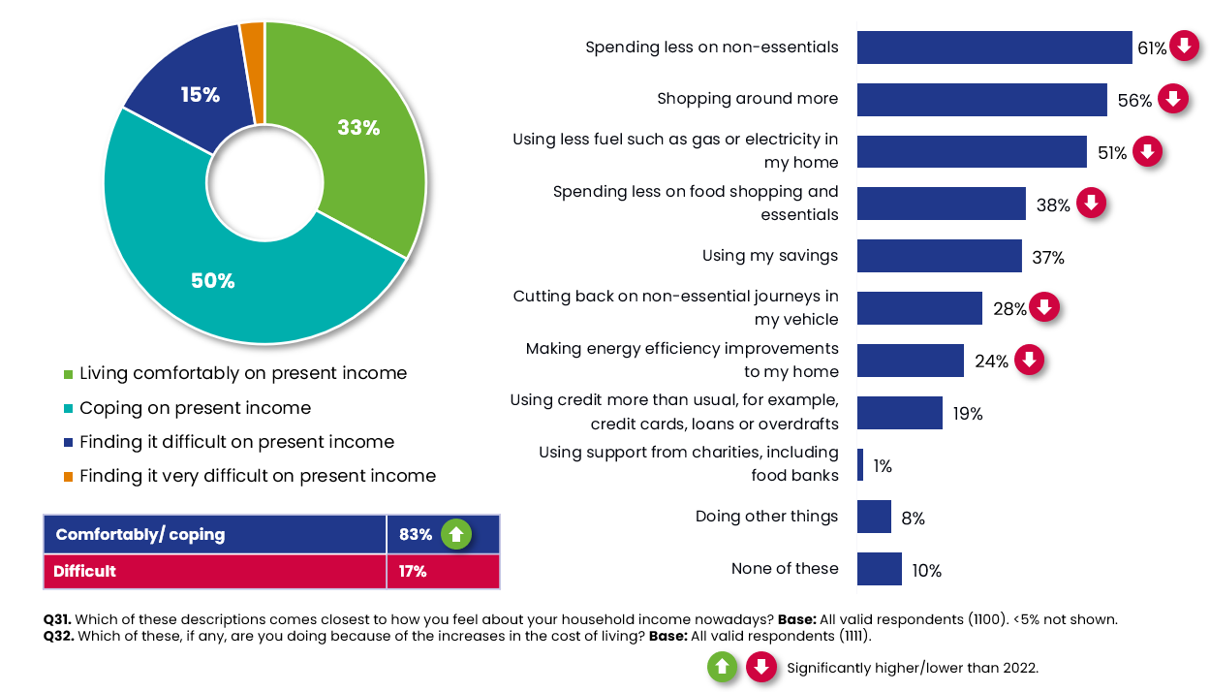
Those who are unemployed (46% vs. 17%), social tenants (35%), live in the Southern area (27%) and are carers (23%) are significantly more likely than residents on average to say they are finding it difficult on their present income.

Self-reported health
Two thirds (65%) of residents consider their health to be ‘very good’ or ‘good’. This has remained fairly consistent with the 2022 survey.
The results by area indicate that residents living in the Eastern area are more likely to report their health as ‘good’ (71% vs. 65% overall). In contrast, those living in the Southern area are most likely to say they have bad health (14% vs. 9% overall).
Figure 28: Health in general
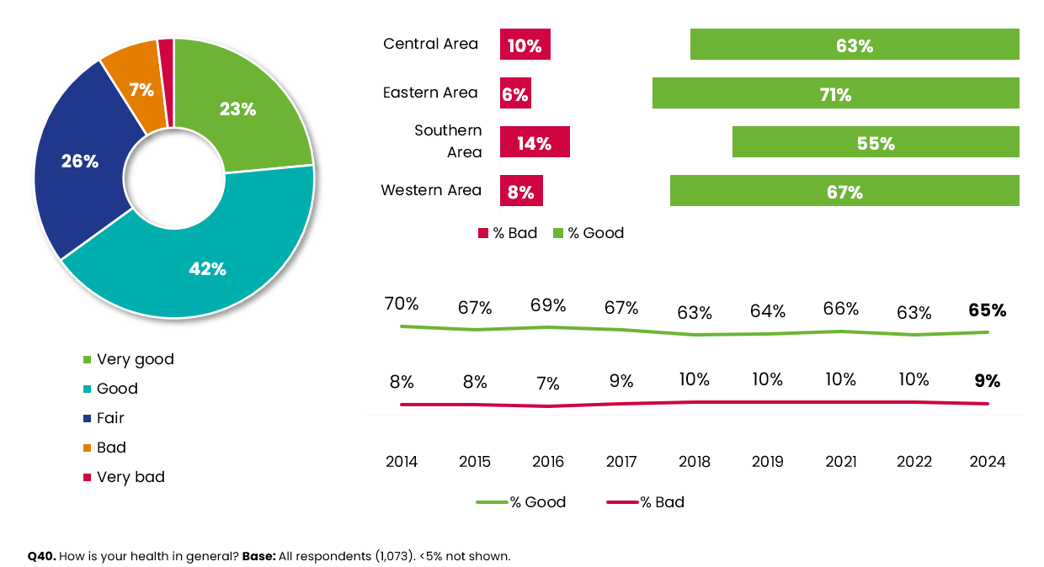
When looking at self-reported health by subgroup, the results indicate that residents in vulnerable groups are much more likely to have poor self-reported health. The most notable differences versus the average (9%) are:
- Those who are unemployed (43%)
- Social tenants (33%)
- Those living with an illness or disability (25%)
- Residents aged 65+ (13%)
- Retired residents (12%)
In contrast, homeowners are more significantly more likely to say they have good health (70% vs. 65% overall). The same is also true amongst residents who claim to be financially comfortable (82% vs. 65%).

Exercise
Overall, 44% of residents are getting the recommended 150 minutes or more of moderate physical activity per week. This has remained consistent with the 2022 figure of 42%.
Figure 29: Amount of exercise in an average week
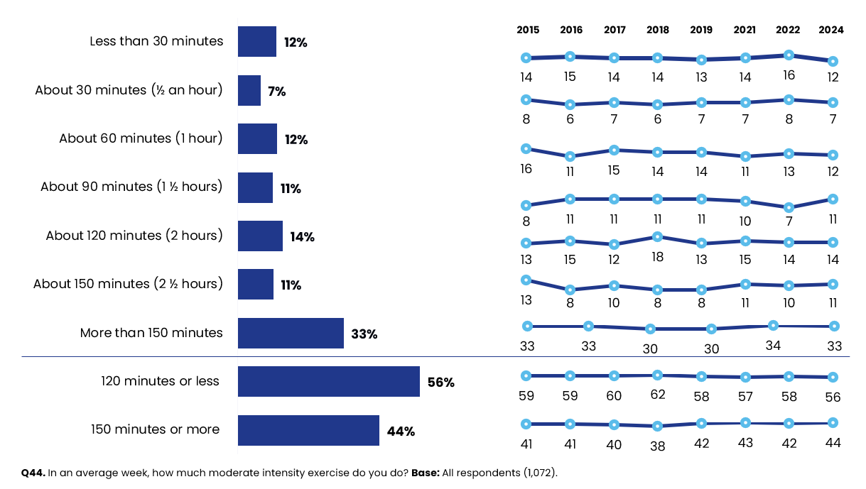
It should be noted that there are some variations between different demographic groups. The most notable are as follows:
- Residents aged 18-34 are doing significantly less than the recommended amount of exercise per week (36% vs. 44% overall). This is also the case for those who are unemployed (17%), have a long-term illness or disability (35%) and social tenants (29%).

Mental health and well-being
The survey included the seven statements from the Warwick Edinburgh Mental Well-being Short Scale (SWEMWBS). These seven statements were used to calculate an overall (mean) well-being scale. All residents were asked to indicate how frequently they have experienced certain feelings over the last two weeks. The scale ranged from 1 (none of the time) to 5 (all of the time). Scores range from 7 to 35. Higher scores indicate higher positive mental well-being.
The seven statements that contribute to the SWEMWBS index score are presented in Figure 30 below:
Figure 30: Mental health and well-being statements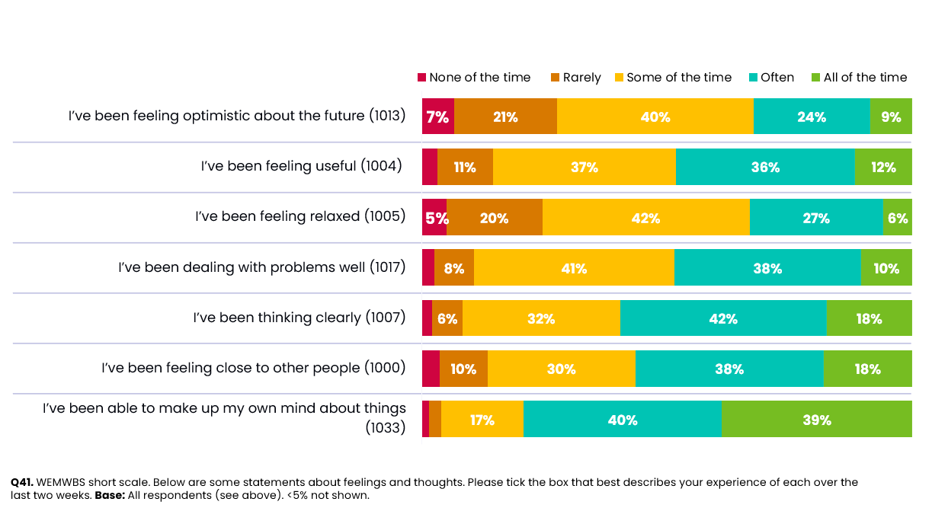
The pie chart below shows the range of scores calculated from these combined statements. The majority of residents score between 21-30 points out of the 35, with 3% scoring above 30 points; indicating a high level of mental well-being. Scores of 20 or less indicate a low level of mental well-being, with 41% of residents falling within this range. The average well-being score amongst all residents is 22.3 out of a maximum of 35 points.
Figure 31: Mental health and well-being scores
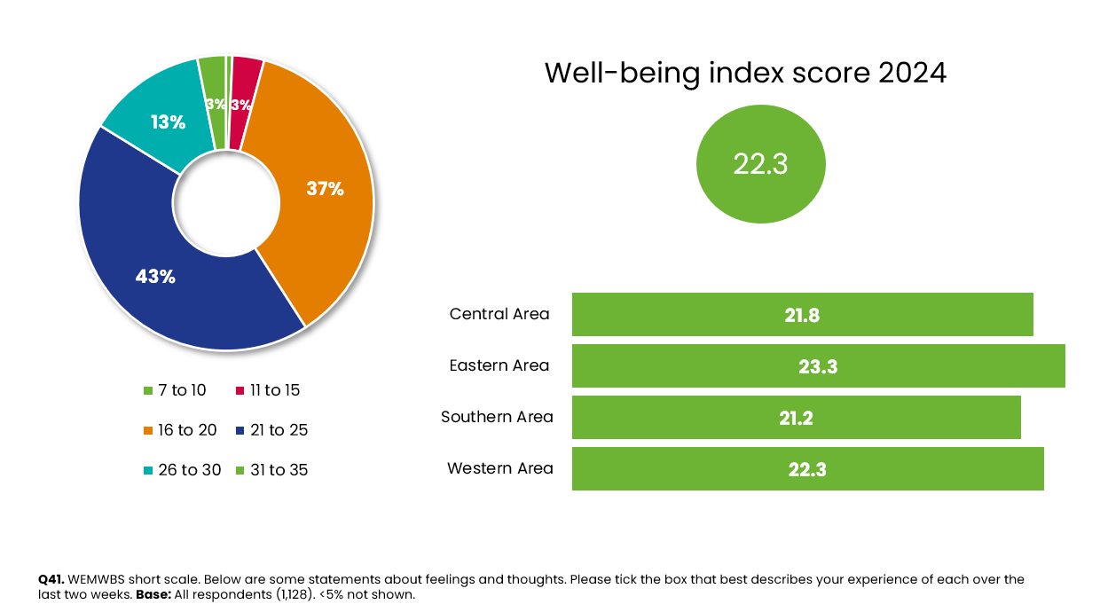
Figure 32 below highlights how levels of wellbeing vary between different demographic groups. Notably, well-being scores are lower amongst those who are unemployed (19.1 vs. 22.3 overall) and social tenants (20.0).
Figure 32: Health and wellbeing by demographics
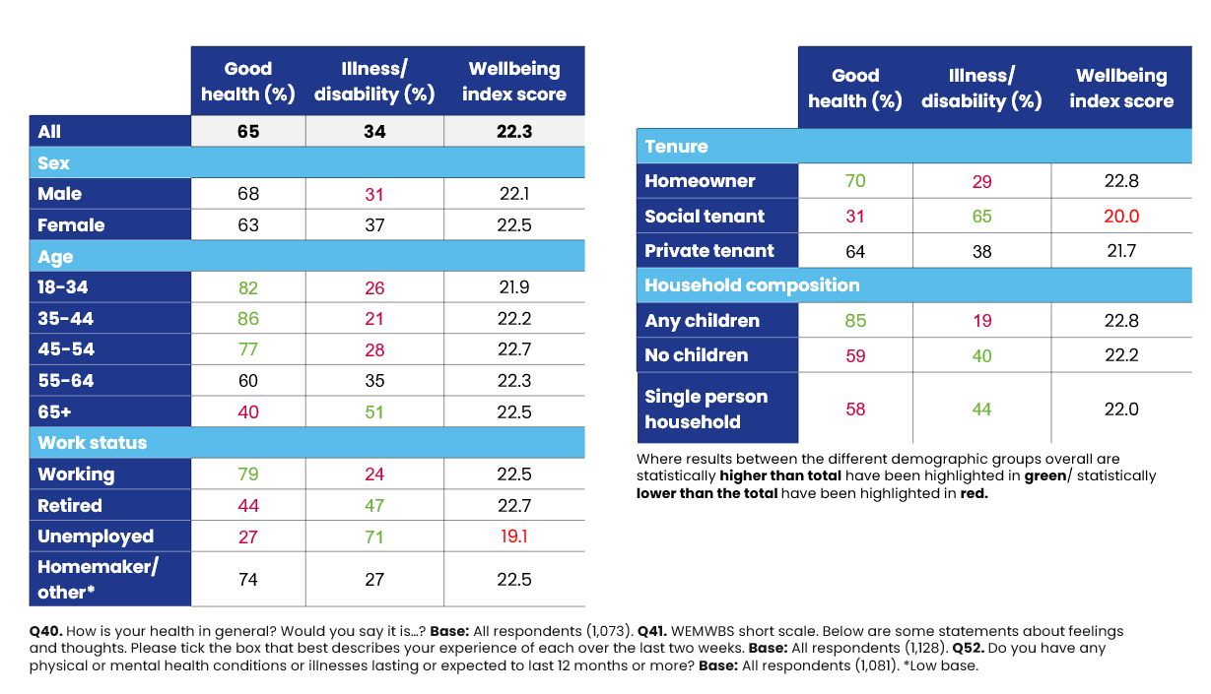

Loneliness and isolation
All residents were asked two questions in relation to social isolation. Overall, 8% of survey respondents stated that they feel lonely or isolated where they current live most or all of the time. A quarter of residents (23%) report these feelings some of the time. Both of these results are consistent with the 2022 survey.
Linked to this, residents were asked if they had anyone they really count on to help them. 7% said ‘No’ which is in line with the 2022 survey (8%).

Figure 33: Feelings of loneliness and isolation
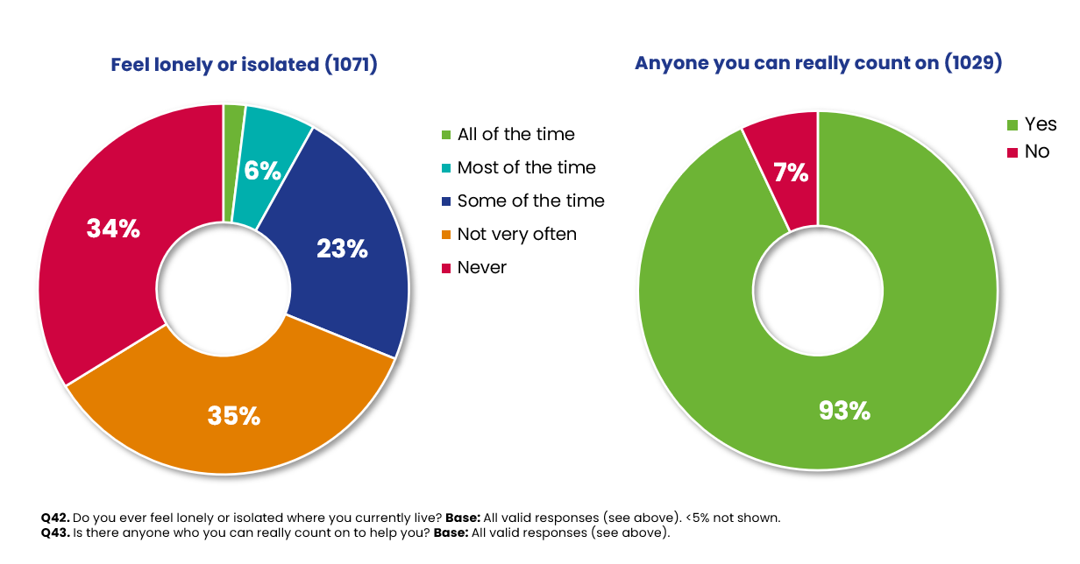
Analysis by sub-group indicates that:
- Residents aged 18-34 (16% vs. 8% overall) and unemployed (33%) are more likely to feel isolated most/all of the time. The same is true amongst residents living in the Southern area (14%) and those with an illness or disability (15%).

- Those with an illness or disability are more likely to say they have nobody they can count on (12%, vs. 7% overall), it is a similar case for single person households (13%).

Satisfaction with employment opportunity
Maintaining a secure North Tyneside also includes ensuring that there is a sufficient supply of jobs and apprenticeships for residents.
Overall, of those that provided a rating, satisfaction is highest for the availability of jobs, with just over a quarter of residents (26%) stating they are satisfied with this aspect, yet around one third are dissatisfied. This compares to only 14% of residents satisfied with the opportunities for work placements, apprenticeships and training for 16-24 year olds and more than two fifths dissatisfied.

Figure 34: Satisfaction with employment opportunity
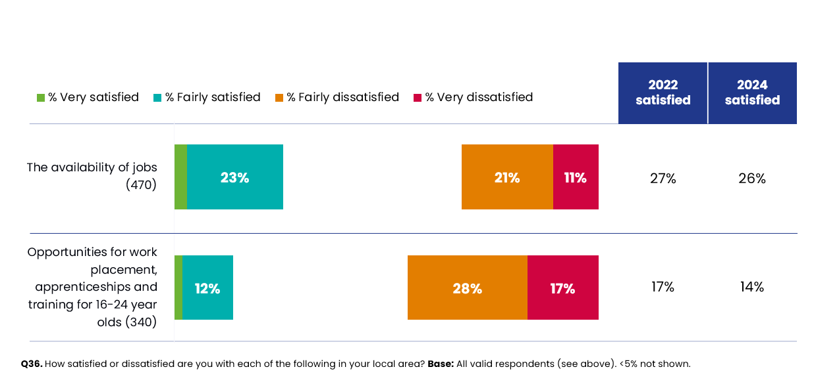
Analysis by sub-group indicates the following significant differences:
- Females are significantly more likely to be satisfied with the availability of jobs (35% vs. 17% males). Satisfaction is also higher than average amongst those aged 45-54 (33% vs. 26% overall) and those in the higher SOC job bands (32% vs. 26% overall).

- Looking at the opportunities for work placements we see a similar sentiment, with females significantly more satisfied than males (22% vs. 7% males).

A Family Friendly North Tyneside
The ‘Our North Tyneside Plan 2021-2025’ outlines that a ‘Family Friendly North Tyneside’ will consist of the following:
- We will support local schools, making sure all children have access to a high-quality education with opportunities to catch up where needed after the pandemic.
- We will provide outstanding children’s services, events and facilities so North Tyneside is a great place for family life.
- We will ensure all children are ready for school including through poverty proofing the school day – giving our kids the best start in life.
This section focuses on the usage and satisfaction of Children’s Services in North Tyneside.

Section summary
Service usage of Children’s Services remains consistent with previous years, with just over a quarter of residents (26% vs. 28% in 2022) using the service at least once a month and 41% of residents over the past year (37% in 2022).
User satisfaction with Children’s services has decreased since 2022, from 57% to 48% this year.

Use of Children’s services
As with previous years, the residents’ survey tracks residents’ satisfaction with Children’s services. This includes: education, children’s centres and social care.
Service usage of Children’s Services remains consistent with previous years, with just over a quarter of residents (26% vs. 28% in 2022) using the service at least once a month and 41% of residents over the past year (37% in 2022).
Compared with an average of 41% overall, users are most likely to be:
- Females (46%)
- 35-44 year olds (63%)
- Those working in North Tyneside (52%)
When looking at satisfaction levels, the latest results indicate that around half of users (48%) are satisfied with this service. This represents a decrease of nine percentage points compared to the 2022 survey. Overall satisfaction however, is in line with the LGA benchmark of 36%.
Figure 35: Satisfaction with Children's services
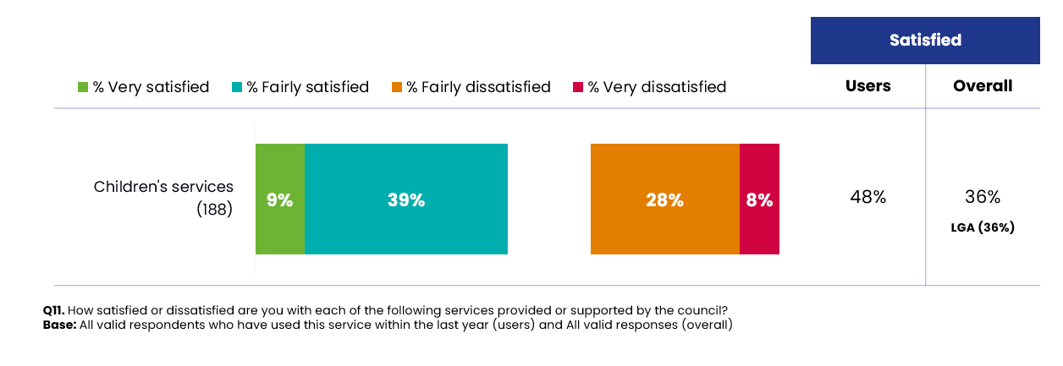
Figure 36: Satisfaction with Children's Services over time
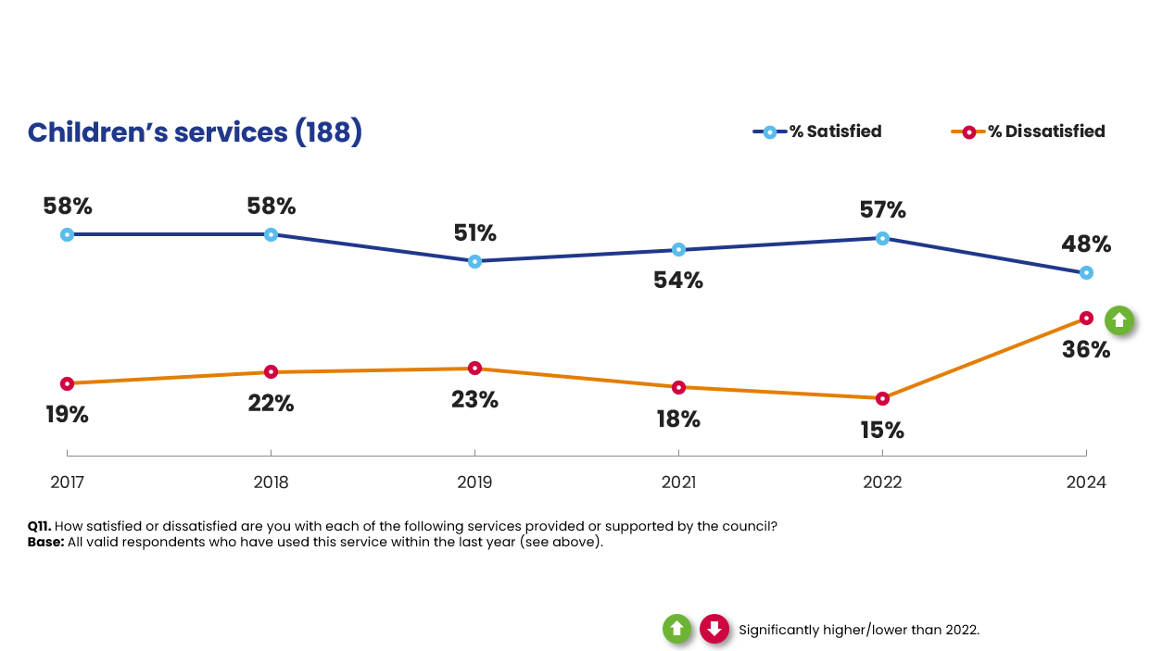

A Caring North Tyneside
The ‘Our North Tyneside Plan 2021-2025’ outlines that a ‘Caring North Tyneside’ will consist of the following:
- We will provide great care to all who need it, with extra support available all the way through to the end of the pandemic.
- We will work with the care provision sector to improve the working conditions of care workers; People will be cared for, protected and supported if they become vulnerable, including if they become homeless.
- We will support local community groups and the essential work they do.
- We will work to reduce inequality, eliminate discrimination and ensure the social rights of the people of North Tyneside are key to council decision making.
This section examines aspects of community cohesion such as the extent to which people belong to the area, mix with other residents, volunteer and how well they feel that different groups of people get on well together. This section also reports on those who care for others and satisfaction with Adult Social Care Services.

Section summary
Almost three quarters of residents (72%) feel a sense of belonging to North Tyneside. This result has remained consistent with the 2022 survey (71%). It is also significantly higher than the 2023-24 Community Safety Survey benchmark of 61%. However, residents in the Southern area of the borough are less likely to feel such a sense of belonging.
Perceptions of local community cohesion remains fairly stable at 61%, although this is significantly below the national benchmark (81%) and residents in the Southern area and in more deprived communities are more likely to provide a negative response on this measure.

Overall, 42% of residents believe people pull together to improve their local community, which again is a stable measure, however it is below the national benchmark (56%).

In all these aspects, it is residents in the Eastern part of the borough who are most positive.

Both formal (17%) and informal (25%) volunteering are in line with the 2022 survey and the national average measured by the Community Life Survey.
Overall, almost a quarter of residents (22%) provide help or support to a family member, friend or neighbour because of ill health or old age. This is identical to the 2022 survey.
Usage of Adult Social Care services remains in line with 2022. Amongst the North Tyneside population, 23% have used this service at least once in the past year. All residents who have used Adult Social Care Services were asked how satisfied or dissatisfied they are with this service. Similar to 2022, a higher proportion of users are dissatisfied (41%) than satisfied (35%).

Feeling of belonging
Almost three quarters of residents (72%) feel a sense of belonging to North Tyneside. This result has remained consistent with the 2022 survey (71%). It is also significantly higher than the 2023-24 Community Safety Survey benchmark of 61%.
Residents living in the Eastern area are significantly more likely than other areas to strongly agree with this statement (85% vs. 72% overall), while residents in the Southern area are most likely to disagree.
Figure 37: Sense of belonging in the local area
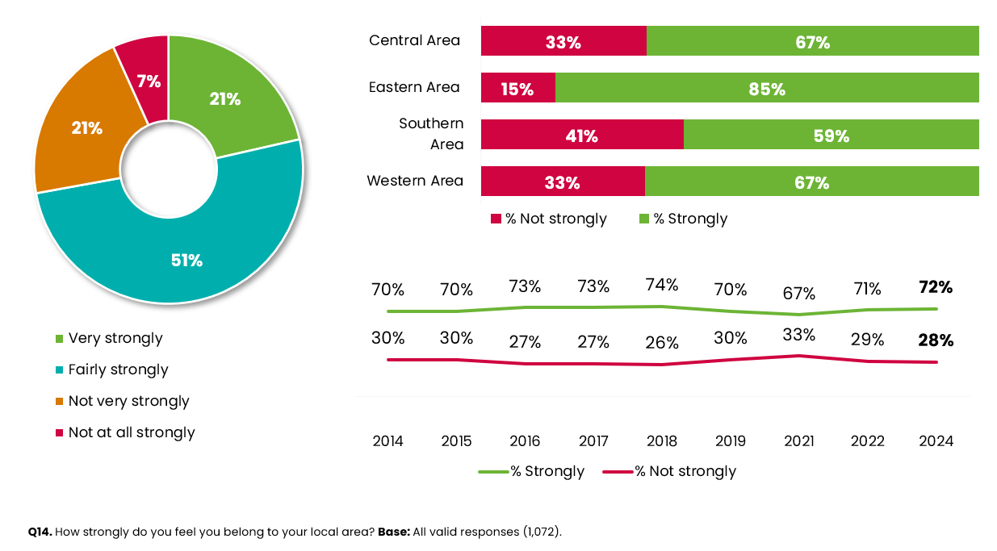
Sense of belonging is highest amongst the older age groups (77% vs. 72% overall), those from a White ethnic background (73%) and those who agree that people from different backgrounds get on well together (84% vs. 72% overall). Those with an illness or disability are more likely to disagree with this statement (34% vs. 28% overall).

Community cohesion
Residents were asked whether they agreed that their local area is a place where people from different backgrounds get on well together. Around six in ten residents (61%) agree with this statement and only 15% disagree. However, the level of agreement, is significantly lower than the 2023-24 Community Life Survey benchmark of 81%.
Figure 38: Community cohesion in the local area
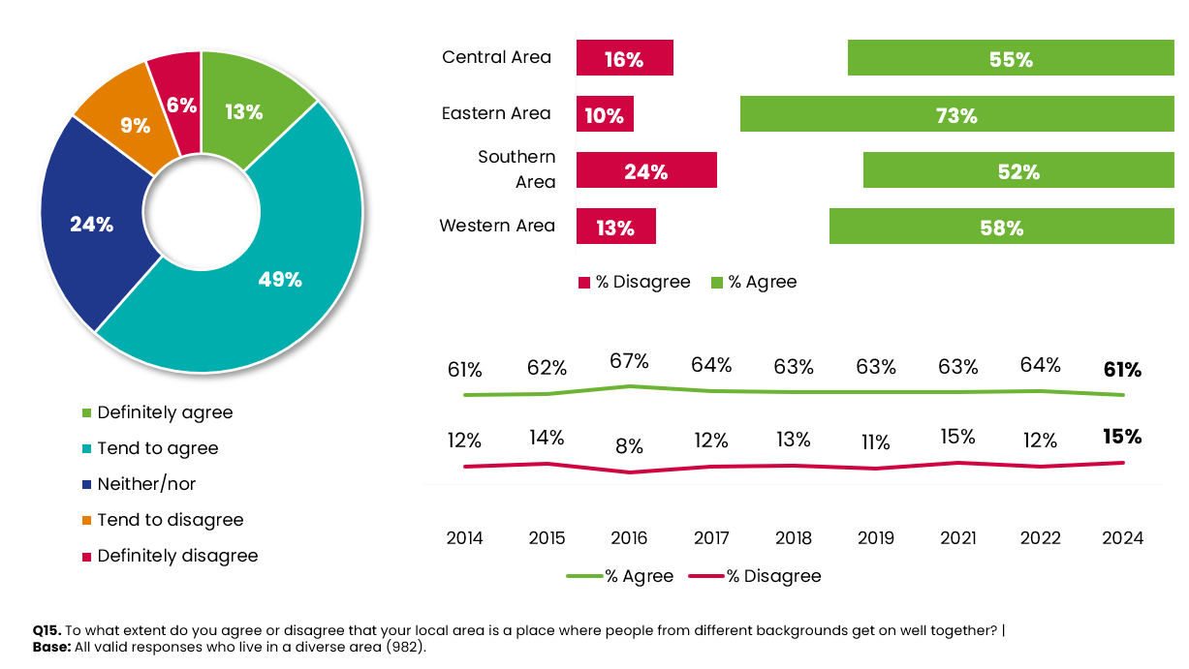
Opinions of community cohesion appear to vary across demographic groups:
- Agreement levels are significantly higher than average amongst females (65% vs. 61% overall) and those aged 18-34 (69%). The same is also true of homeowners (63%) and those living in the Eastern area (73%).

- Disagreement levels are significantly higher in the Southern area (24% vs. 15% overall) and in the most deprived areas (27% in IMD 1).

Pulling together to improve the local area
Overall, 42% of residents agree that people in their local area pull together to improve their communities. This has remained consistent with the 2022 survey (41%), although it is significantly lower than the 2023- 24 Community Life Survey benchmark of 56%.
Residents living in the Southern (38% vs. 25% overall) and Central (30% vs. 25% overall) areas are significantly more likely to disagree that people in their local area pull together to improve their communities. In contrast, residents in the Eastern area are most likely to agree (54% vs. 42%).
Figure 39: Pulling together to improve the local area
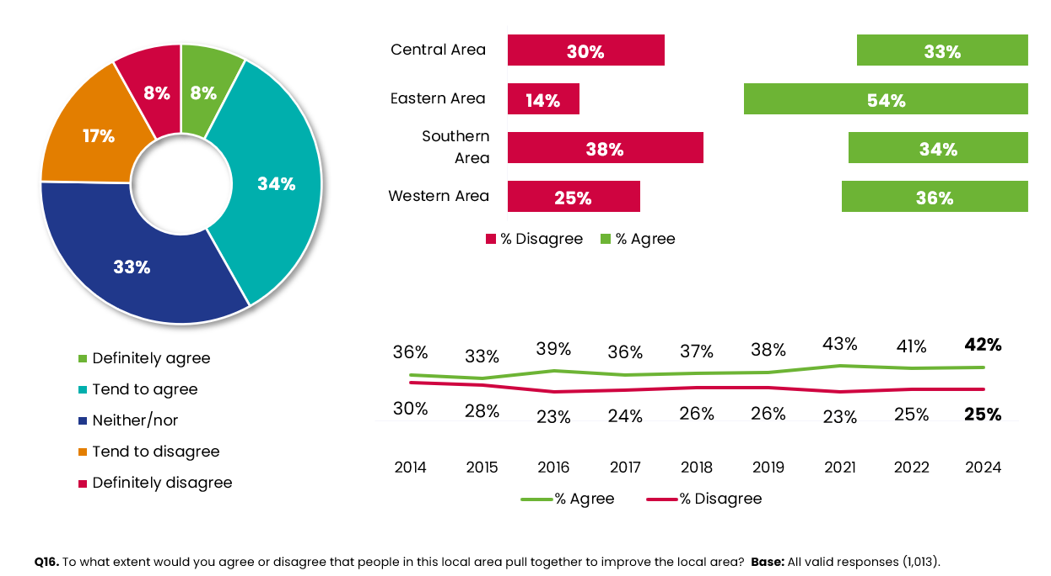
Those aged 35-44 (52%) or own a home (44%) are significantly more likely than average to agree that people pull together. Agreement levels are also higher amongst residents who feel they belong to their local area (51% vs. 18% who don’t), who believe people from different backgrounds get on well together (56% vs. 16% who don’t) or have volunteered (45% vs. 36% who have not volunteered).
Participation in regular volunteering
The national benchmark for volunteering is whether someone gives up their time formally or informally at least once a month. In the 2023-24 Community Life Survey, the national benchmark was measured at 16% for carrying out formal volunteering and 24% having taken part in informal volunteering.
Formal volunteering in North Tyneside stands at 17% and informal volunteering at 25%, in line with the national benchmarks. There has been an upward trend in formal volunteering since 2021.
Similar to 2022, residents living in the Eastern area are significantly more likely to state they volunteer formally at least once a month (22% vs. 17%). This also reflects their higher tendency to agree that their local area pulls together to improve their local area.
Residents aged 45-54 are more likely to formally volunteer at least once a month (22% vs. 17% overall).
Levels of regular informal volunteering is higher amongst the following demographic groups:
- Residents aged 45-54 (35% vs. 25%)
- Residents with children (32%)
- Carers (41%)
Figure 40: Frequency of volunteering activity
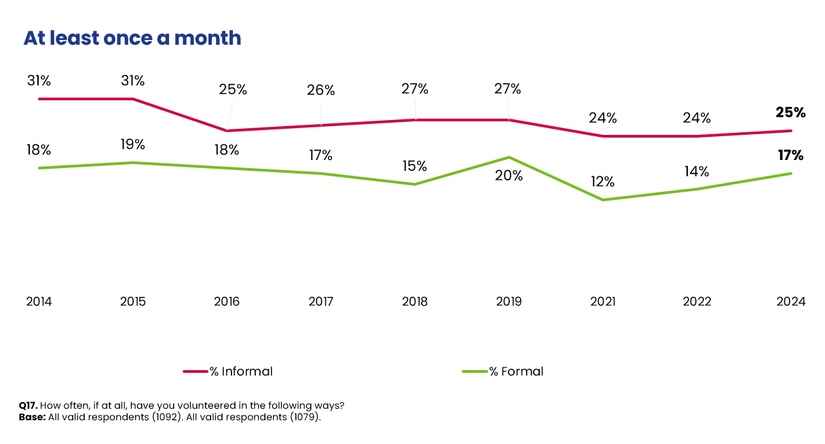

Caring responsibilities

Provide help or support to others
Overall, almost a quarter of residents (22%) provide help or support to a family member, friend or neighbour because of ill health or old age. This is identical to the 2022 survey. However, it should be noted that longer term trends show this proportion has continued to gradually decline in recent years.
Residents aged 45-54 (33% vs. 22%) are significantly more likely than average to provide help or support to a family member, friend or neighbour because of ill health or old age.

Figure 41: Provide help or support to others
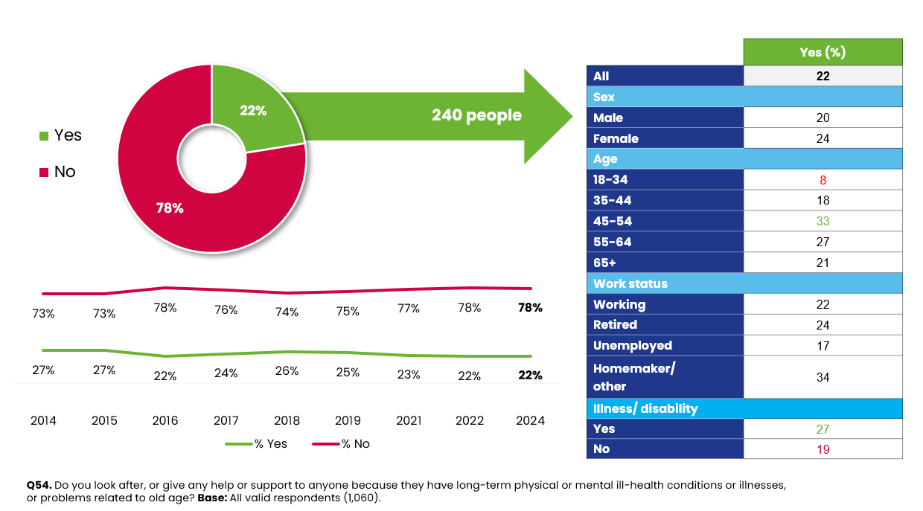

Use of Adult Social care
Residents were also asked about their usage and satisfaction with Adult Social Care. Almost a quarter of residents (23%) have used Adult Social Care services in the past year. This is broadly in line with the 2022 survey (21%).
The following demographic groups are significantly more likely to use these services than others:
- Residents with a long term illness or disability (29% vs. 17% without)
- Social tenants (36% vs. 19% homeowners)
- Carers (42% vs. 16% who are not carers)
- Those with bad health (44% vs. 18% of residents with good health)
All residents who have used Adult Social Care Services were asked how satisfied or dissatisfied they are with this service. Similar to 2022, a higher proportion of users are dissatisfied (41%) than satisfied (35%).

Figure 42: User satisfaction with Adult Social Care over time
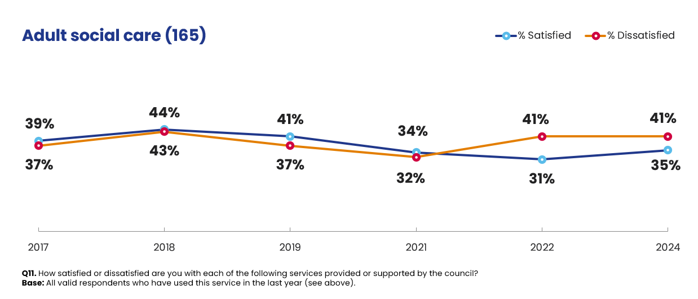

A Green North Tyneside
The ‘Our North Tyneside Plan 2021-2025’ outlines that a ‘Green North Tyneside’ will consist of the following:
- We will keep increasing the amount of waste that can be recycled and introduce food waste collections and deposit return schemes.
- Council environmental hit squads will crack down on littering.
- We will secure funding to help low-income households to install low-carbon heating.
- We will increase opportunities for safe walking and cycling, including providing a segregated cycleway at the coast.
- We will publish an action plan of the steps we will take and the national investment we will seek to make North Tyneside carbon net-zero by 2030.
In this chapter we report on resident satisfaction with waste and recycling services, perceptions of the council’s actions on climate change and willingness of residents to make changes to help reduce their carbon footprint.

Section summary
Around three quarters of residents (73%) are satisfied with the refuse and waste collection service provided by the council. This represents a four-percentage point decrease since 2022 (77%), though it is in line with the LGA benchmark (76%).
Satisfaction levels are much lower when it comes to doorstep/kerbside recycling, with 62% stating they are satisfied with this service. This measure has also dropped significantly compared with the 2022 survey, as has satisfaction with local tips/recycling centres, by five percentage points to 57%.
Overall, residents’ views on whether the council is taking action on climate change has remained largely unchanged since the 2022 survey. Just over a quarter of residents (27%) agree that the council is taking action and a fifth (21%) disagree. The remaining 51% are ambivalent. This continues to highlight a further need for the council to raise awareness of the action it is taking as an organisation.
The results indicate some notable shifts in behaviour compared to 2022, especially concerning planned behaviour. For example, the differences between the proportions who are willing and not willing to generate energy at home over the next five years has narrowed from +24 percentage points in 2022 (56% willing vs. 32% not willing) to just +12 percentage points in 2024 (51% willing vs. 39% not willing).
We also see a similar trend with regards to future willingness to replace a typical car with an electric or hybrid alternative. While the proportions currently doing so have increased, the differences between the proportions who are willing and not willing to take this action over the next five years has also narrowed significantly, from +22 percentage points in 2022 (53% willing vs. 31% not willing) to just +2 percentage points in 2024 (40% willing vs. 38% not willing).
In both cases, this signals a general change in mood that residents’ intentions on both actions (generating energy at home and switching to an electric or hybrid car) are looking less positive than in the last survey.
As in 2022, when asked what is stopping them from reducing their carbon footprint, the majority (59%) of residents say that cost is the main factor. Men are significantly more likely to cite expense as a barrier to behaviour change (67% vs. 54% of women). The same is also true when looking at the younger age groups, with those aged 18-34 more likely than average to cite cost as a barrier (83% vs. 59% overall), as are those who are finding it difficult or very difficult to manage on their present income. The second most commonly mentioned barrier is poor public transport provision (34%).

Satisfaction with waste and recycling
Around three quarters of residents (73%) are satisfied with the refuse and waste collection service provided by the council. Whilst this figure represents a four-percentage point decrease since 2022 (77%), it is in line with the LGA benchmark (76%).
Residents living in the Eastern area continue to be significantly more satisfied than those living in other parts of the borough (79% vs. 73% overall).
Satisfaction levels are much lower when it comes to doorstep/kerbside recycling, with 62% stating they are satisfied with this service. This is also significantly lower than the 2022 survey (67%).
When looking at the results by area, satisfaction with doorstep/kerbside recycling is significantly lower than average amongst residents living in the Southern area (46% vs. 62% overall). In contrast, it is significantly higher amongst residents living in the Eastern area (69% vs. 62%).
Since 2022, satisfaction with local tips/recycling centres has also significantly decreased, by five percentage points to 57%. As in 2022, residents living in the Eastern area have the highest levels of satisfaction (67%), whereas those living in the Western part of the borough are most likely to be dissatisfied (37% vs. 23% dissatisfied overall).
Figure 43: Satisfaction with waste and recycling services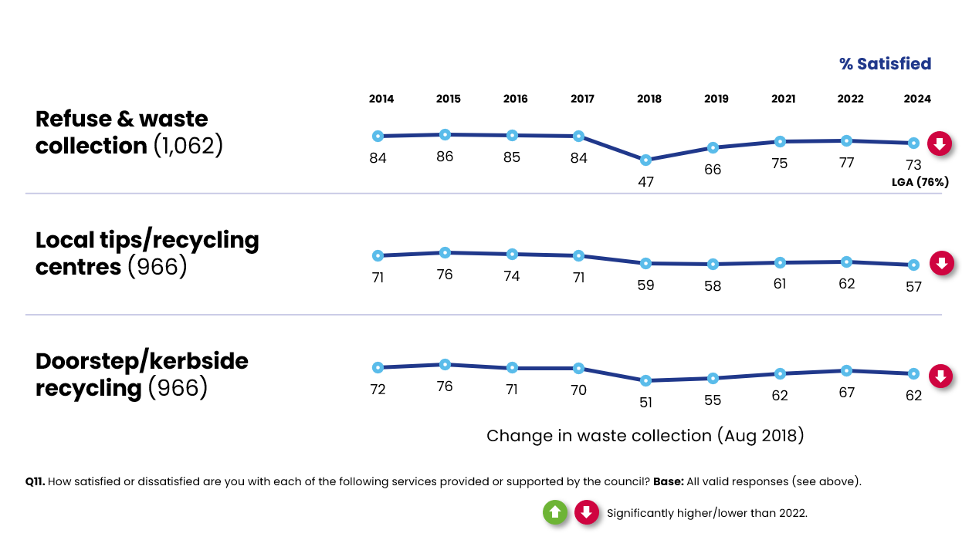

The council’s action on climate change
Overall, residents’ views on whether the council is taking action on climate change has remained largely unchanged since the 2022 survey. Just over a quarter of residents (27%) agree that the council is taking action and a fifth (21%) disagree. The remaining 51% are ambivalent. This continues to highlight a further need for the council to raise awareness of the action it is taking as an organisation.
Figure 44: Council's action on climate change
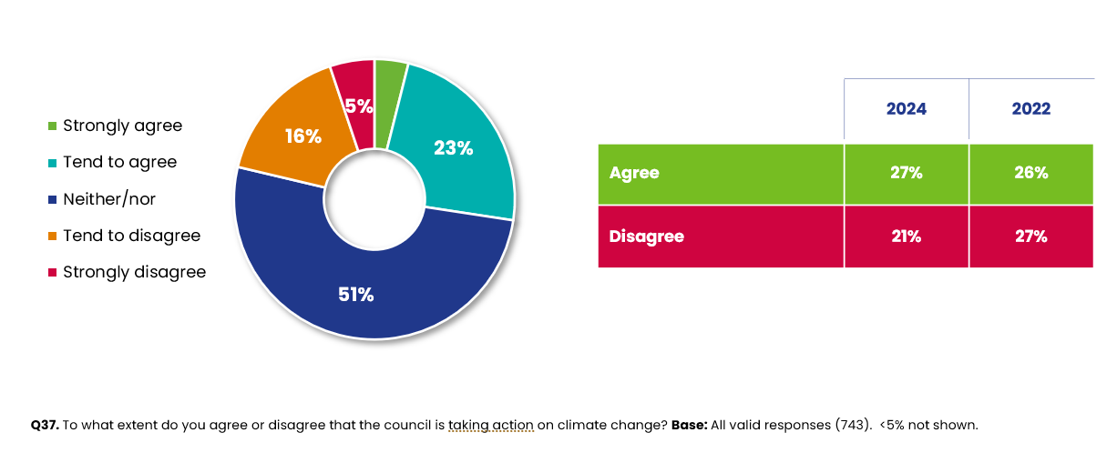
Analysis by sub group indicates that:
- Residents living in the Eastern area are significantly more likely to agree with this statement (34% vs. 27% overall). Whereas, residents living in the South of the borough are less likely to agree (20%).

Willingness to change behaviours
All residents were presented with a list of eleven measures and asked which they currently do, are willing to do, or not willing to do over the next five years to help reduce their carbon footprint. As Figure 45 shows the majority of residents claim to recycle and reduce waste (97%) and shop locally (91%).

Figure 45: Residents' current actions to help reduce their carbon footprint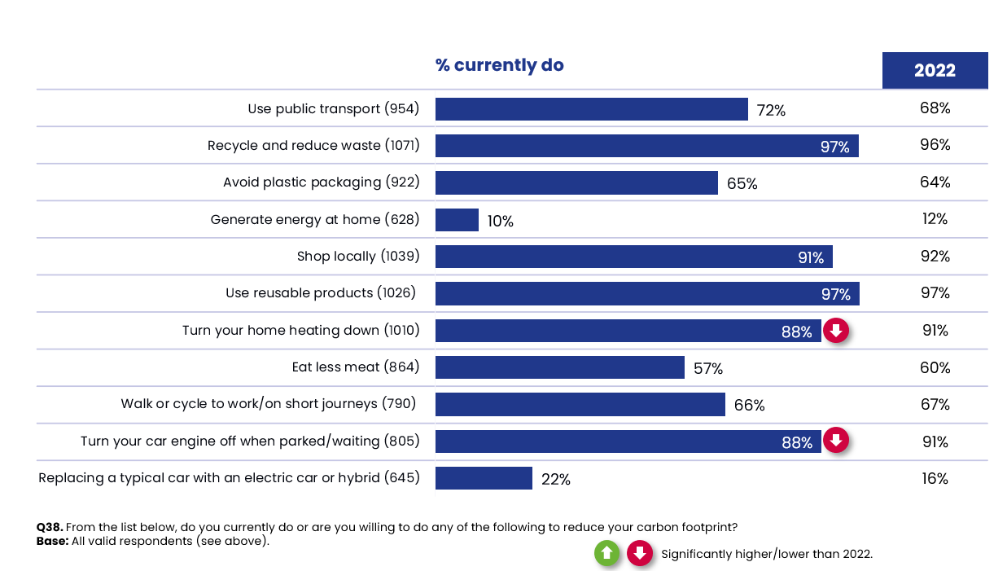
Figure 46 shows the full breakdown of what residents are currently doing, willing to do and not willing to do over the next 5 years. The most notable results include:
- Whilst only 10% of residents are currently generating energy at home, just over a half (51%) are willing to do this over the next five years.

- Around a quarter of residents (22%) are currently replacing their cars with an electric or hybrid alternative. However, opinions appear to be divided about future intentions with four in ten (40%) willing to do this over the next five years but a similar proportion unwilling to do over the same time period (38%).

Figure 46: Current behaviours and intended behaviours over the next five years
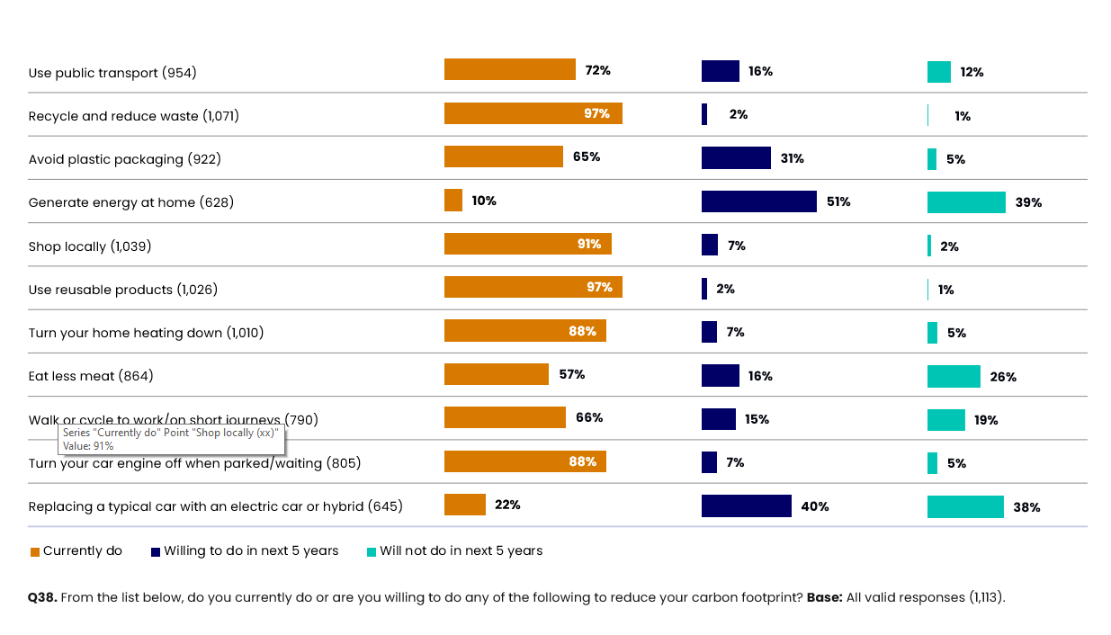
Figure 47 indicates some notable shifts in behaviour compared with 2022, especially concerning planned behaviour, as outlined below:
- The differences between the proportions who are willing and not willing to generate energy at home over the next five years has narrowed from +24 percentage points in 2022 (56% willing vs. 32% not willing) to just +12 percentage points in 2024 (51% willing vs. 39% not willing).

- We also see a similar trend with regards to future willingness to replace a typical car with an electric or hybrid alternative. While the proportions currently doing so have increased, the differences between the proportions who are willing and not willing to take this action over the next five years has also narrowed significantly, from +22 percentage points in 2022 (53% willing vs. 31% not willing) to just +2 percentage points in 2024 (40% willing vs. 38% not willing).

- In both cases, there has been a significant increase in the proportions that are not willing to take these actions over the next five years, coupled with a decrease in willingness to do them over the same period. This signals a general change in mood that residents’ intentions on both actions are looking less positive than in 2022.

Figure 47: Current and planned behaviours over time
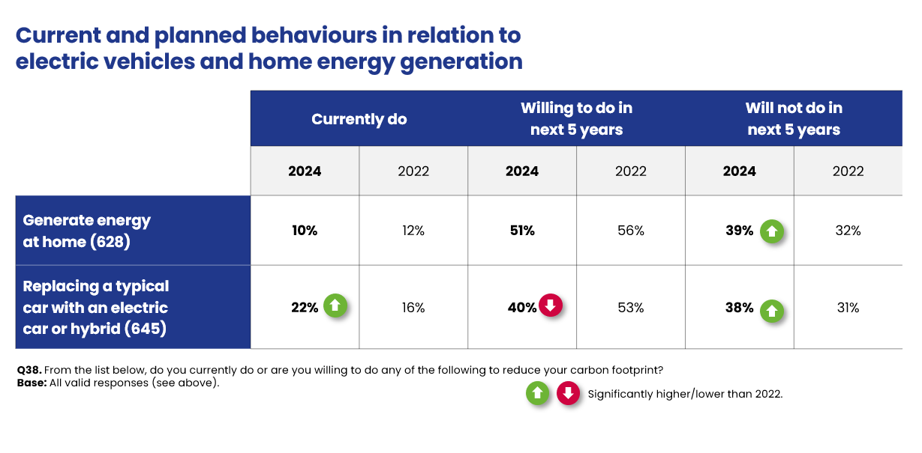
Figure 48 highlights the differences in current and intended behaviour by demographic group.
As in 2022, women are significantly more likely to use reusable products and eat less meat. Men are both less likely to be eating less meat now and less willing to make this change over the next five years.
The latest survey results also highlights gender differences relating to transport choices, with women more likely to have bought an electric or hybrid car (26% vs. 19% males).
Those aged 65+ are significantly more likely to say they currently wiling to use public transport (82% vs. 72% overall), generate energy at home (20% vs. 10% overall), shop locally (95% vs. 91%) and eat less meat (69% vs. 57%).
Those aged 18-44 who are more likely to consider generating energy at home in the next five years.
Similarly, 18-44 year olds are the most likely to consider buying an electric or hybrid car in the next 5 years, with the 65+ age group more likely to say they will not do so.

Figure 48: Current and planned behaviours by demographic groups
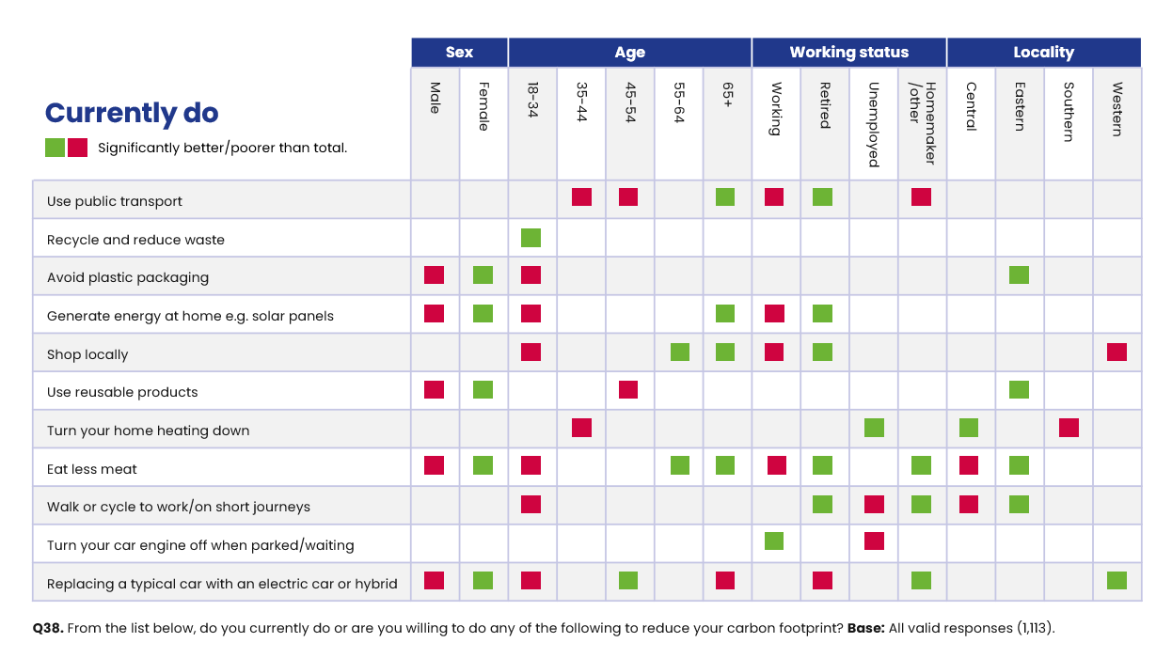
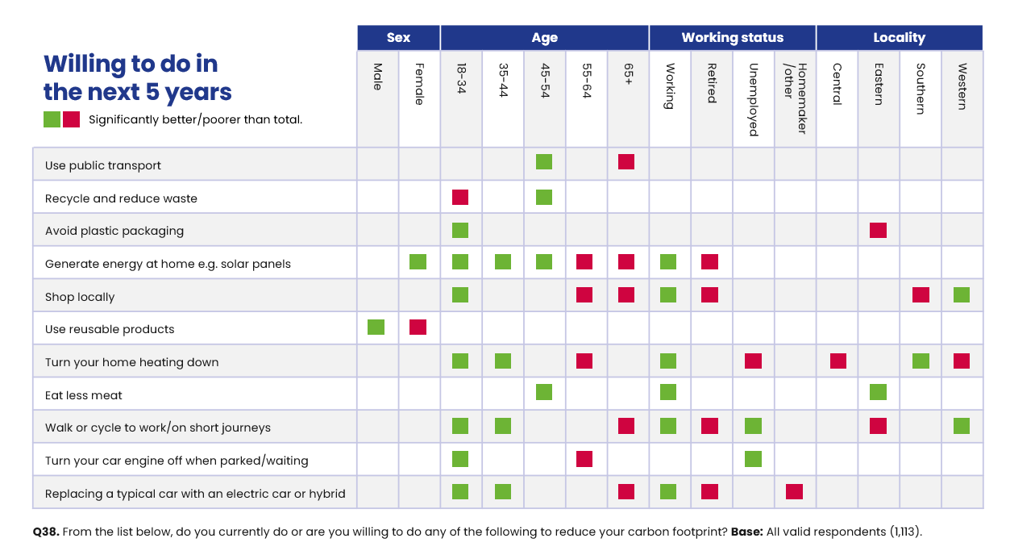
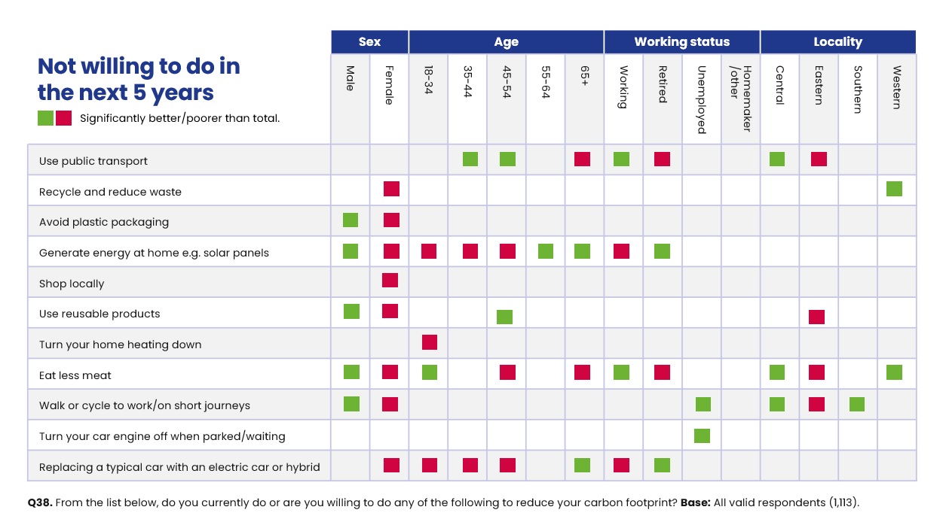
In addition, analysis by deprivation level (IMD quintile) also indicates several differences, including that residents in the least deprived communities (IMD 5) are more likely to be currently cycling to work/on short journeys (73%), more likely to be willing to replace their car with an electric or hybrid in the next 5 years (49%) but also more likely to say they will not generate energy at home in the next 5 years (45%).
Barriers to changing behaviours
All residents were asked what barriers they face when reducing their own carbon footprint. Similar to the 2022 survey, the majority of residents (59%) feel that cost is the main factor, followed by poor public transport provision. Proportions mentioning lack of knowledge, health issues and taking too much effort are identical to the previous survey (19%, 18% and 7% respectively).
Figure 49: Residents' barriers to reducing carbon footprint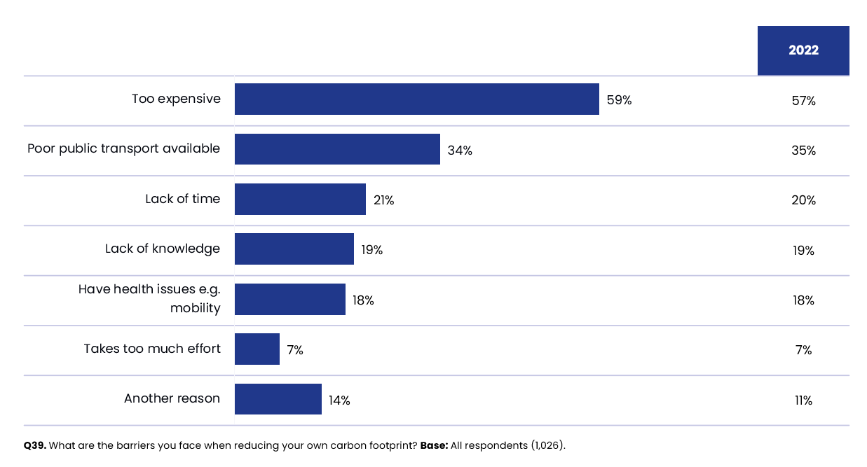
Analysis by subgroup indicates the following significant differences:
- Men are significantly more likely to cite expense as a barrier to behaviour change (67% vs. 54% of women). The same is also true when looking at the younger age groups, with those aged 18-34 more likely than average (83% vs. 59% overall) and those who are finding it difficult or very difficult to mange on their present income.

- Those aged 65+ are significantly least likely to cite the cost (40% vs. 59% overall) and lack of time (7% vs. 21%) as barriers to behaviour change. However, they are significantly more likely to cite a lack of knowledge (24% vs. 19% overall).

- Likewise to 2022, those who are employed are more likely to state that time and money stand in the way of reducing their carbon footprint (29% and 70% respectively), while those who are workless or retired are more likely to cite health issues as a barrier (60% and 33% respectively).

- By tenure, health issues are more commonly cited by social tenants (46% vs. 18% overall), with owner occupiers more likely to mention the cost (64% vs. 59% overall).

- Those living in households with children are more likely to mention cost and time as barriers to behaviour change (67% vs. 59% overall and 29% vs. 21% overall respectively).

Satisfaction with the council
The final section of this report focuses on the council’s performance on several key indicators which measure overall performance. It also looks at the customers’ experience when contacting the council and whether that experience meets their expectations.

Section summary
There has been a continued decrease in the proportion of residents who say they are either very satisfied or fairly satisfied with how the council runs things from 56% in 2021, to 49% in 2022 and now to 48% in 2024. This figure is significantly lower than the latest LGA benchmark figure of 56%. Compared with 2022, dissatisfaction with the council has increased significantly, to 28%.
Overall satisfaction with the council is significantly lower than average in the Southern area of the borough (42%) and significantly higher in the Eastern area (56%).
As in 2022, residents’ perceptions of the extent to which the council provides value for money is the most important factor in the key driver analysis on council satisfaction.

Refuse and waste collection remains the number one most important service offered by the council (23%), closely followed by children’s services (17%).
Almost four in ten (39%) residents agree that the council provides good value for money. This figure is almost identical to last year’s findings (40%) and higher than the LGA benchmark (36%).
Similar to 2022, ‘Acting on the concerns of residents’ continues to be the strongest driver of the council’s perceived value for money, explaining 21% of the variation. Satisfaction with the local area is the second highest driver.
The proportion of residents who have not noticed any changes to services delivered by the council has reduced significantly, to 72% this year, while disagreement on this measure has increased significantly. Disagreement levels are significantly higher than average amongst residents living in the Eastern area (34% vs. 28%).
Only four in ten residents (41%) think the ‘Council acts on the concerns of local residents’. This result is significantly lower than the LGA benchmark of 53%.

While there are no significant changes in this measure since 2022, when comparing the results to 2021, we can see there is a widening negative gap, between those who do and do not think the council acts on residents’ concerns. In 2021 there was a net difference of just -2 percentage points, between those who think the council acts ‘A great deal or fair amount’ on residents’ concerns and those that selected ‘Not very or not at all’. In 2022 the gap widened to -12 percentage points and has now widened further to -18 percentage points (59% vs. 41%).
Overall, 38% of residents would be advocates of the council, either spontaneously or if asked. This figure has remained unchanged since the 2022 survey. However, looking back to 2021, when there was a positive difference of + 15 percentage points between those who would (44%) and would not (29%) advocate for the council, this gap has now reduced significantly, to just +1 percentage point (38% and 37% respectively).
Almost six in ten residents (57%) have contacted the council in the last 12 months, broadly the same as 2022 (62%).
Telephone remains the most popular method of contacting the council, with 50% selecting this method; and this represents a significant increase since the last survey. Residents who are more likely to contact the council by telephone include social tenants, residents in bad health and the unemployed.
On a positive note, there has been a significant improvement in the proportion of residents able to do everything themselves online when they last accessed a council service online, via the council website. However certain sub-groups of residents, including social tenants and retired individuals are less likely to have accessed any council services online.
When looking at the nature of contact, environment, waste and recycling services (38%) still accounts for the largest proportion of resident contact with the council. It should be noted that contact for this reason has increased by fourteen percentage points since 2022; which is a significant difference and consistent with the significant decline seen in satisfaction levels for refuse and waste collection, local tips/recycling centres and doorstep recycling reported earlier in the report.
Just under six in ten residents who have contacted the council say their overall experience was positive (59% vs. 57% in 2022).

Finally, when looking at information provision, over half (54%) of residents feel informed about the services and benefits provided by the council. This figure is significantly higher than the LGA benchmark (47%).

General satisfaction with North Tyneside Council
In terms of overall satisfaction, there has been a continued decrease in the proportion of residents who say they are either very satisfied or fairly satisfied with how the council runs things, from 56% in 2021, to 49% in 2022 and now to 48% in 2024. This figure is significantly lower than the latest LGA benchmark figure of 56%. In addition, the proportion of residents dissatisfied with the council has increased significantly, compared with 2022 (from 23% up to 28%).
The lowest satisfaction levels are amongst residents living in the Southern area (42% vs. 48% overall) and highest amongst those living in the Eastern part of the borough (56%).
Figure 50: Satisfaction with the council
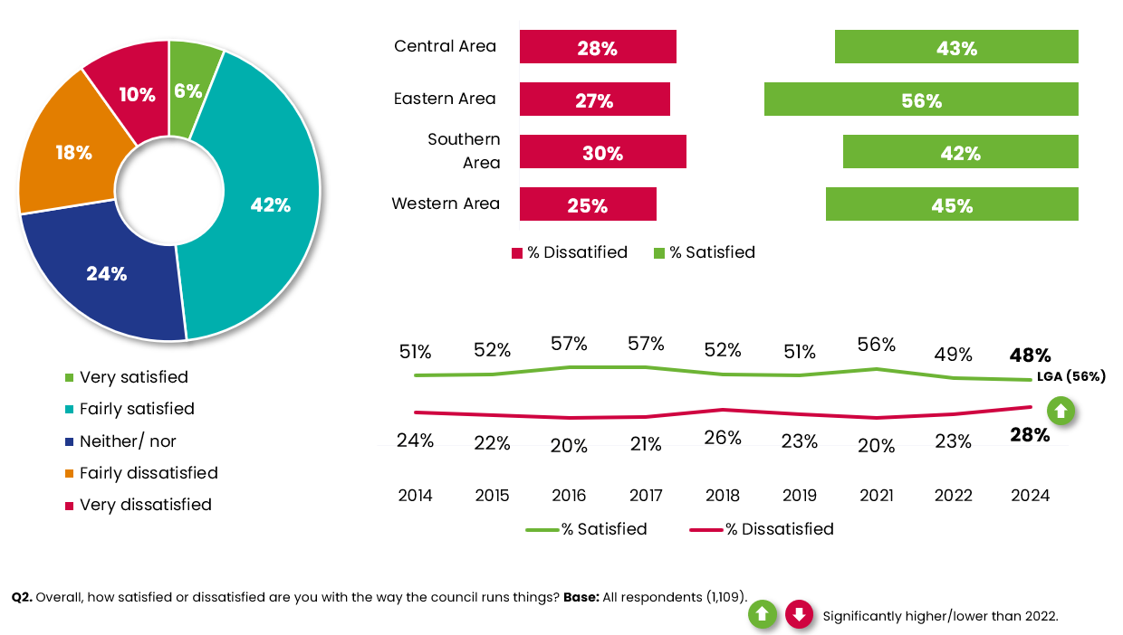
As in previous years, satisfaction with the council tends to correlate with other factors, such as satisfaction with the local area, household income and self-reported health. For example, 39% of residents who do not feel a strong sense of belonging to the local area are dissatisfied with the council, compared to 23% who do.
Levels of satisfaction vary according to residents’ financial security. More than a third (35%) of residents who find it difficult or very difficult to manage on their present income are dissatisfied with the council. In contrast, 61% who say they are living comfortably on their present income are satisfied with the council.
More than half (54%) of residents who consider themselves to be in good health are satisfied with the council. This drops to 37% amongst those who are in bad health.

Key drivers of council satisfaction
Multiple Regression was undertaken to identify the questions in the questionnaire, which together have the most influence on residents’ satisfaction with the council. The overall goodness of fit for this model is strong, with an R-square of 71.8%. This means that the 10 key drivers listed in Figure 51 explain 71.8% of the variance in satisfaction with the council.
Similarly to the 2022 survey, ‘The council provides value for money’ is once again the most influential factor. People who agree with this statement tend to be more satisfied with the way the council runs things.
The relative importance of ‘The council provides value for money’ is 29%. This means that it is almost twice as influential on satisfaction with the council than the second driver ‘Satisfaction with the local area as a place to live’ which has relative importance of 15% and around three times as important as ‘Acting on the concerns of residents’, which has relative importance of 9%.
‘Local tips/recycling centres are ranked 10^{th.} This means it is the least influential of all the key drivers, but it still contributes significantly to the model and has significant influence on satisfaction with the council.
The performance scores come directly from the survey data. For example, 73% of residents are satisfied with their refuse and waste collection. This is a relatively high-performance score with the vast majority of residents reporting they are satisfied. ‘Acting on the concerns of residents’ has a lower performance score with just 41% of residents agreeing with this statement. Making improvements in this area could potentially lead to a significant improvement in residents’ satisfaction with the council.

Figure 51: Key Drivers Analysis: Satisfaction with the council
Rank | Question | Relative importance (%) | Performance
1 | The council provides good value for money | 29% | 39%
2 | Satisfaction with your local area as a place to live | 15% | 74%
3 | Satisfaction with refuse and waste collection | 12% | 73%
4 | Council acts on the concerns of local residents | 9% | 41%
5 | Satisfaction with Killingworth | 9% | 52%
6 | Whether local area has got better or worse or not changed much over the last 12 months (% better) | 6% | 69%
7 | Satisfaction with street cleaning | 6% | 48%
8 | Satisfaction with Wallsend | 5% | 24%
9 | Satisfaction with pavement maintenance | 5% | 22%
10 | Satisfaction with local tips/recycling centres | 4% | 57%

The most important services delivered by the council
All residents were presented with a list of services and asked to choose the three they consider to be most important and rank them in order of importance.
Refuse and waste collection remains the number one most important service offered by the council (23%). Given the importance of these services to residents, the significant decreases in satisfaction noted for these services in section 7.2 may be contributing to the downward trend in satisfaction with the council. Children’s services (17%) is considered the second most important service. Figure 52 below presents the full rankings. Priority services remain broadly consistent with the 2022 survey.
Figure 52: Most important services delivered by the council
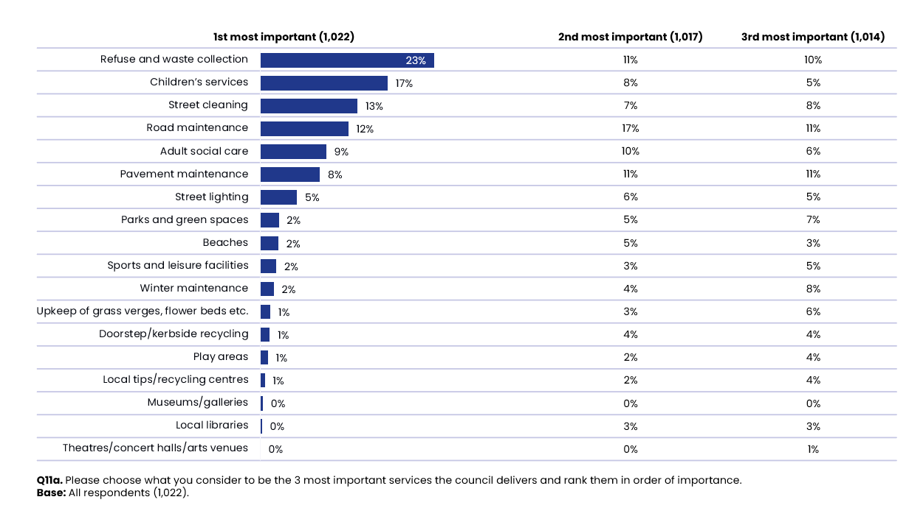
When looking at resident priorities by area, Figure 53 indicates that refuse and waste collection is number one in each of the four areas. There are some slight differences when looking at secondary priorities. Children’s services are commonly cited amongst residents living in Central (18%) and Eastern areas (21%), although this is replaced by street cleaning in Southern (22%) and Western areas (17%).
Figure 53: Residents' priorities by area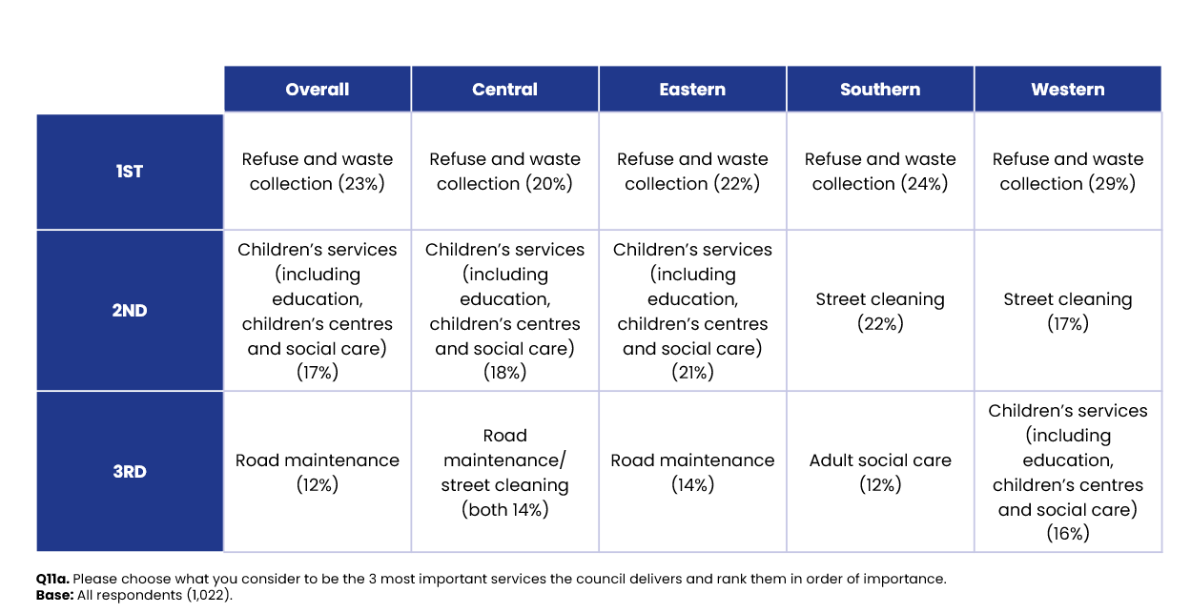

Value for money
Almost four in ten residents (39%) either strongly agree or agree that the council provides value for money. This figure is in line with the 2022 survey (40%) and is higher than the LGA benchmark of 36%.
Figure 54: Good value for money
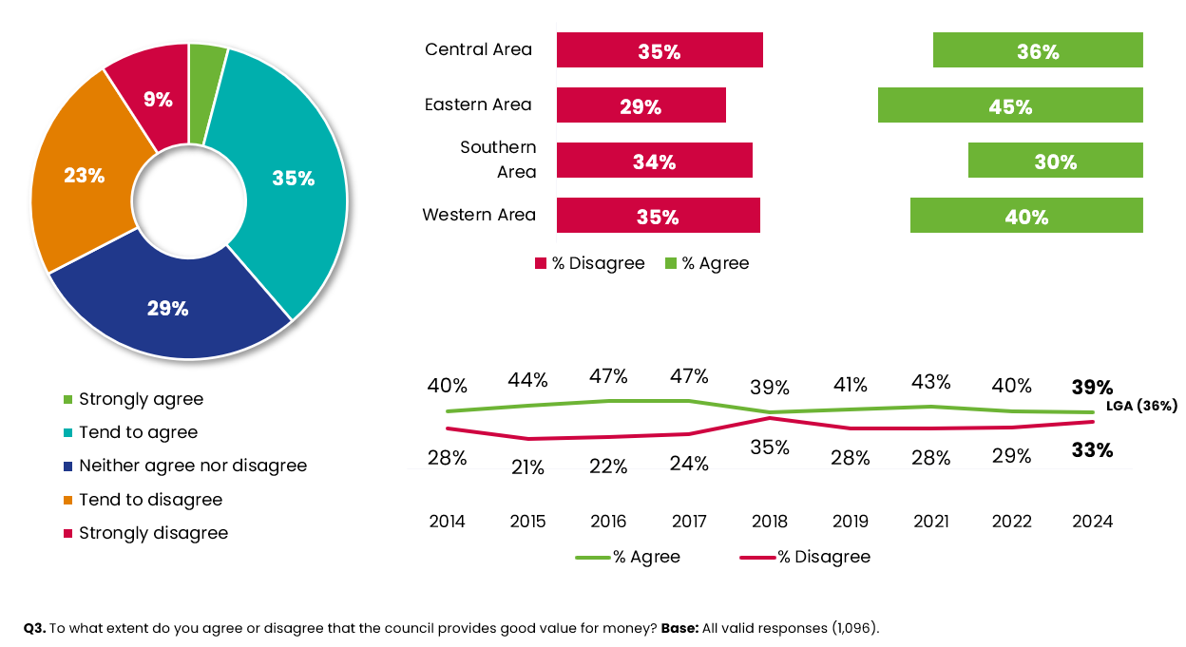
Those who are more likely to agree that the council provides value for money include women (43%), social tenants (47%) and those living in the Eastern area (45%).

Key drivers of value for money
Once again Multiple Regression was undertaken to identify the questions in the questionnaire, which together have the most influence on residents’ perception of whether the council provides value for money. The overall goodness of fit for this model is strong, with an R-square of 61.6%. This means that the 11 key drivers listed below together explain 61.6% of the variance.
The most influential factor is whether the ‘Council acts on the concerns of local residents’. People who agree with this statement tend to consider the council to provide value for money. The relative importance of 21% means that it is almost twice as influential as the third driver (‘Feel well informed about the services and benefits the council provides’).

Satisfaction with parks and green spaces‘ is ranked 11th , which is the least influential of the key drivers but still contributes significantly to the model and has significant influence on value for money.
Figure 55: Key Drivers Analysis: value for money
Rank | Question | Relative importance (%) | Performance
1 | The council acts on the concerns of local residents | 21% | 41%
2 | Satisfaction with place to live | 12% | 74%
3 | Feel well informed about the services and benefits the council provides | 11% | 54%
4 | Satisfaction with refuse and waste collection | 9% | 73%
5 | Satisfaction with upkeep of grass verges, flower beds, trees and shrubs in streets and public spaces | 9% | 55%
6 | Satisfaction with sports and leisure facilities (includes swimming pools) | 8% | 62%
7 | Satisfaction with road maintenance | 8% | 26%
8 | The availability of jobs | 7% | 26%
9 | Local area has got better or not changed much (% better/same) | 6% | 69%
10 | Satisfaction with winter maintenance (e.g. gritting the roads) | 5% | 45%
11 | Satisfaction with parks and green spaces | 5% | 72%

Changes to local services
Overall, almost three quarters of residents (72%) agree that ‘They haven’t really noticed any changes to the services provided by their local council’. However, this a significant decrease of seven percentage points compared to the 2022 survey. The proportion in disagreement on this measure has increased significantly.

Figure 56: Changes to local services
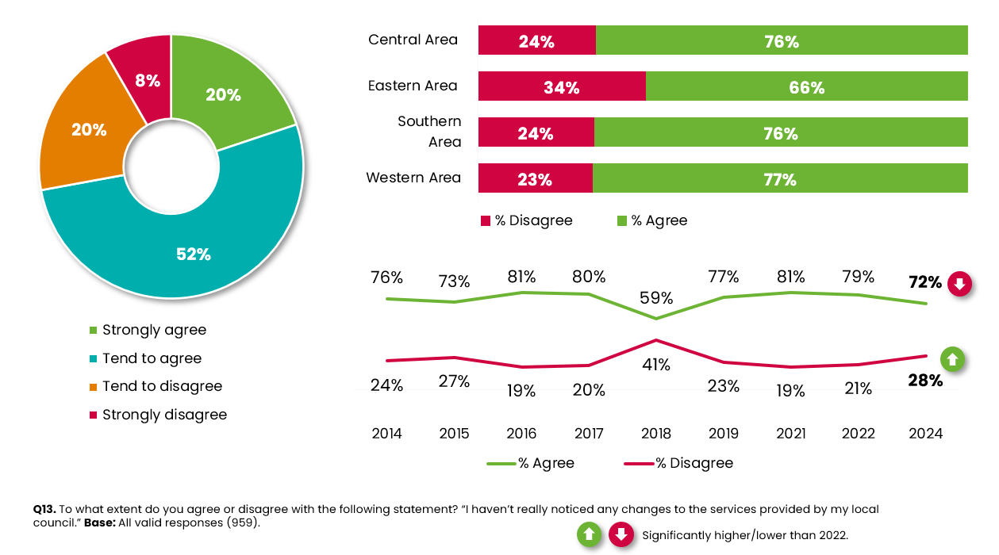
Disagreement levels are significantly higher than average amongst residents living in the Eastern area (34% vs. 28%).
All residents who disagreed with the statement, ‘I haven’t really noticed any changes to the services provided by my local council’ were asked to comment on the changes they have experienced. The most frequently mentioned theme related to lack of maintenance of roads, hedges, grass verges etc. Some example comments from residents are presented below:
“Reduction in hedge trimming in Souter parks. Reduction in gully cleaning and leaf cleaning.”
“Wild flower areas in Wallsend area just look like weeds. Roads are in disrepair and are often patched up rather than repaired correctly.”

Actions taken on residents’ concerns
Acting on the concerns of residents is one of the council’s performance indicators. Only four in ten residents (41%) think the council acts on the concerns of local residents. This result is significantly lower than the LGA benchmark of 53%.
While there are no significant changes in this measure since 2022, when comparing the results to 2021, we can see there is a widening negative gap, between those who do and do not think the council acts on residents’ concerns. In 2021 there was a net difference of just -2 percentage points, between those who think the council acts ‘A great deal or fair amount’ on residents’ concerns and those that selected ‘Not very or not at all’. In 2022 the gap widened to -12 percentage points and has now widened further to -18 percentage points (59% vs. 41%).
Figure 57: Acts on the concerns of local residents
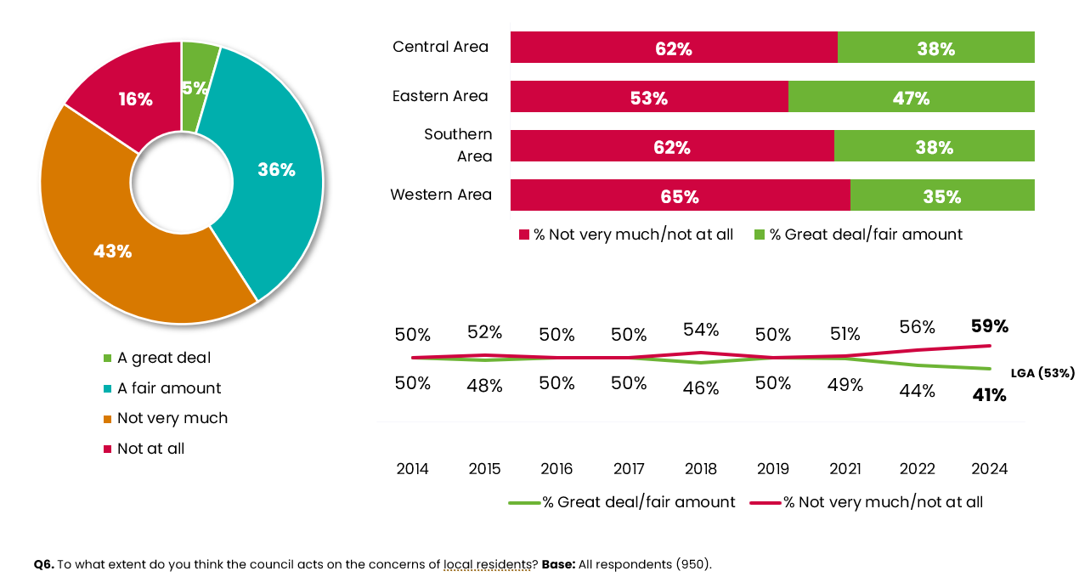
There is little variation between subgroups apart from those living in the Eastern area are more likely to agree (47% vs. 41%), whereas agreement levels are lower amongst those with caring responsibilities (34% vs. 43% non-carers).

Advocacy
Overall, 38% of residents would be advocates of the council, either spontaneously or if asked. This figure has remained unchanged since the 2022 survey, although the proportion of residents identifying as critics of the council has increased by two percentage points since 2022 to 37%.
In addition however, looking back to 2021, when there was a positive difference of + 15 percentage points between those who would (44%) and would not (29%) advocate for the council, this gap has now reduced significantly, to just +1 percentage point (38% and 37% respectively).

Figure 58: Advocacy
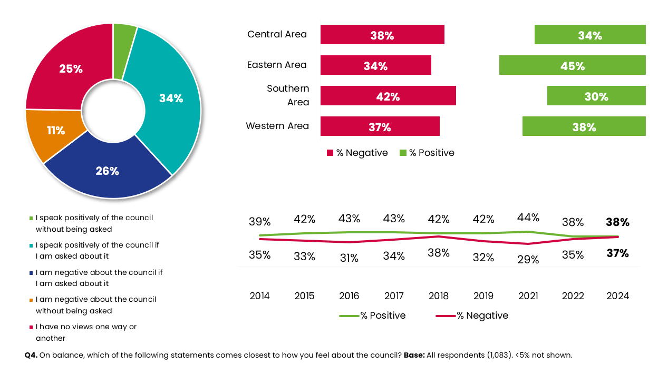
Female residents (43%) remain more likely to be advocates of the council. Residents of the Eastern area are also more likely to be advocates (45%).
The demographic profile of those most likely to be critics of the council are similar to 2022 and include males (42%), residents in bad health (48%) and carers (44%).
As in previous years, those who are positive about the council in other areas are more likely to be advocates, including residents who feel informed about the council’s services and benefits (58% vs. 18% of those not informed), and those who feel that the council provides value for money (74% vs. 5% who feel it does not).
Also, in line with previous years, advocacy of the council correlates with general attitudes to the local area; residents who are satisfied with the local area are more likely to speak highly of the council (49% vs. 6% of those who are dissatisfied). A similar pattern is seen in relation to those who feel they belong to the local area (45% vs. 23% of those who feel they do not belong).

Contacting the council
Almost six in ten residents (57%) have contacted the council in the last 12 months, broadly the same as 2022 (62%).
The following groups are more likely to have contacted the council over this time period:
- Residents aged 55-64 (65% vs. 57% overall)
- Residents who have a long-term illness or disability (65%)
- Social tenants (82%)
- Those with bad health (69%)
Residents who are dissatisfied with their local area are more likely to have contacted the council (72%).
All residents who contacted the council within the last 12 months were asked for the method of contact on the last occasion. Similar to 2022, the telephone remains the most popular method, with 50% selecting this method (a significant increase of seven percentage points compared to 2022). This is followed by the council’s website (21%) and email (16%). Both of these have remained broadly similar to the 2022 survey.
Figure 59: Contacting the council
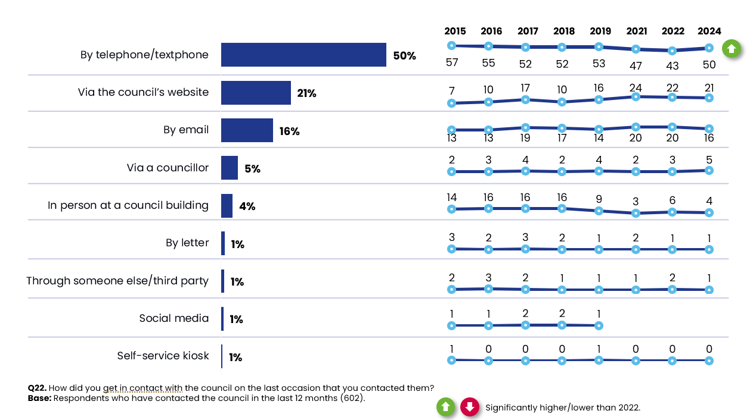

The following table highlights the demographic groups who are more likely to visit the council’s website and contact the council by telephone.
Figure 60: Communication methods by demographics
Communication method | Demographic group
Via the council’s website (21%) | 35-44 (40%)  Those working (25%)  Homeowners (26%)  Live in the Eastern area (28%)
Telephone (50%) | Unemployed (72%)  Social tenants (77%)  Live in the Central area (63%)  Those in bad health (67%)

The Council’s website
All residents were asked to think about the last time they used a council service (via the council’s website) and asked to select the statement that best describes their experience.
Encouragingly, almost six in ten (58%) state they are able to do everything themselves online. This is a significant improvement of six percentage points compared to the 2022 survey.

Figure 61: Experience of using the council's website

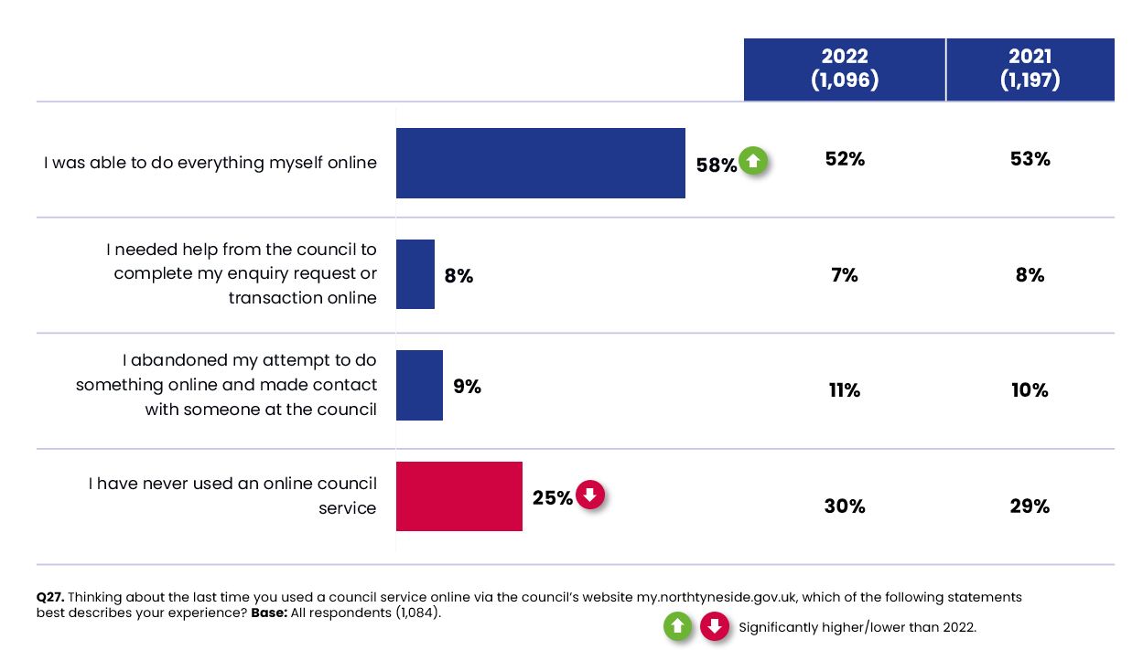
Residents who are less likely to use any online council service are those aged 65+ (45%), retired (38%), social tenants (39%), single person households (33%) and those living in the Central area (31%).

Why contact was made, how and with whom?
Almost three in ten residents (29%) contacted the council to report a problem. Whilst this figure remains consistent with 2022 (26%), the proportion of residents contacting the council to make a payment for a council service has increased significantly to 21% (compared to 13% in 2022).

Figure 62: Reasons for contacting the council
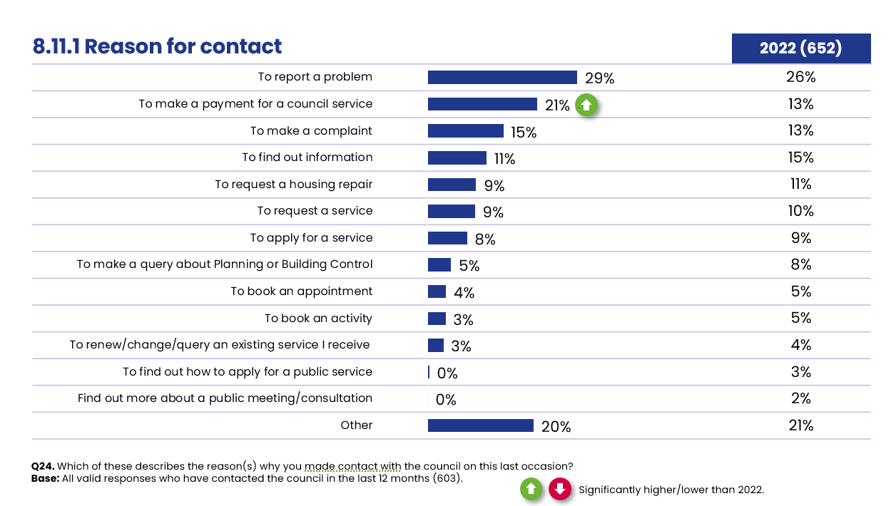
Males (34% vs. 29% overall), those aged 35-44 (43%), homeowners (31%) and those with children are most likely to have contacted to report a problem (e.g. streetlight needing a repair etc) in the last 12 months.
Those aged 18-34 (35% vs. 21% overall) and private tenants (40%) are also most likely to contact the council to make payment for a council service (e.g. council tax, rent etc).
8.11.1 Services related to contact
Environment, waste and recycling services (38%) still accounts for the largest proportion of resident contact with the council. It should be noted that contact for this reason has increased by fourteen percent since 2022; which is a significant difference and consistent with the significant decline seen in satisfaction levels for refuse and waste collection, local tips/recycling centres and doorstep recycling reported earlier in the report.
There has also been a five percentage point decrease for advice, benefits and council tax. The remaining commonly-cited reasons remain consistent with the 2022 survey.

Figure 63: Related service for last contact
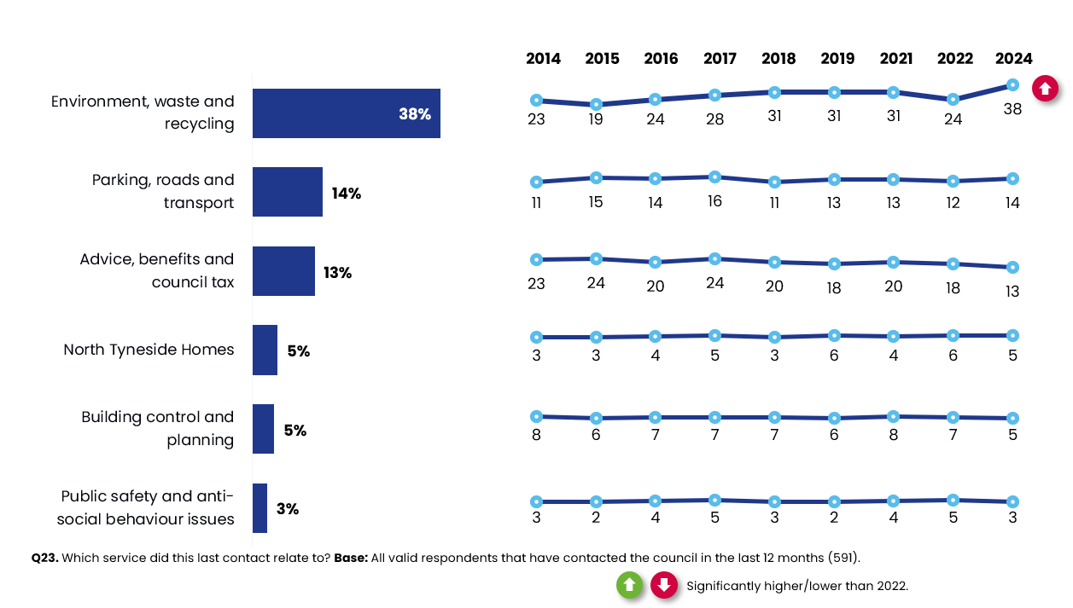
Figure 64 below shows the top modes and reasons for contact for each service category. Telephone/textphone is the most commonly used contact method for four out of six categories, with 50% contacting the council about advice, benefits and council tax using this method. Around a third of residents use email for building, control and planning (30%) or parking, roads and transport (32%).
Figure 64: Reasons and modes for making contact with the council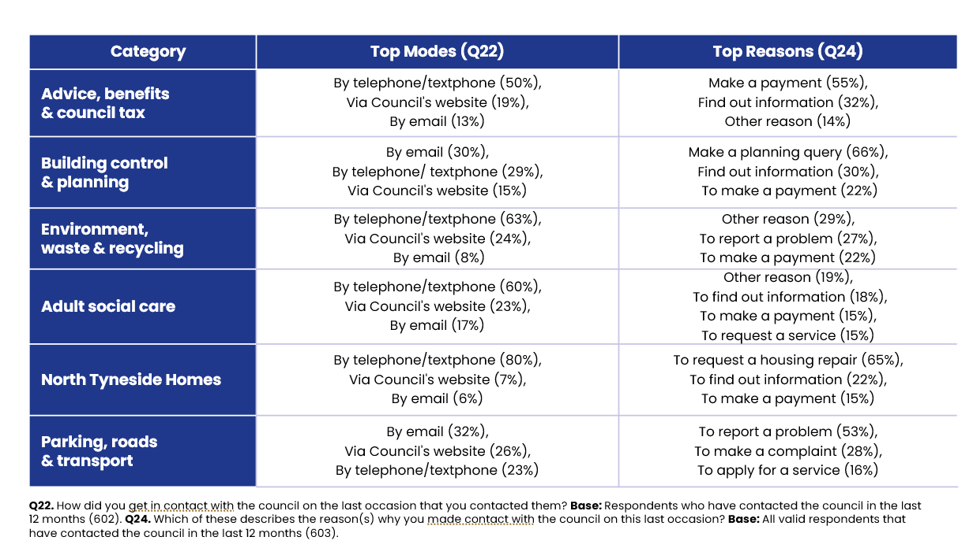

Satisfaction with contact experience
The key measures to rate customer satisfaction interaction with the council has remained fairly stable since the 2022 survey. As in 2022, just under six in ten residents who have contacted the council say their overall experience was positive (59% vs. 57% in 2022). A similar proportion feel their query was cared about (58% vs. 56%). Also, in line with 2022, 65% (vs. 64%) feel listened to and that the council did what they said they would do (63% vs. 62%).
Figure 65: Satisfaction with aspects of contact experience
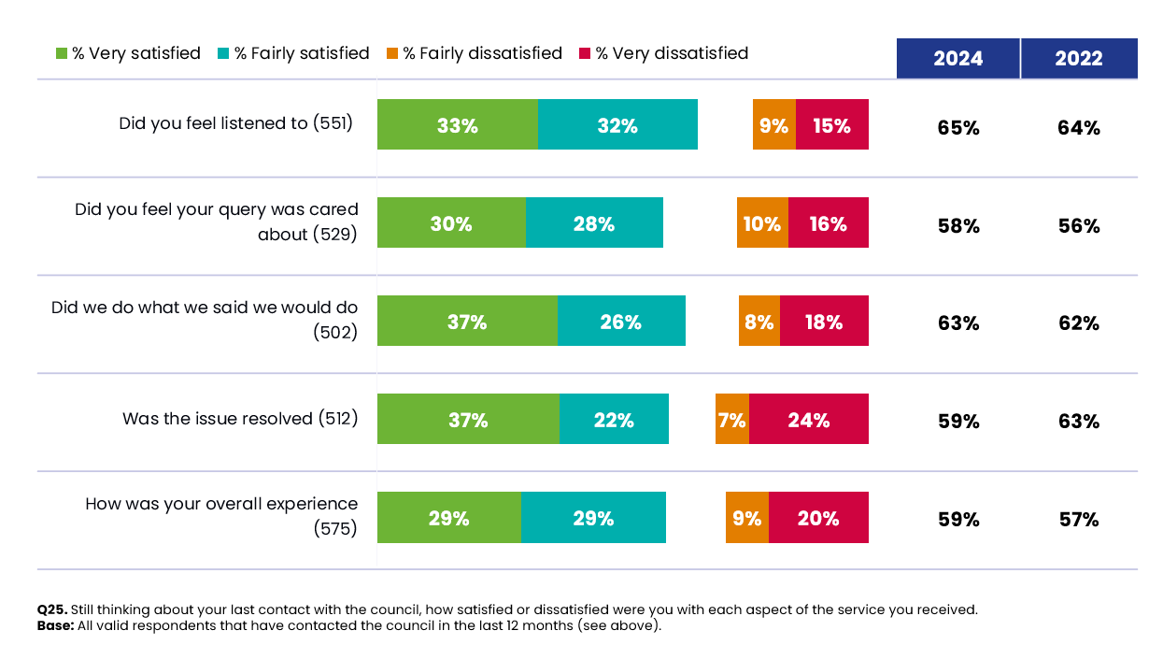
Women (65%), those aged 18-34 (74%) and social tenants (72%) are the most likely to be satisfied with their overall contact experience.

Expectations of customer contact experience
Figures relating to whether their last contact with the council has changed their opinion of the council has remained fairly consistent since 2022, with 66% saying their opinion did not change, 20% feel it has changed for the worse and 14% that it changed for the better.
Figure 66: Last contact changed opinion of council?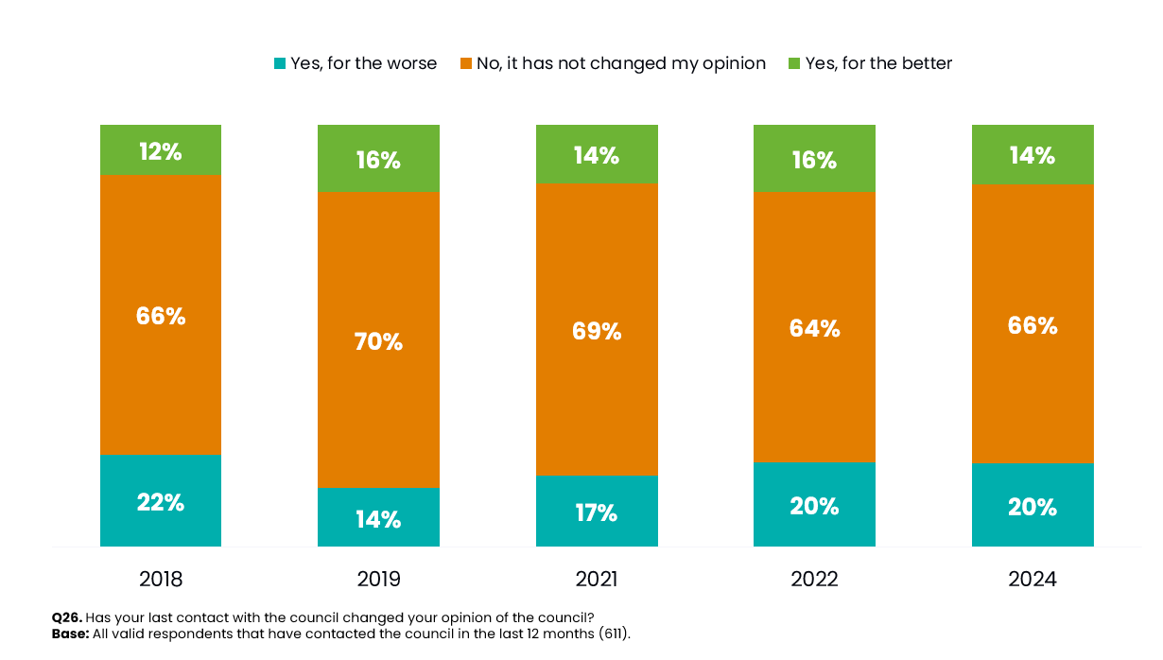
There are few significant variations by demographic group in relation to this question:
- Females (18%) and those aged 65+ (20%) are more likely than average to say their opinion of the council has changed for the better.

- Those making contact by telephone are more likely to have changed their opinion of the council for the better (20%).

- As seen in previous surveys, if the purpose of the contact was to make a complaint, then that resident is significantly more likely to say their opinion has changed for the worse (40%), as is the case for those reporting a problem (36%). Those requesting a housing repair (29%) or contacting the council to apply for a service (26%) are more likely to come away with a better opinion of the council.

Feeling informed

Information provision

Just over half (54%) of residents feel informed about the services and benefits provided by the council. This figure is significantly higher than the LGA benchmark (47%).
Figure 67: Keeping residents informed
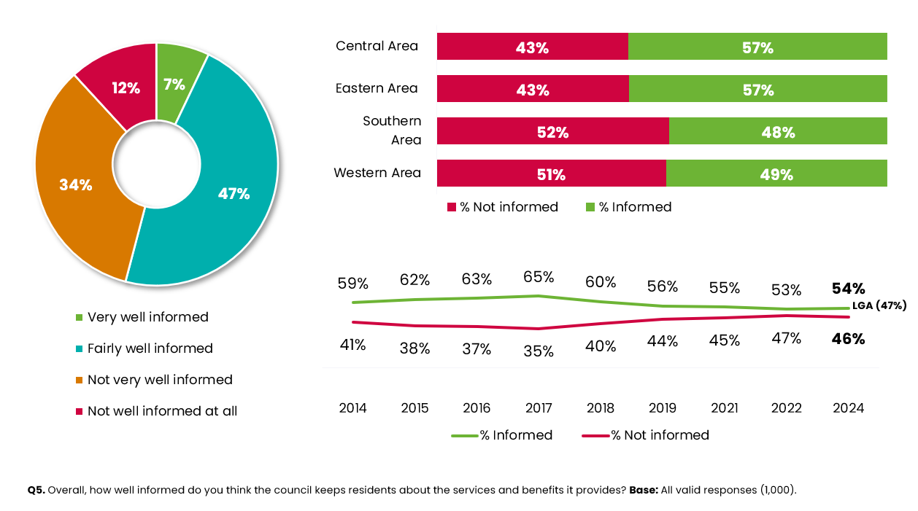

Sources of information
When asked where residents currently obtain most of their information about the council, the council website and ‘Our North Tyneside’ magazine (both 51%) remain the most popular. However, usage of both sources has decreased significantly by seven and six percentage points respectively since the 2022 survey.
The downward trend in the popularity of local media has continued, with it now being selected by just under a quarter of residents (23%) as a current source of information (down from 30% in 2019).
Preferences on obtaining information has remained fairly consistent since 2022, although the proportion preferring to receive information via ‘Our North Tyneside’ (the residents’ magazine) has decreased slightly by four percentage points to 25%.

Figure 68: Current and preferred sources of information
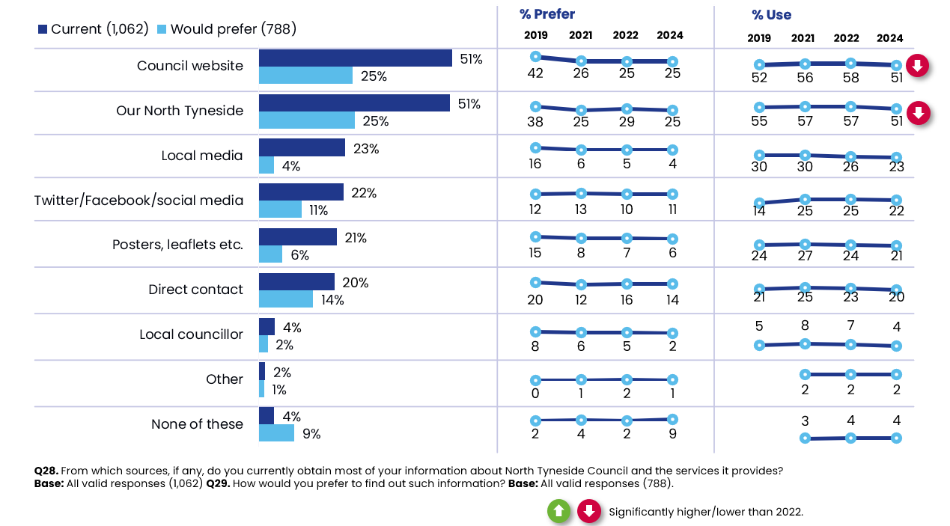
When looking at differences by sub-group, we see that:
- Those aged 45-54 are most likely to obtain information about North Tyneside and the service it provides via the website (67% vs. 51%). Those who are working are also significantly more likely to obtain information using this channel (58%).

- Owner occupiers (54%) and those living in the Eastern area (55%) are also more likely to use ‘Our North Tyneside’ as a source of information while social tenants most commonly prefer to use direct contact (39%).

Technical report

Respondent profile
Figure 69 shows the profile of participants that participated in the 2024 survey, in terms of the unweighted profile and then once weighted to the demographic profile of the North Tyneside population aged 18+. The unweighted sample of participants almost matches the profile of borough population by sex and ethnicity. However, participation in the survey was higher amongst older residents and matched the population exactly in terms of 55-64 year olds (at 19%). However, as in previous years, participation rates were lower amongst the youngest residents.

This variance in response to the survey, and consistent with previous years, was corrected through weighting. All data in this report is based on the weighted data and is therefore representative of the local population. Please note: the demographic section of the survey was not compulsory.
Figure 69: Respondent profile (Weighted vs. Unweighted)
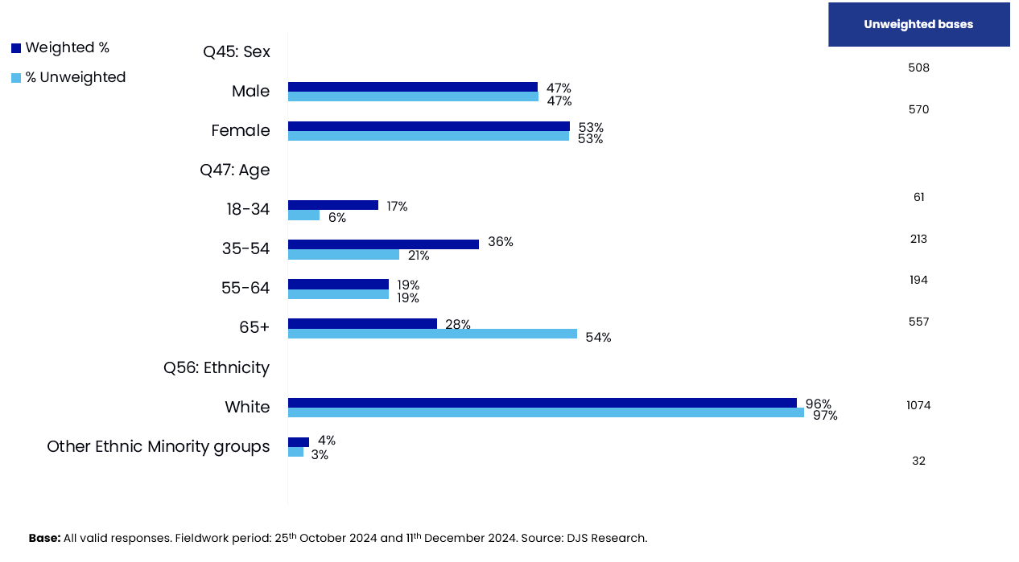

Sample frame and design
As with previous waves, the Royal Mail Postcode Address File (PAF) was used to create the sampling frame. This was chosen as it is the most up-to-date source of addresses available.
In previous years, the resident survey was conducted through a postal survey of residents across the borough. In 2024, it was agreed that the approach would change to a ‘push to web’ methodology. This methodology gave respondents the option of completing the survey via the paper/postal copy enclosed with the survey invites or completing the survey online.
A ’push to web’ approach was selected as it generally generates a more balanced sample, than if just one methodology is used, i.e. postal only and makes the survey more accessible and appealing to all sub-groups of the population. A push to web approach is also considered to be more sustainable; involving less printing and the associated CO2 emissions of posting/transporting completed paper questionnaires.
DJS Research drew a random sample of 5,000 residential addresses from the Royal Mail Postcode Address File (PAF), which had first been stratified by the four areas within North Tyneside and then by IMD quintile (deprivation level), ensuring a representative sample of households was selected and each household had an equal chance of being selected.
Ahead of the full roll-out of the survey, a ‘soft’ launch was undertaken. This involved posting the survey to 500 addresses from the sample first, to allow initial survey completions to be returned and reviewed before the remaining sample was mailed.
A 12-page questionnaire and covering letter (see Appendices) were sent out to each address in the sample. The covering letter explained the options of completing the survey by post (and returning it in the pre-paid envelope), or via the online survey (using the link or QR code provided on the letter).
One reminder mailing, again including a paper copy of the survey, as well as details of how to complete the survey online, was sent out to households who had not responded to the initial mail-out after a couple of weeks. The fieldwork closed on 11th December 2024, after a period of around six weeks, to ensure residents had ample time to complete the survey but that all fieldwork was completed well before Christmas.
There were 1,128 valid responses from the original sample, which is a response rate of 23%, in line with the previous year (24%). The split of responses by completion method was as follows:

- 740 paper responses
- 388 online responses

Weighting
Data was weighted back to the known population profile of the area to counteract non-response bias. Data was weighted by age within gender bands and ethnicity. The weighting profile was based on 2021 Census information.
This weighting approach is also consistent with previous waves of the study.

Data analysis, editing and coding

DJS Research took responsibility for the data processing and analysis of the survey data, this included receipt of the postal returns and the online responses which were merged into one combined data set based on a data specification agreed with the Council.
All stages were quality assured by the Data and Research teams to check for completeness and accuracy of the final data and analysis.

Statistical reliability

A total of 1,128 responses were obtained. This equates to a margin of error of +/-2.91% based on a statistic of 50% at the 95% confidence interval. This means that if we found a satisfaction level of 50%, we can be 95% confident that this figure lies between 47.09% and 52.9% if every resident of North Tyneside took part in the survey.
The table below illustrates the predicted ranges for different sample sizes and percentage results at the 95% confidence interval.
Figure 70: Sampling tolerances
Sample size | Approximate sampling tolerances
 | 10% or 90% | 30% or 70% | 50%
100 | +/-6% | +/-9% | +/-10%
200 | +/-4% | +/-6% | +/-7%
500 | +/-3% | +/-4% | +/-4%
1,128 | +/-2% | +/-3% | +/-3%





For more information…
Julie Hollingsworth, Associate Director
jhollingsworth@djsresearch.com
Clare Rapkins, Senior Research Manager
crapkins@djsresearch.com
Jasmine Palin, Research Executive
jpalin@djsresearch.com

Please note: the wording of the question in the Community Life survey is slightly different (How strongly do you feel you belong to your immediate neighbourhood)?

